Kongsberg Maritime launch fully-remote, practical Dynamic Positioning Operator training
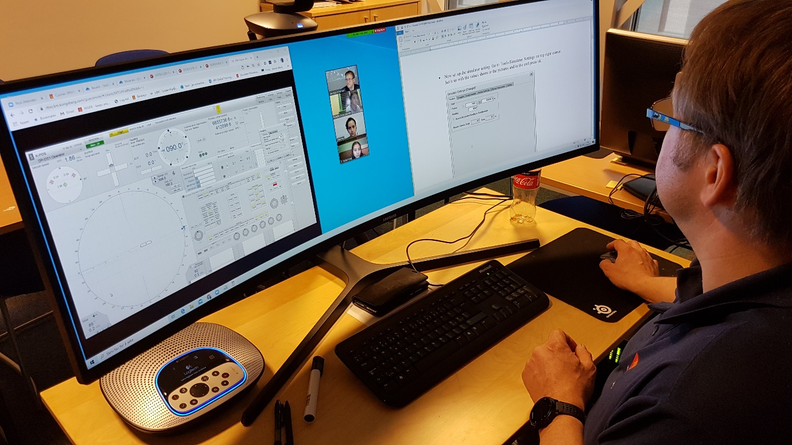
Kongsberg Maritime have developed the first remote basic DPO courses to offer practical training
Kongsberg, Norway, 25th June 2020 – As part of Kongsberg Maritime’s plan to ramp up remote delivery of targeted education using digital platforms, KONGSBERG is delighted to offer the first basic Dynamic Positioning Operator (DPO) courses to be available fully remotely from start to finish, including the practical part of the training.
Using virtual machines, students can engage in practical exercises with a remote K-Pos trainer, in addition to completing theory and assessment modules online. This unique addition of hands-on experience is fully compliant with the DNVGL DPO preparation course and has been approved by The Nautical Institute for their DP Induction course: the first remotely-delivered DPO training ever to receive this accolade.
DPO courses are often requested by ship owners on behalf of their trainees, and also by self-sponsored candidates. By enabling students to complete the course from their home or office using cloud-based K-Pos trainer consoles, KONGSBERG is making training more accessible by removing both the disruption and expense caused by travelling.
Delivery of remote training – already a focus for Kongsberg Maritime – has been accelerated by the Covid-19 situation and is likely to become the main method of training in the future. Applicable to all vessels and industries using DP, the course material is made available online, with competence assessments at each stage provided either by KONGSBERG or by a third party.
Ends

For further information, please contact:
Gunvor Hatling Midtbø, VP Communication
Kongsberg Maritime
Tel: +47 9921 4209
gunvor.hatling.midtbo@km.kongsberg.com
David Pugh
Saltwater Stone
Tel: +44 (0)1202 669244
d.pugh@saltwater-stone.com

About Kongsberg Maritime
Kongsberg Maritime is a global marine technology company providing innovative and reliable ‘Full Picture’ technology solutions for all marine industry sectors including merchant, offshore, cruise, subsea and naval. Headquartered in Kongsberg, Norway, Kongsberg Maritime has manufacturing, sales and service facilities in 34 countries.
Kongsberg Maritime solutions cover all aspects of marine automation, safety, manoeuvring, navigation, and dynamic positioning as well as energy management, deck handling and propulsion systems, and ship design services. Subsea solutions include single and multibeam echo sounders, sonars, AUV and USV, underwater navigation and communication systems.
Training courses at locations globally, LNG solutions, information management, position reference systems and technology for seismic and drilling operations are also part of the company’s diverse technology portfolio. Additionally, Kongsberg Maritime provides services within EIT (Electro, Instrument & Telecom) engineering and system integration, on an EPC (Engineering, Procurement & Construction) basis.
Kongsberg Maritime is part of Kongsberg Gruppen (KONGSBERG), an international, knowledge-based group that celebrated 200 years in business during 2014. KONGSBERG supplies high-technology systems and solutions to customers in the oil and gas industry, the merchant marine, and the defence and aerospace industries.
Web: Kongsberg Gruppen | Kongsberg Maritime
Social media: LinkedIn | Twitter | Facebook

