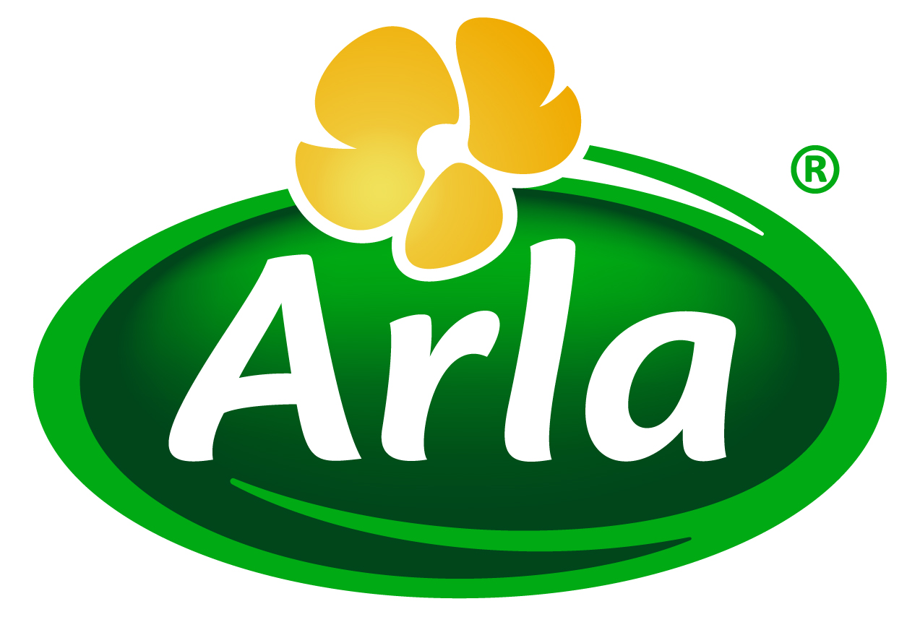
16 September 2013
PRESS RELEASE

We can help you make money from acid whey,
says Arla Foods Ingredients
Arla Foods Ingredients has launched an innovative processing solution that enables manufacturers of traditional Greek strained yoghurts to profit from their acid whey waste stream.

Based on Arla Foods Ingredients’ Nutrilac® protein, the new process allows companies to use their acid whey to make value-added dairy products, such as high protein fermented beverages, whey smoothies and fermented desserts.

Acid whey has been put into the spotlight recently as a result of the booming popularity of Greek yoghurt. For every 100kg of milk used to make traditional Greek yoghurt, only 33kg ends up used in the final product. The remaining two-thirds is acid whey, a by-product that must be dealt with by the processor.

Until now, Greek yoghurt makers have tended to offload acid whey into the animal feed and biofuels markets. But handling costs are high and returns are low, making both of these uneconomical options. Alternatively, some producers simply dispose of acid whey in their waste stream, a solution that attracts unwelcome overheads and zero income – and controversy on environmental grounds.

However, Arla Foods Ingredients has developed a unique and simple process using Nutrilac® protein, which is derived from milk, to turn acid whey into a range of dairy products that can be sold at a high margin on consumer markets. The result is a fresh tasting and nutritious product that is a good source of calcium, protein and essential amino acids. In addition, using acid whey in this way eliminates the storage and transportation requirements associated with other methods of disposing of it.

Torben Jensen, Application Manager at Arla Foods Ingredients, said: “Until now it has simply been accepted that acid whey is an unavoidable waste product of Greek yoghurt production – but not any more. With the addition of our Nutrilac® protein solution to the acid whey, what was once a waste product is now a raw material that can be used to create a high quality product with added value.”

Arla Foods Ingredients’ acid whey concept is also suitable for use in other applications where acid whey is a by-product, including quark production.

ENDS

For more information, images or to arrange an interview with an Arla Foods Ingredients representative on this subject, please contact:

Miranda Mills, Ingredient Communications
Tel: +44 207 193 4167
Email: Miranda.mills@ingredientcommunications.com

About Arla Foods Ingredients
Arla Foods Ingredients is a leading developer and supplier of nutritional and functional milk-based ingredients to the global food industry. The company operates production facilities in Denmark, Sweden, Argentina and Germany, application centres in Denmark and Argentina, and a worldwide network of sales offices. Its North American sales office is based in Basking Ridge, New Jersey. Arla Foods Ingredients is a subsidiary of Arla Foods, one of Europe’s principal dairy groups.

RSS Feed
Visit our website at www.arlafoodsingredients.com/news and sign up to our News RSS feed for all the latest developments – updated regularly.

Twitter
Follow us on twitter for all the latest updates @ArlaIngredients

