**Jessica Bäckman is ready for the new race weekend**

**August 19–21st ADAC TCR Germany and its participants take over the Lausitzring track in Germany. The Sweden National Team driver Jessica Bäckman is charged for another new race weekend.**

**- Lausitzring is a completely new track for me, and it seems to be a technically advanced track. It will be a challenge to get up to speed quickly this weekend, I am ready to take on the challenge, Jessica Bäckman says.**

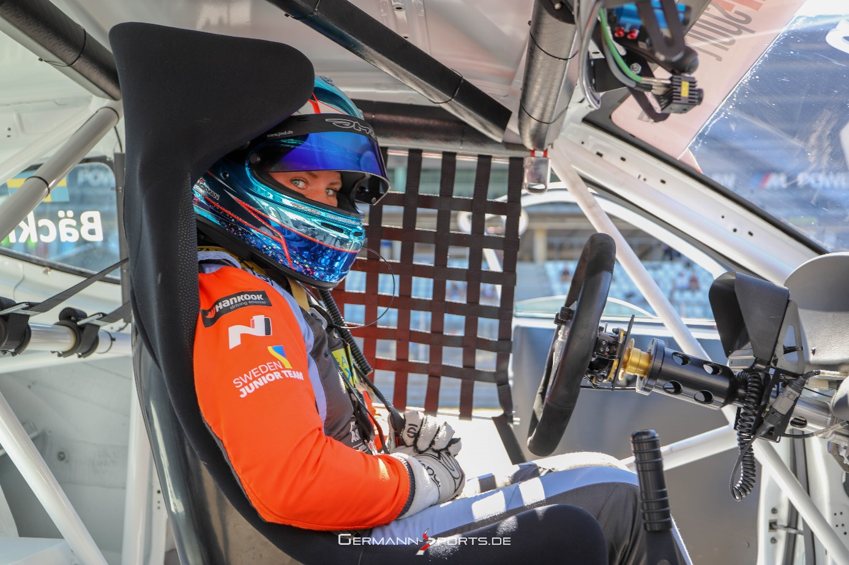

The Lausitzring track (formally known as the Dekra Lausitzring for ownership reasons) is a racetrack located near Klettwitz (a civil parish in Schipkau) in the state of Brandenburg in northeastern Germany. The Lausitzring has a feature unique to continental Europe: a high-speed oval racetrack, used in the United States by NASCAR and IndyCar. The Deutsche Tourenwagen Masters, DTM, is the main event regularly staged at the Lausitzring these days, which has also hosted several editions of the Superbike World Championship in the past. The Laustizring track has many different layouts, and it is the shorter version of the track that ADAC TCR Germany will race on. Next weekend it's time for ADAC TCR Germany's fifth round to run at the track and the Sweden National Team driver is looking forward to competing again.  
- I'm looking forward to jump into the car again after the short break after Nürburging two weeks ago. I hope for a problem-free weekend with good speed, I'm charged and I will give my all, **Jessica Bäckman** says.

**New technical advanced track for Jessica**Lausitzring is a track with many advanced and tight corner sections where qualifying will be a decisive factor. Jessica has loaded up with a lot of simulator training to be in the match from the start.- Lausitzring is a completely new track for me, and it seems to be a technically advanced track. It will be a challenge to get up to speed quickly this weekend, I am ready to take on the challenge, **Jessica Bäckman** says.

**Timetable for this weekend:**  
*(all times in CET)*

**Friday August 19th:**  
08:55 Free practice 1  
12:55 Free practice 2  
18:15 Q1  
  
**Saturday August 20th:**10:00 Q2  
16:55 Race 1 [TV link for Race 1](https://motorsport.tv/adac/video/lausitzring-race-1/148250)  
**Sunday August 21st:**11:30 Race 2 [TV link for Race 2](https://motorsport.tv/adac/video/lausitzring-race-2/148255)

**Live-TV**Both races can be streamed live at motorsport.tv  
Race 1: [Click to watch Race 1](https://motorsport.tv/adac/video/lausitzring-race-1/148250)  
Race 2: [Click to watch Race 2](https://motorsport.tv/adac/video/lausitzring-race-2/148255)  
  
Both races can also be watched re-live at [www.youtube.com/adacmotorsports](http://www.youtube.com/adacmotorsports) and Motorsport.tv

**Live-timing**  
All practices, qualifyings and races can be followed live through live-timing <https://www.adac-motorsport.de/adac-gt-masters/live-timing>

**About the track:**

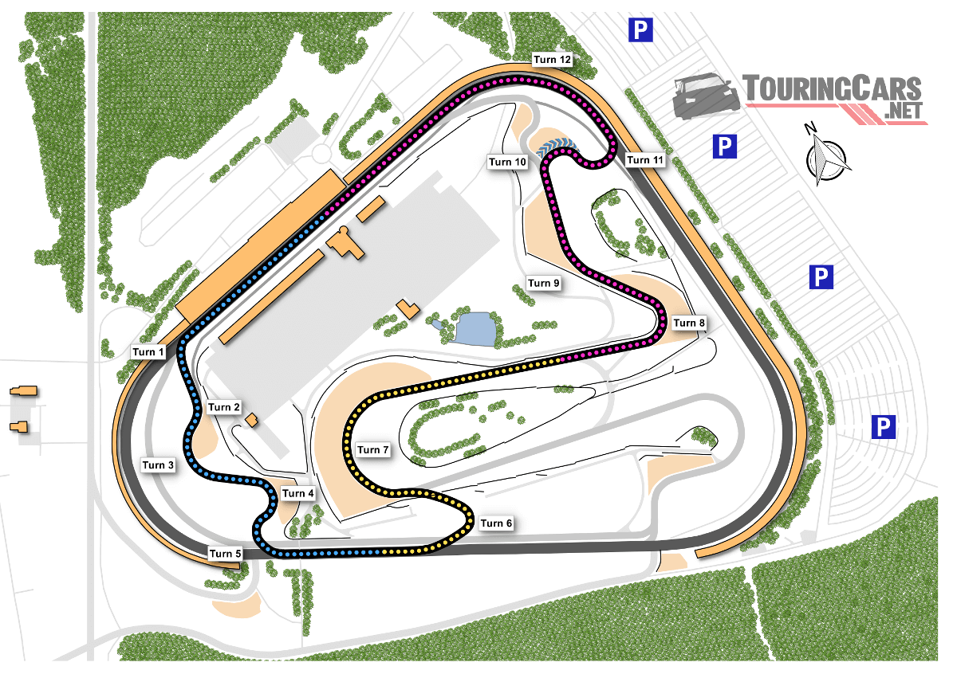

**Place:**Lausitzring, Germany  
**Length:**3,410 km  
**Corners:**12  
**Race length:**30 minutes + 1 lap

**ADAC TCR Germany Calendar 2022:  
*April 22-24th -*** Oschersleben, Germany  
***May 20-22nd -*** Red Bull Ring, Austria  
***June 17-19th***- Salzburgring, Austria  
***August 5-7th***- Nürburgring, Germany  
***August 19-21st -*** Lausitzring, Germany  
***September 23-25th*** - Sachsenring, Germany  
***October 21-23rd***- Hockenheim, Germany

**Championship standings:**

**ADAC TCR Germany – Total (Top three)**  
ADAC TCR Germany 2022 (after 4 out of 7 rounds)

1: Martin Andersen (DKK), 234 p.  
**2: Jessica Bäckman (SWE), 205 p.**3: Szymon Ladniak (POL), 162 p.

[Click to see full championship standings](https://www.adac-motorsport.de/adac-tcr-germany/rankings/2022)

***Free rights to use images.***