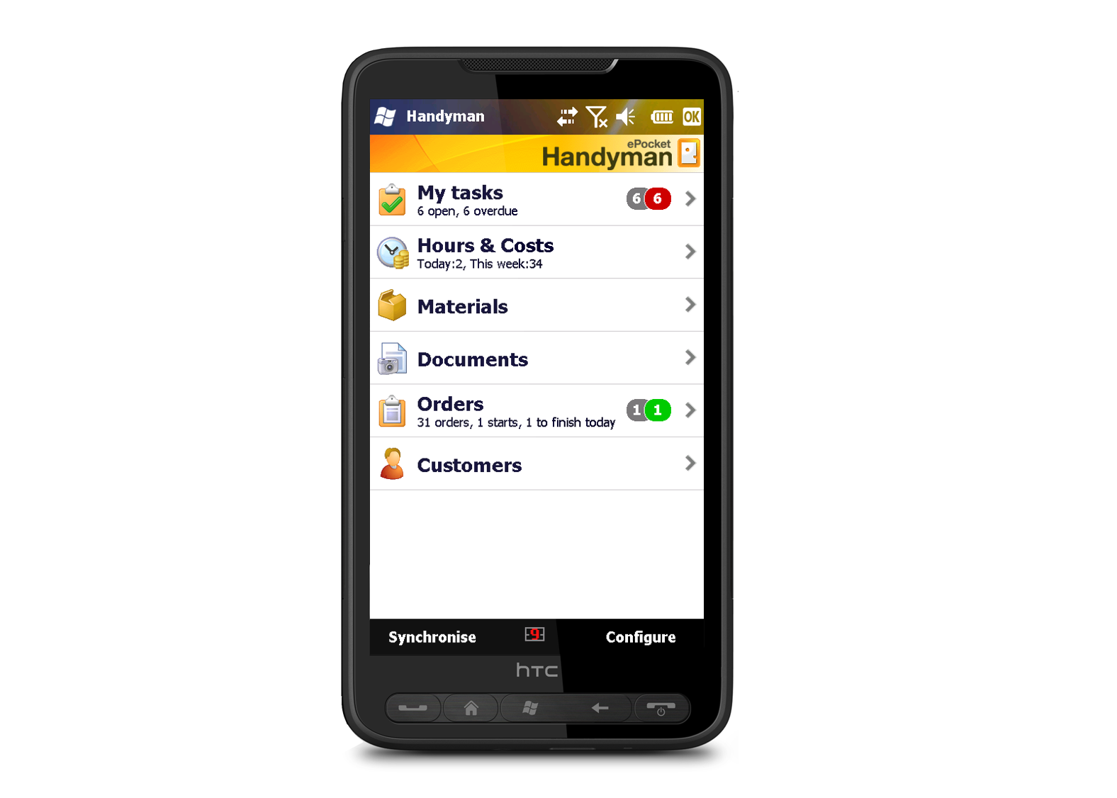[](http://www.epockethandyman.com)

PRESSRELEASE · Wednesday, 19 May 2010

# ePocket Handyman — mobile field service software now integrated with SAP products

**ePocket Solutions AS** has its main office in Oslo, Norway, and several offices in Europe. Via a partner network ePocket Solutions AS has coverage in 14 other countries including Denmark, Finland and the Baltic states. In Scandinavia, ePocket is the market leader and the company is expanding its European customer base rapidly.

**Handyman** is the world’s most advanced service management software suite, adapted to the needs of mobile service technicians and their office-based co-workers. Handyman allows the service technician in the field to exchange data with office- based co-workers using a PDA or smartphone. The ability to access and input data on the move speeds up critical processes improves service quality and minimizes downtime.

**ePocket Solutions AS** has deep expertise in both the technology and process of field service management The all star software development team and innovative software design practices behind the Handyman platform ensures consistency and completeness in managing almost any service task. ePocket Solutions agile software development methodology helps provide regular product updates to customers with minimum disruptions to their business.



**next page >>**

ePocket Solutions, a leading provider of standardized mobile software solutions to field service organizations, has announced the successful integration of its flagship Handyman product with SAP CRM, SAP ERP and SAP Business One®. ePocket Handyman is amongst the world’s most advanced mobile work order management solutions and it enables mobile users equipped with a PDA or Laptop to view open work-orders, register work tasks as they are completed, manage the inventory onboard their service vehicle and to purchase materials on-line from wholesalers´ catalogs.

ePocket Solutions uses the SAP PI library to integrate with SAP CRM, SAP ERP and SAP Business One. Handyman already integrates with several other leading ERP systems and the recent SAP integration is an important addition to cover the widespread use of SAP solutions in leading service companies.

ePocket Solutions CEO Jarl Spandow says, “Our integration of Handyman with the SAP ecosystem will help our enterprise customers get the most out of their SAP investment. Using Handyman to run their service front office they can quickly share critical service data with the SAP applications that support their finance, people or customer relationship management processes.”

**Handyman SAP CRM Integration**

*The Handyman SAP CRM integration provides the following capabilities*

* SAP PI converts the orders from IDOC to XML data for Handyman. This information is then sent to the Handyman device of the assigned technician.
* Any order changes inputted on a Handyman device are pushed to SAP PI for synchronization
* Orders created on the Handyman can be directly fed to SAP CRM

**Handyman SAP ERP Integration**

*The Handyman SAP ERP CATS integration provides the following capabilities*

* Order Synchronization with SAP ERP using SAP PI.
* Proxy Interface for CATS handling
* Comprehensive Error Logging for Handyman – SAP ERP CATS Interface

**Handyman SAP Business One Integration**

*The Handyman SAP Business One® integration provides the following capabilities*

* Bi-Directional data exchange and synchronization between SAP Business One and Handyman
* Fully Compliant with SAP B1 Ad-On Concept
* Connection to SAP Business One service calls and service activities
* Exchange of additional order information including custom fields, orders, equipments

**About SAP**

SAP is the world's leading provider of business software, offering applications and services that enable companies of all sizes across more than 25 industries to become best-run businesses. With more than 95,000 customers in over 120 countries, the company is listed on several exchanges, including the Frankfurt stock exchange and NYSE, under the symbol "SAP."

<http://www.sap.com>

**About SAP CRM**

The SAP Customer Relationship Management (SAP CRM) application is a part of the [SAP Business Suite](http://www.sap.com/solutions/business-suite/index.epx), SAP CRM is an application designed to help companies manage their relationships with their customers. It is an Internet-based, standardized platform for sales, marketing, and service, and enables a 360-degree view of the customer.

<http://www.sap.com/solutions/business-suite/crm/index.epx>

**About SAP Business One®**

The SAP Business One application integrates core business functions – including financials, sales, customer relationship management, inventory, and operations. SAP Business One is a single application, eliminating the need for separate installations and complex integration of multiple modules.

<http://www.sap.com/sme/solutions/businessmanagement/businessone/index.epx>

Keywords: ePocket, epocket handyman, epocket PDA, epocket service, handy man software, handyman enterprise software, handyman field service software, epocket sap, epocket sap business one, epocket sap crm, epocket sap erp, handyman sap, handyman sap business one, handyman business one, handyman erp, handyman xml erp interface, handheld erp integration, handyman erp integration, handyman sap crm, handyman sap erp

For more **information** : [**www.ePocketHandyman.com**](http://www.ePocketHandyman.com)

Jarl Spandow, Mobile phone: +47 900 34 713

E-mail: [jarl.spandow@epocket.no](mailto:jarl.spandow@epocket.no)

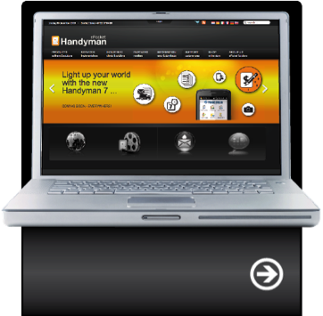

read more about us:

epockethandyman.com

