NEIL YOUNG + PROMISE OF THE REAL
PARADOX (Original Music From The Film) ON REPRISE RECORDS MARCH 23

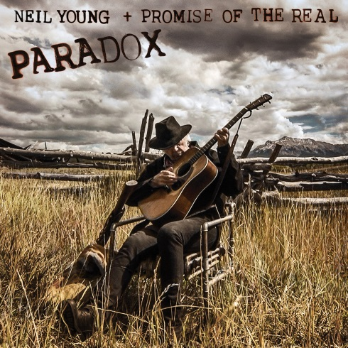
(Cover image)

March 12, 2018 (Burbank, CA) – Neil Young + Promise Of The Real will release PARADOX (Original Music from The Film) on double vinyl and digital on March 23, with the CD to follow on April 20. PARADOX (Original Music from the Film) features music from Young + POTR and Young with an Orchestra recorded on the MGM Soundstage, Young backed by Jim Keltner, Paul Bushnell and Joe Yankee, and several solo electric guitar passages. All music was recorded spontaneously with no overdubs (with the exception of Joe Yankee, who phoned in his part from Canada) and provides the soundtrack to Paradox, the film. Click here to pre-order PARADOX (Original Music from the Film)
PARADOX, the film, written and directed by Daryl Hannah features Neil Young + Promise of the Real. A fantasy, a loud poem and a whimsical tale of music and love, PARADOX is a sweetly idiosyncratic personal expression. Sometime in the future-past, a band of outlaws hides out high in the Mountains. The "Man in the Black Hat" (Neil Young), the "Particle Kid" (Micah Nelson) and "Jail Time" (Lukas Nelson) and a band of cowboys and outlaws pass the days digging for treasure while they wait for the full moon to bring its magic, the music and let the spirits fly.
PARADOX will world premiere at next week’s SXSW Film Festival on March 15, will launch on Netflix on March 23 and will play in a limited theatrical release.
Songs written by Neil Young unless otherwise noted.
Track listing for PARADOX (Original Music From The Film):
Produced by Neil Young and John Hanlon
Side 1:
Many Moons Ago In The Future (Narration by Willie Nelson)
Show Me
Paradox Passage 1
Hey
Paradox Passage 2
Diggin’ In The Dirt - Chorus (written by Neil Young, Lukas Nelson &
Micah Nelson)
Paradox Passage 3
Peace Trail (Engineered and Mixed by Tim Mulligan and Dave Lohr)
Side 2:
Pocahontas (Engineered and Mixed by Tim Mulligan and Dave Lohr)
Cowgirl Jam ((Engineered and Mixed by Tim Mulligan and Dave Lohr)
Angel Flying Too Close To The Ground (written by Willie Nelson)
Side 3:
Paradox Passage 4
Diggin’ In The Dirt (written by Neil Young, Lukas Nelson & Micah Nelson)
Paradox Passage 5
Running To The Silver Eagle (written by Neil Young + POTR)
Baby What You Want Me To Do? (written by Jimmy Reed)
Paradox Passage 6
Offerings
How Long? (written by Huddle Ledbetter)
Happy Together (written by Garry Bonner & Alan Lee Gordon)
*Tumbleweed
* Produced by the Volume Dealers. Engineered and mixed by Al Schmitt.
Side 4:
Etched artwork
In other news, Neil Young + Promise Of The Real will perform live at Arroyo Seco Weekend on June 23, in Pasadena, CA. Click here for further details. Then on July 6, Young + POTR will perform at Festival d’Été de Québec, the largest music festival in Canada. Click here for further details.

Click here to learn more about Neil Young Archives.

# # #

Official Site/NYA: neilyoungarchives.com
YouTube: www.youtube.com/NeilYoung
Twitter: @NeilYoung
Facebook: www.facebook.com/NeilYoung
Instagram: @NeilYoung

Press materials:
http://press.wbr.com/neilyoung

