Jays signs American distribution deal with Smart IT

Swedish earphone manufacturer Jays AB has signed an agreement with Smart IT USA LLC to distribute its full range to the American market.
Jays has developed a strong international reputation over the last 12 months thanks to a number of five star product reviews in key media, particularly in the US. This increased exposure has generated a surge in demand for Jays products across the Americas, especially in the US, the world’s toughest audio market. The deal with Smart IT aims to meet this demand head on.

Smart IT is a global distributor of electronics established in 1999 with headquarters in Denmark. The company, which has doubled its turnover every year since its inception, is now represented in ten countries including China, Australia, Germany and Great Britain. Smart IT USA is located in Los Angeles and covers markets in North, South and Central America.
“This agreement with Smart IT in the US provides us with the distribution resources we need to achieve our potential in this very competitive market,” says Rune Torbjörnsen, CEO of Jays AB. “We know that our products are unparalleled in quality and have now found a distributor who meets the very high standards we demand for our global expansion now that we are planning listing on AktieTorget.”

Learn more about the expansion at: www.jays.se/site/company/share-listing.html

* Memorandum: www.jays.se/images/download/sharelisting/jays_sharelisting_memorandum.pdf

* Awards & reviews: www.jays.se/products/general/awards-reviews.html
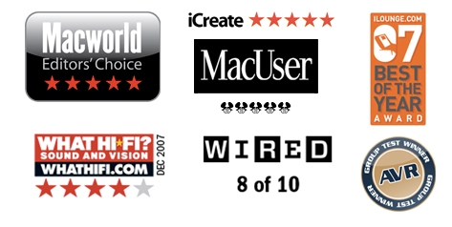
* Fans: www.jays.se/blog/words-about

For more information, please contact:
Rune Torbjörnsen, CEO Jays AB (publ)
Cell: +46-(0)733-730 770
E-mail: rune.torbjornsen@jays.se

Jays AB (publ) develops, designs and produces earphones and equipment for portable media players. Jays supplies high quality products, aimed to provide the user with maximum sound experience. Jays passion is the quest for the perfect sound – the sound that affects and inspires a user’s body and soul.The company is expanding rapidly and its products are being sold in more than 20 countries worldwide.

