EMBARGOED UNTIL 23rd MARCH 2022, 10AM GMT

RÖYKSOPP TEAM UP WITH ASTRID S ON NEW PROFOUND MYSTERIES INSTALMENT BREATHE

FEATURING THE EXTRAORDINARY I HATE MY SHELF SHORT FILM BY ACCLAIMED DIRECTOR ANDREAS NILSSON

PROFOUND MYSTERIES
AVAILABLE FROM 29TH APRIL, 2022

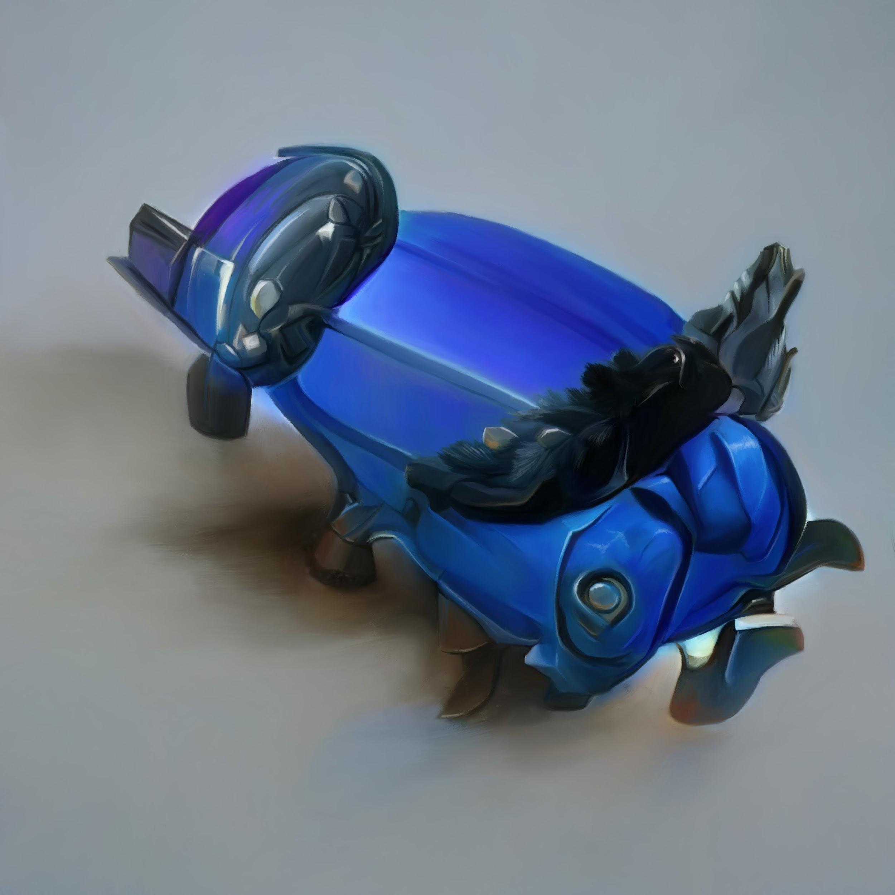
05. Breathe - available 23rd March 2022
Artefact and visualizer by Jonathan Zawada
I hate My Shelf directed by Andreas Nilsson

Röyksopp have teamed up with Norwegian singer songwriter Astrid S on this new instalment from their Profound Mysteries project, Breathe.

“I have always wanted to collaborate with Röyksopp, they have been and continue to be a huge inspiration for me. I’m really excited for the music to finally come out!” - Astrid S

Alongside the effervescent electronic beat-driven Breathe featuring ice cool vocals from Astrid S, the Profound Mysteries creative world grows with a new artefact and visualiser from artist Jonathan Zawada, this time in the form of a vivid blue industrial design with black feathers.

The Breathe film I Hate My Shelf adds to the visual adventure, directed by award-winning and internationally acclaimed Swedish filmmaker Andreas Nilsson (Kanye West, 2 Chainz, MGMT). Nilsson, known for his visually dynamic sense of humour, is a long time Röyksopp collaborator having previously worked on short films for their albums Junior, Senior and the music video for This Must Be It. I Hate My Shelf is a compulsive watch, set in a hotel corridor with a woman, a man and a spinning shelf.

A bespoke immersive Breathe AR Filter based around the Profound Mysteries trefoil logo has launched today on Röyksopp's Instagram account. The filter was developed by Somewhere Systems, the immersive web agency responsible for the ‘Press R’ landing page.

Profound Mysteries is an expanded creative universe and prodigious conceptual project brought to you by Röyksopp, featuring a host of audio-visual collaborators.

On January 1st, 2022 Röyksopp launched the film (Nothing But) Ashes… and fans were encouraged to Press «R». Alongside the Kasper Häggström-directed short film BJA, a second piece of music, The Ladder, was released.

A new artefact and visualiser, created by Jonathan Zawada, brought the music to life. On 2nd February, following the premiere of The Downfall by Marc Reisbig, another chapter was revealed with Impossible featuring Alison Goldfrapp — the first human voice to be heard on Profound Mysteries. A third artefact and visualiser expanded the hyper real collection. On 22nd February another short film was released; The Conversation from award winning Danish director Martin De Thurah, a previous Röyksopp collaborator (Do It Again and What Else Is There), followed by This Time, This Place, featuring vocals from creative polymath, conceptualist and film director Beki Mari. All elements are accessible through the Profound Mysteries portal.

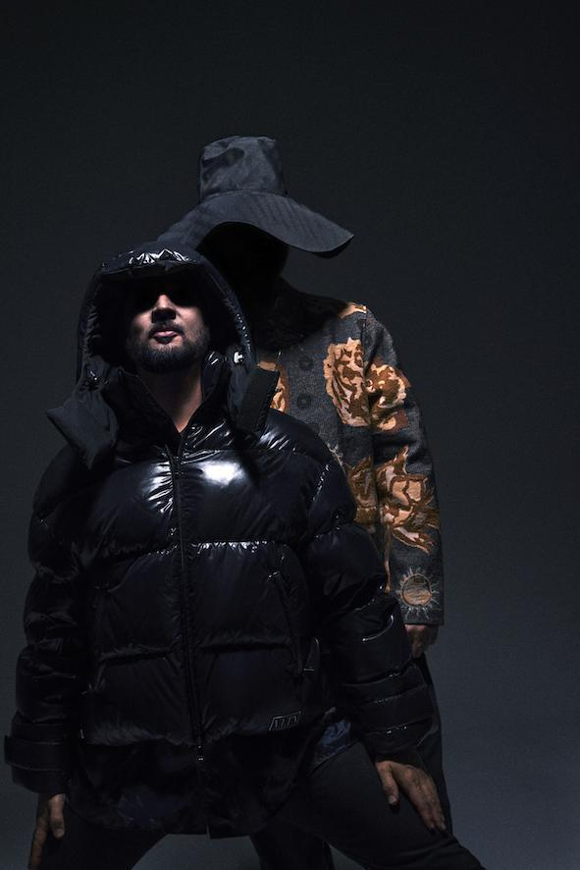
Download photos here
Credit: Stian Andersen

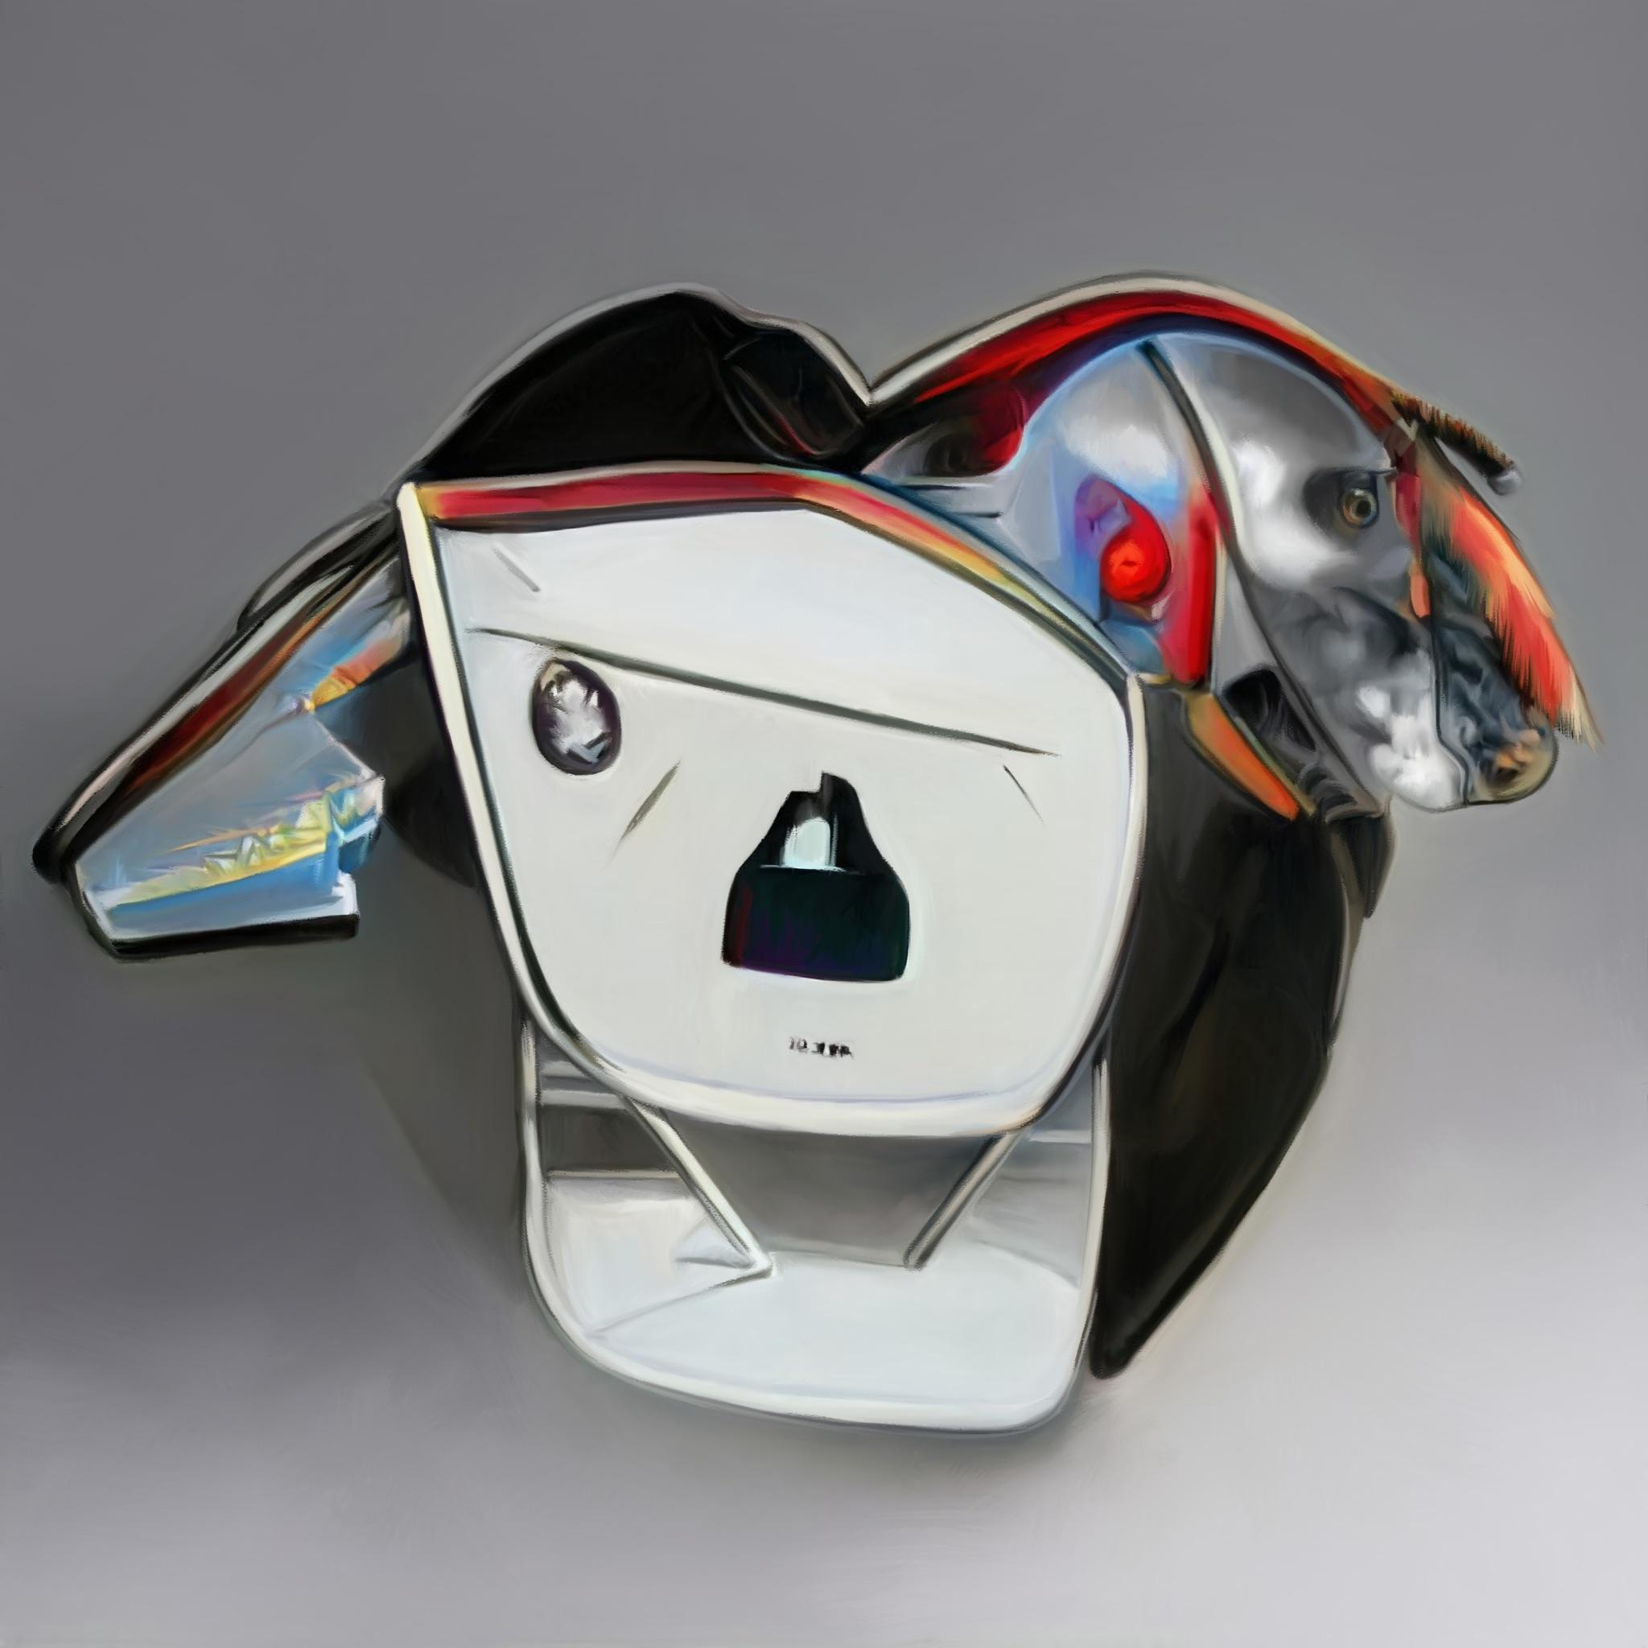
04. This Time, This Place - available 23rd February 2022
Artefact and visualizer by Jonathan Zawada
The Conversation directed by Martin De Thurah

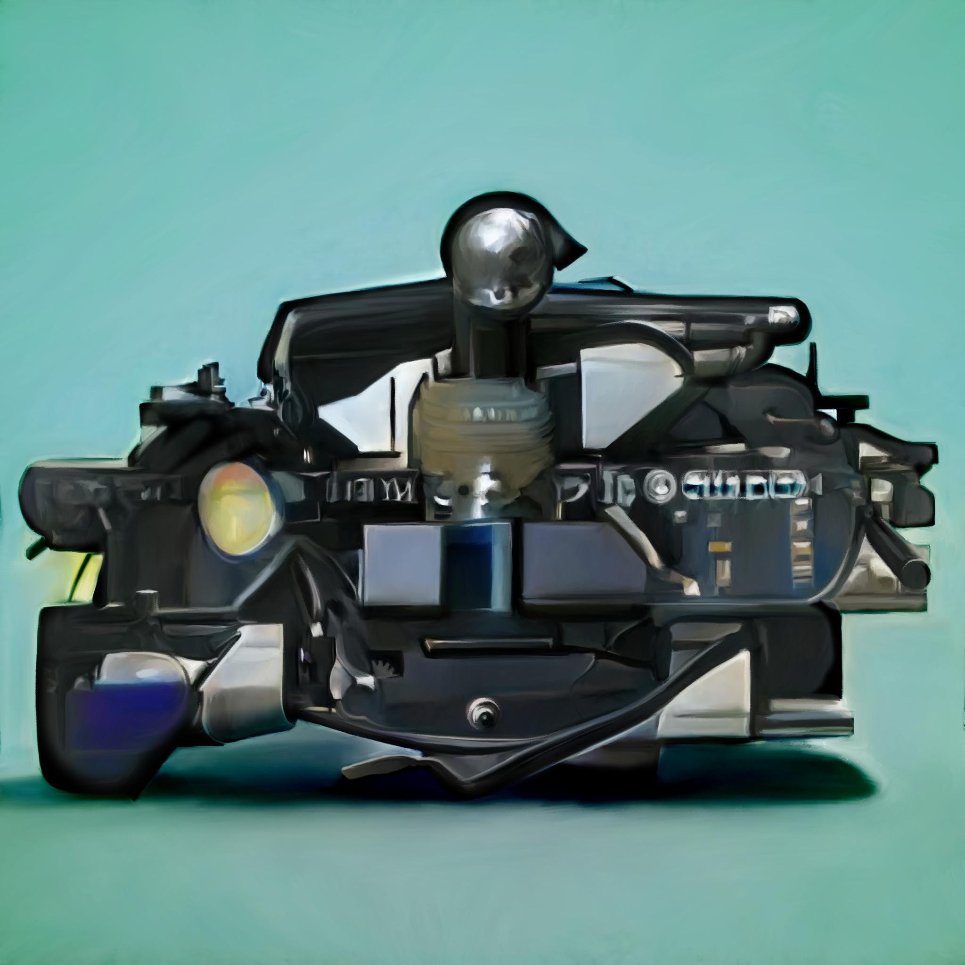
03. Impossible - available 2nd February 2022
Artefact and visualizer by Jonathan Zawada
The Downfall directed by Marc Reisbig

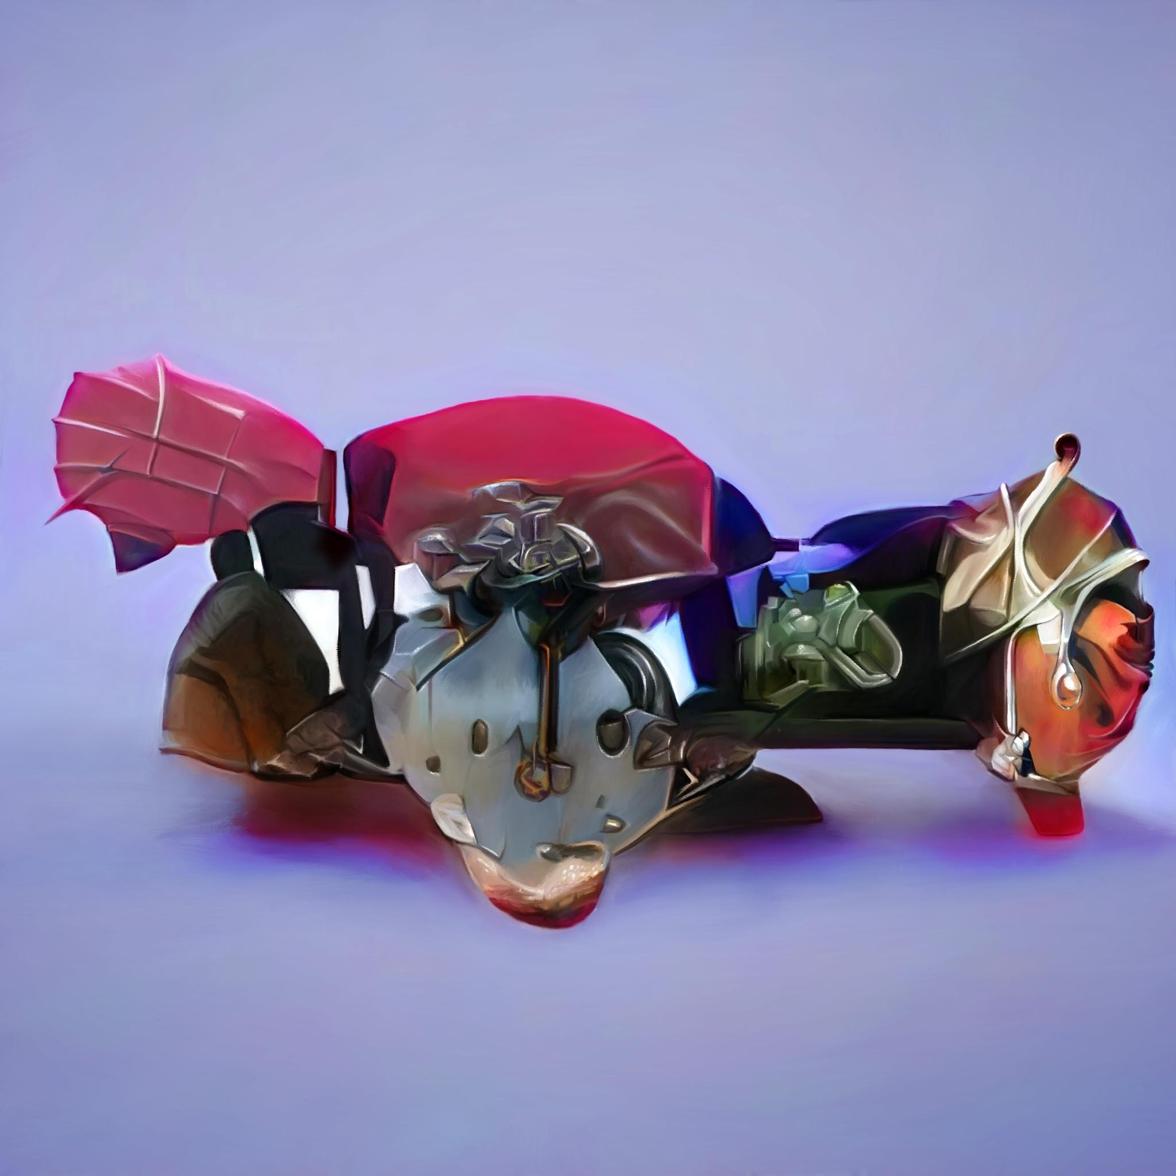
02. The Ladder
Available 13th January 2022
Artefact and visualizer by Jonathan Zawada
BJA directed by Kasper Häggström

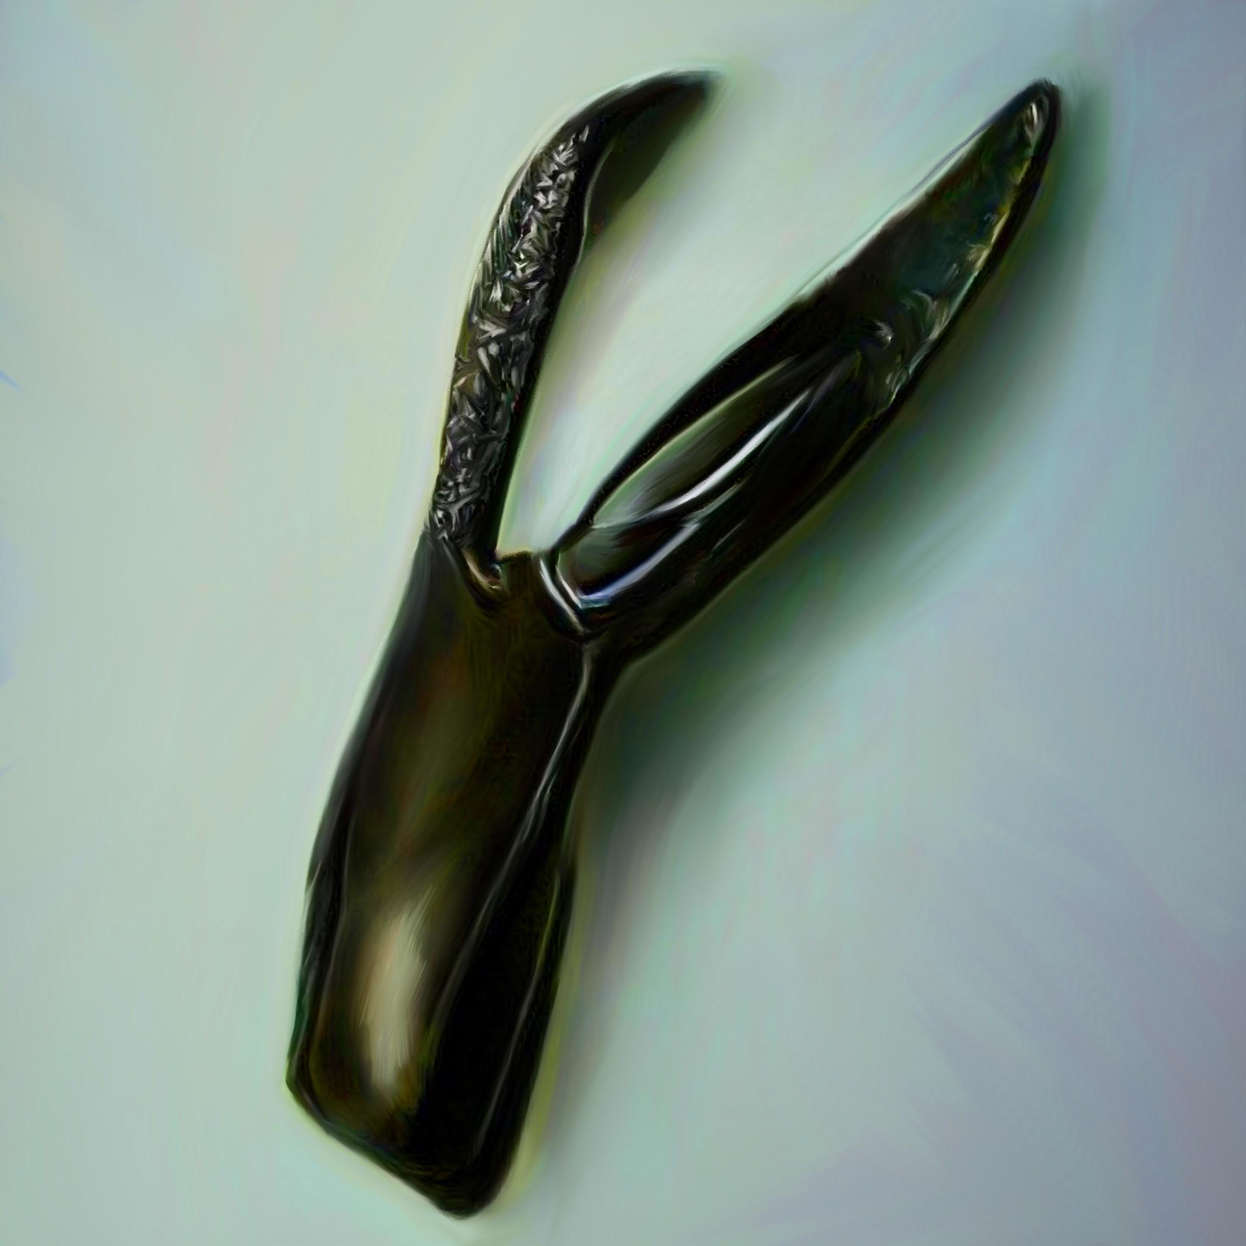
01. (Nothing But) Ashes…
Available 1st January 2022
Artefact and visualizer by Jonathan Zawada
(Nothing But) Ashes... directed by Röyksopp

Profound Mysteries will be available from 29th April 2022. Pre-Order HERE.*
*Formats - CD and cassette only, vinyl to be announced

01. (Nothing But) Ashes...
02. The Ladder
03. Impossible
04. This Time, This Place…
05. How The Flowers Grow
06. If You Want Me
07. There, Beyond The Trees
08. Breathe
09. The Mourning Sun
10. Press «R»

Press R | Facebook | Twitter | Instagram

