Kongsberg Digital’s K-Sim Fishery simulator lands a place on the SAFETY4SEA Training Award shortlist
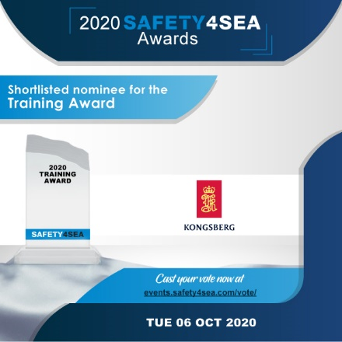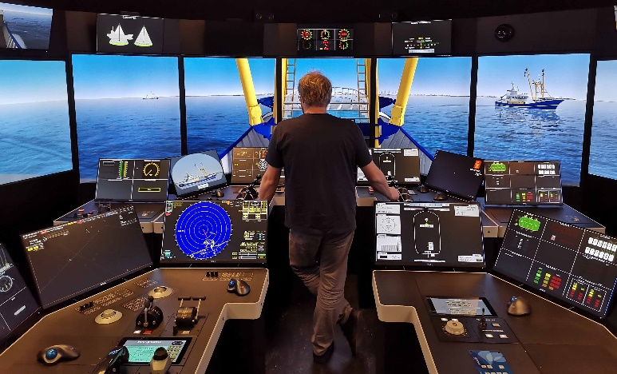

Voting is now open on the SAFETY4SEA website for all categories in its 2020 awards

Kongsberg, Norway, August 4th, 2020 – Kongsberg Digital is pleased to reveal that the company’s K-Sim Fishery simulator has earned a well-deserved place on SAFETY4SEA’s 2020 Training Award shortlist.
The award will go to whichever company is deemed to have made ‘… a significant achievement, breakthrough or contribution in any aspect of maritime training’, and Kongsberg Digital is now inviting all users and supporters of the K-Sim Fishery simulator training solution to register their vote via SAFETY4SEA’s online widget here. The deadline for voting is Friday, September 4, 2020, and the awards ceremony itself is scheduled to take place on Tuesday, October 6, 2020.
As an avidly read and widely circulated shipping news resource, SAFETY4SEA is an influential advocate and mouthpiece for initiatives which promote smart, safe and environmentally-responsible working practices on the world’s oceans. Its annual award scheme and forums not only salute the most principled, sustainable and forward-thinking products on the market, but also serve to encourage further development along those beneficial lines.
The vessel-specific K-Sim Fishery simulator ticks multiple boxes in this regard. It addresses tightened STCW training requirements with a view to enhancing sustainable fishing methods, and completely eliminates potential hazards in the training phase by enabling all exercises to be repeatedly carried out, monitored and assessed in conditions of total safety – even when rehearsing remedial actions and procedures for every kind of emergency scenario.
Presenting trainees with a realistic and immersive facsimile of a fishing vessel’s bridge, the K-Sim Fishery simulator provides them with invaluable, skill-building experience in operating the boat’s control and navigation equipment, in addition to familiarizing them with the winch-handling techniques required to safely and successfully perform all types of trawling activities. Capable of being fully integrated with sonar and echosounder systems from Simrad, K-Sim Fishery enables highly realistic catch monitoring and it also applies sophisticated hydrodynamic modelling to accurately replicate the effects of wave and current interaction. These factors all contribute to a user experience which is effectively indistinguishable from real-life working conditions on board.
“We’re delighted that the K-Sim Fishery simulator has been shortlisted,” says Tone-Merete Hansen, SVP, Kongsberg Digital, “and are very hopeful that it will go on to win the award, so every vote counts. We see the simulator as an exceptionally strong contender because its ability to enhance crew safety, best-practice operations, fuel savings and carbon-footprint reduction is as obvious as it is far-reaching. With its new research-related functionality and configuration flexibility, it’s an indispensable building block in the ongoing construction of a more sustainable and ethical future for the fishing industry.”
Ends

For further information, please contact:

Anne Voith
Marketing Manager, Maritime Simulation
Kongsberg Digital
Tel: +47 4567 8255
anne.voith@kdi.kongsberg.com

David Pugh
Saltwater Stone
Tel: +44 (0)1202 669244
d.pugh@saltwater-stone.com

About Kongsberg Digital
Kongsberg Digital is a provider of next-generation software and digital solutions to customers within maritime, oil and gas, and renewables and utilities. The company consists of more than 500 software experts with leading competence within the internet of things, smart data, artificial intelligence, maritime simulation, automation and autonomous operations.
Kongsberg Digital is subsidiary of KONGSBERG (OSE-ticker: KOG), an international, knowledge-based group delivering high-technology systems and solutions to clients within the oil and gas industry, subsea, merchant marine, defence and aerospace. KONGSBERG has 11,000 employees located in more than 40 countries.
Web: Kongsberg Gruppen | Kongsberg Digital
Social media: LinkedIn | Twitter | Facebook

