Diagram kundnöjdhetsundersökning ColdZyme

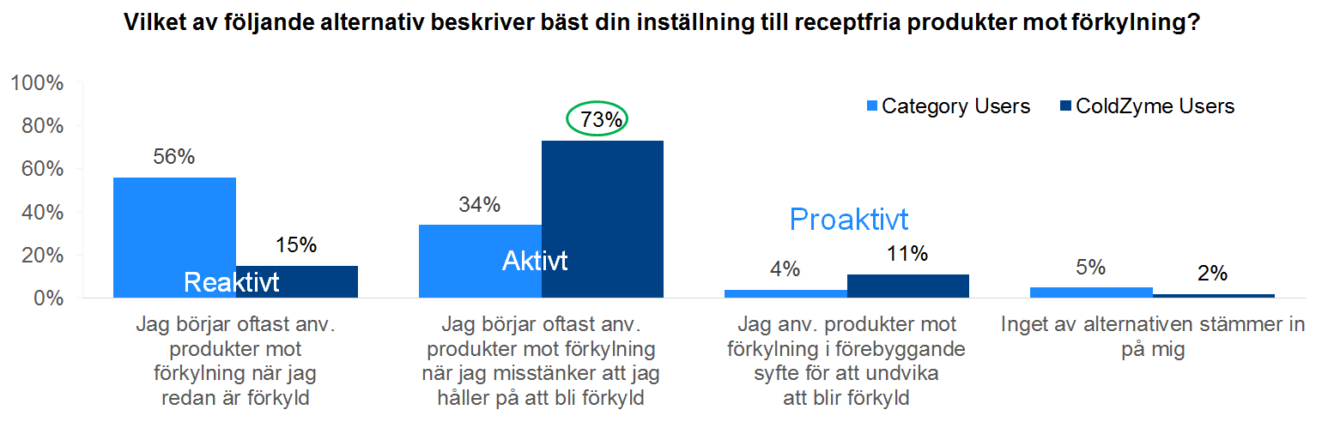
Figur 1: GfK 2014 | Customer insight analysis - ColdZyme | December 2014

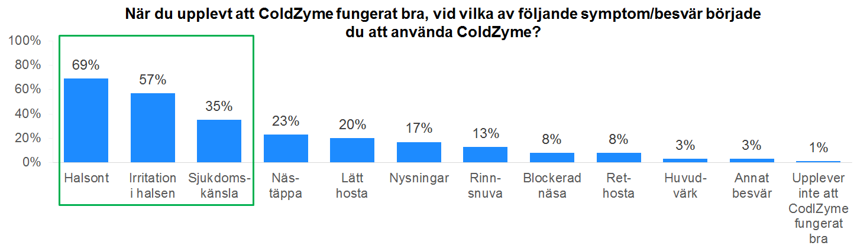
Figur 2: GfK 2014 | Customer insight analysis - ColdZyme | December 2014

