

Fact Sheet

Logitech Illuminated Living-Room Keyboard K830
The best way to control your connected TV, even in the dark.

Announcement Date: April 9, 2014 Shipping: April 2014
Price: €99.99 Available at: www.logitech.com

Product Description

The Logitech® Illuminated Living-Room Keyboard K830 is designed to enhance your connected-TV experience. It’s the best way to wirelessly control your computer when it is connected to the TV, and a must-have for the modern-day living room. The brightness of the backlit keys automatically adjusts based on the amount of light in the room, allowing you to easily type in the dark. Plus, the built-in touchpad gives you precise cursor control from up to 33 feet (10 m)* away. The modern design – combined with extra features such as media-focused hot keys and the ability to quickly recharge – make this the perfect blend of function and form for your modern home.

Key Features
- Backlit keys: Keys automatically dim or brighten based on the amount of light in the room, so you can type easily in any lighting. If no typing is detected after five seconds, the backlight turns off to help you save power.
- Keyboard and mouse all in one: By combining a traditional keyboard and a touchpad into one device, you get streamlined navigation for your connected TV. The touchpad is smooth and responsive with accurate cursor control and enhanced gesture functions for easy navigation.
- Navigate from a distance: Lean back and browse with a fast, reliable wireless connection from up to 33 feet (10 m)* away. The tiny plug-and-play Unifying receiver allows you to start typing immediately, without installing software or pairing the devices.
- Rechargeable:The micro-USB cable makes recharging easy. You can even use your keyboard while it is recharging. A full charge gives you up to 10 days of power.** The On/Off switch and battery indicator light also help you manage the power.
- Living room design: The keyboard is designed to complement the modern living room with a combination of premium textures, metal-like finish and a specific key design crafted into a compact, solid form.
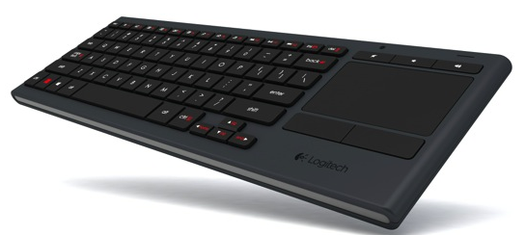

System Requirements
- Windows® 7, Windows 8 or later

Product Specifications
- Design:
- Backlit keys
- Advanced 2.4 GHz wireless with a range of 33 feet (or 10 m)*
- Optimized key layout

- Touchpad:
- Sizable touch area 80 mm x 52 mm (or 3.1 inches x 2.0 inches)
- Superior glide surface
- Separate left- and right-click buttons
- Up to 2-finger gesture support (enabled with Logitech software)
- Extra left-click button
- Keys:
- Key life: up to five million keystrokes
- Key shape: low profile
- Typing noise: within 55 dBA for all keys
- Dimensions:
- Length: 367 mm (or 14.4 inches)
- Width: 125.3 mm (or 4.9 inches)
- Height: 16.5 mm (or 0.65 inches)
- Weight: 495g (or 17.5 oz)

Warranty
- 1-year limited hardware warranty

Press Contact
Juliette Legrand
jlegrand@logitech.com

*Wireless range may vary with environmental and computing conditions.
**Based on typing 2 hours per day with backlight at full brightness. Actual battery life will vary with use, settings, and environmental conditions.

