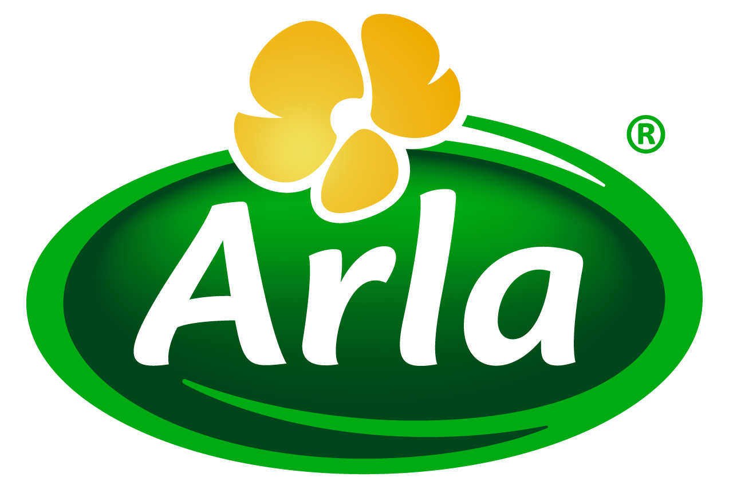
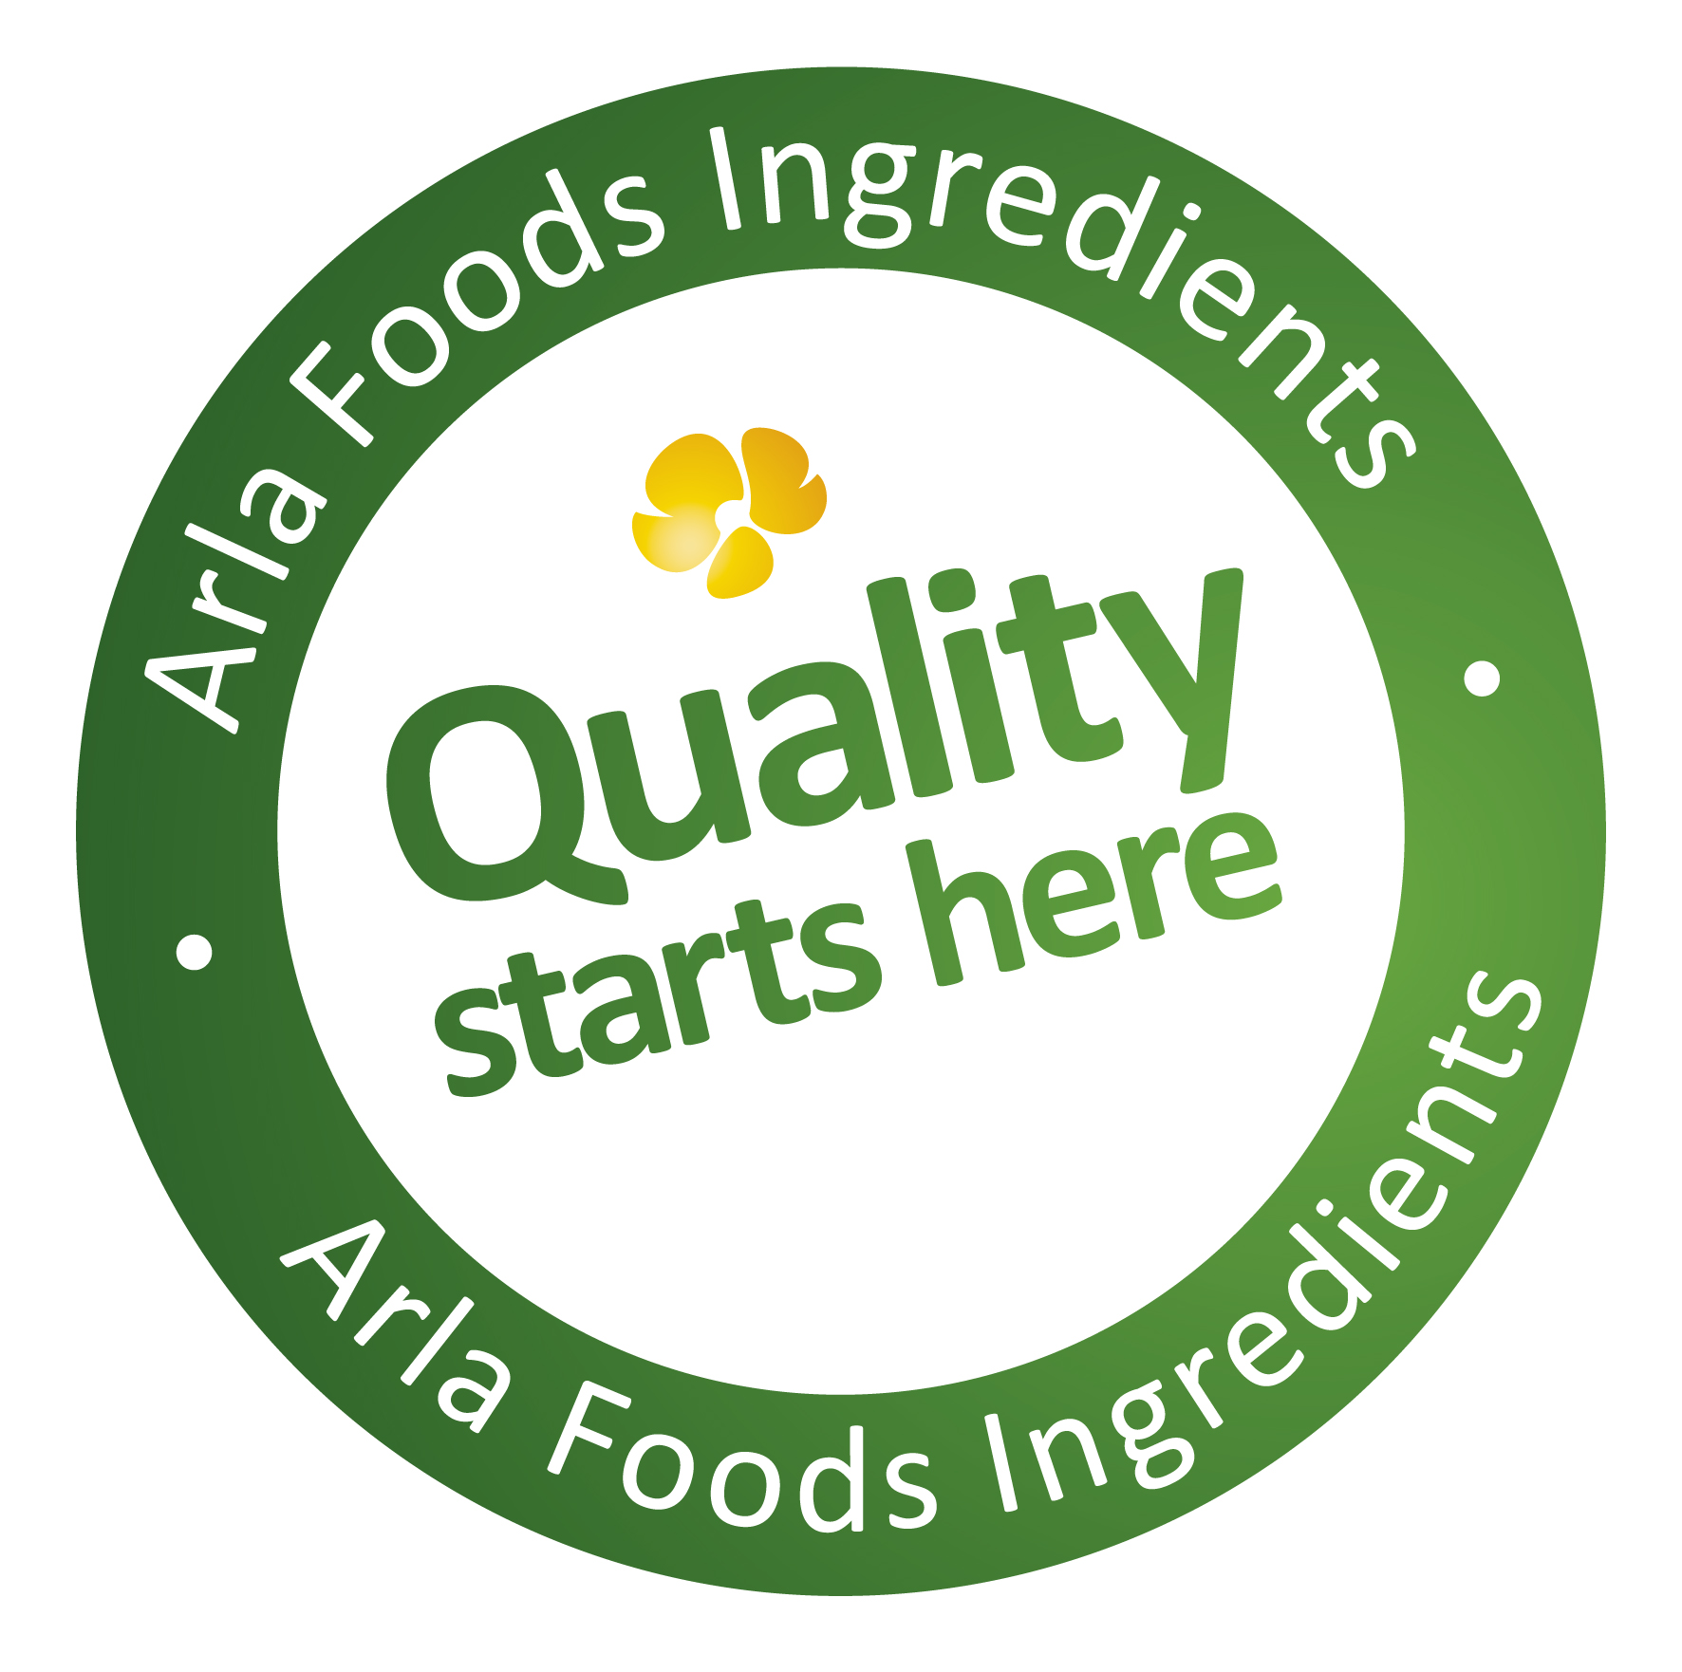

19 June 2014
PRESS RELEASE

Arla Foods Ingredients scores twice at the
World Dairy Innovation Awards

Arla Foods Ingredients is celebrating after triumphing in two categories at the prestigious World Dairy Innovation Awards – for Best Dairy Ingredient and Best Manufacturing or Processing Innovation.

In the Best Dairy Ingredient category, judges gave the award to Arla Foods Ingredients for its protein solution that makes it possible to produce an ice cream version of skyr, the increasingly popular sour milk product. When Nutrilac® IC-6425 is used in frozen skyr, it creates a finished product high in protein and low in fat with a creamy and smooth mouthfeel, as well as a fresh and mild flavour.

In the Best Manufacturing or Processing Innovation category, Arla Foods Ingredients ran out winner with its Nutrilac® FastRipe concept. Nutrilac® FastRipe is a natural milk protein that accelerates the mechanism in cheese that causes it to ripen, enabling cheese-makers to reduce ripening times and save thousands of euros every year without any negative impact on product quality or shelf life.

The winners of the World Dairy Innovation Awards were announced at the Global Dairy Congress in Istanbul, Turkey, on Tuesday 17 June 2014. There were nearly 160 entries from 30 countries, which were judged by an expert panel.

Lars Vestergaard Nielsen, Marketing Communication Manager at Arla Foods Ingredients, said: “Our double success at the World Dairy Innovation Awards underlines the commitment to innovative ingredients that is at the heart of our ‘Quality starts here’ brand platform. Nutrilac® IC-6425 for skyr ice cream and Nutrilac® FastRipe for cheese are just two of the great solutions in our stable of dairy ingredients, all of which offer food and beverage manufacturers tangible benefits in terms of process improvements and help them to meet demand among consumers for high quality end-products.”

ENDS

For more information, please contact:

Miranda Mills, Ingredient Communications
Tel: +44 207 193 4167
Email: Miranda.mills@ingredientcommunications.com

About Arla Foods Ingredients
Quality starts here: Arla Foods Ingredients is a global leader in natural whey ingredients for products in a range of categories – from bakery, beverages, dairy and ice cream to clinical, infant and sports nutrition.
The cornerstones of our business are innovative ingredients, world-class facilities and a staff of dedicated experts. Drawing on our portfolio of functional and nutritional whey proteins, milk minerals, lactose and permeate, our expert team delivers solutions that bring new food products quickly and efficiently to market. Our application centres run hundreds of customer product trials every week. All ingredients are produced using state-of-the-art processing technology at our plant in Denmark, or by one of our joint ventures in Argentina, Germany and the UK.
Arla Foods Ingredients Group P/S is a 100% owned subsidiary of Arla Foods, a global dairy company and cooperative owned by dairy farmers in Denmark, Sweden, the UK, Germany, Belgium and Luxemburg.

RSS Feed
Visit our website at www.arlafoodsingredients.com/news and sign up to our News RSS feed for all the latest developments – updated regularly.

Twitter
Follow us on twitter for all the latest updates @ArlaIngredients

