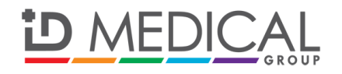

**PRESS RELEASE**

**For immediate release: Monday 5th May 2014**

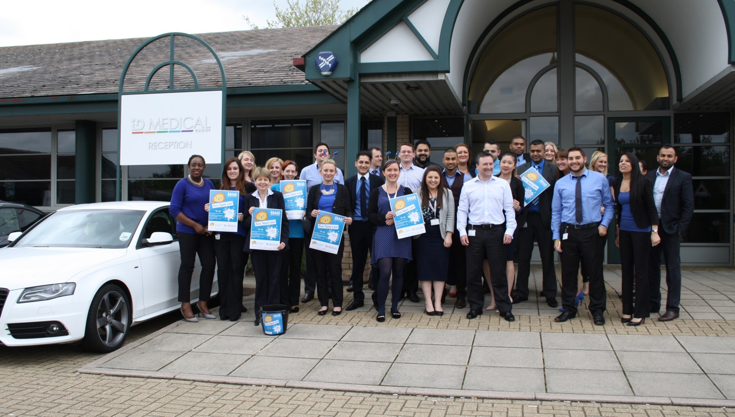**Leading Milton Keynes based healthcare recruiter ID Medical wears it blue for Leo’s Appeal**

On Friday 2 May, ID Medical joined in on the Team Leo fundraising fun once again, this time for MK Hospital Charity’s first ever ‘Wear it Blue’ day, with its 300+ strong workforce wearing the bluest of blue items of clothing and accessories, and each donating a minimum £1 for Leo’s Appeal. In total, ID Medical, the UK’s leading multi-discipline healthcare recruiter raised £189.35 on Wear it Blue Day 2014.

ID Medical has been supporting Leo’s Appeal since its launch back in September 2014 and is proud to be a participating member of Team Leo, helping to contribute to the charity’s ultimate goal of raising £200,000 to enhance the children’s services at Milton Keynes Hospital.

**ENDS**

**About Milton Keynes Hospital Charity**

The Milton Keynes Hospital Charity raises money to fund projects at Milton Keynes Hospital that are outside the scope of the NHS. Last year the charity raised more than £380,000. Fundraising makes a huge difference to the many wards and departments needing equipment and other items, and has helped change the lives of thousands of patients and their families.

**About ID Medical**

Award-winning, multi-discipline healthcare recruiter ID Medical was formed in 2002 and is a superior quality supplier of locum doctors, nurses, allied health professionals and clerical staff to over 90% of NHS hospitals and private medical sector organisations.

From its headquarters in Milton Keynes as well as its central London office, ID Medical provides practical, cost-effective and innovative workforce solutions, supplying more than 3 million hours to the NHS per annum. Crown Commercial Service (CCS), HealthTrust Europe (HTE) and London Procurement Partnership (LPP) framework approved, ID Medical supplies medical staff into over 38,000 available shifts per month in hospitals nationwide.

Within each of its professional divisions, the workforce solutions provider has dedicated client and candidate teams covering the multitude of medical specialties and roles to ensure every valued customer receives its premier level service, ultimately ensuring patients are always put first. Further to this, ID Medical School was launched in 2014 to offer candidates Continuing Professional Development accredited courses and workshops to enhance their medical careers.

Since its foundation, the company has earned itself industry-wide accreditation and success with an amounting collection of accolades. These include the Recruiter FAST 50, Real Business Hot 100, Recruitment International Top 250 and The Sunday Times Virgin Fast Track 100. Most notably, through an abiding focus on employee satisfaction, ID Medical was crowned Recruitment International’s ‘Best Recruitment Company to Work for 2013’ and made its debut in The Sunday Times Best Companies to Work for 2014 at list position 33. ID Medical is delighted that for the second year running it features in The Sunday Times Best Companies to Work for 2015.

For more information please visit our website at [www.id-medical.com](http://www.id-medical.com), view our [Facebook](https://www.facebook.com/IDMedical) page or follow us on Twitter [@IDMedical](https://twitter.com/IDMedical).

**Caryn Cooper**

head of marketing

Description: markdes

ID MEDICAL - ID House - 1 Mill Square - Wolverton Mill South - Milton Keynes - MK12 5ZD

**t:** +44 (0) 1908 555 498 **f:** +44 (0)1908 552 825

**w:** id-medical.com   **e:** [caryn.cooper@id-medical.com](mailto:caryn.cooper@id-medical.com)

[cid:image002.png@01CE94EA.3632CC80](http://www.linkedin.com/company/id-medical)  [cid:image003.png@01CE94EA.3632CC80](http://www.facebook.com/IDMedical)  [](http://www.twitter.com/idmedical)  [](https://plus.google.com/104338735298043774830/posts)