Text and photo: Jan Bjørkelund
Last year, Halden municipality was approached by a Swedish firm enquiring whether it would like to participate in a project providing free dog-waste bags at multiple locations around the town. Companies are able to purchase advertising space on the bag stands, which finances the replenishment of new free-of-charge dog-waste bags and allows advertisers for their part to demonstrate their environmental credentials. The bags are made of biodegradable materials, and the municipal engineering department is responsible for ensuring that sufficient bags are made available.
There are currently 25 such stations located in the town centre. Halden was the first in Norway to introduce the scheme, something the municipality is proud of. Dog owners are now being urged to make use of this facility.
An excellent Swedish idea
Stig-Arne Mårtensson, owner and founder of TiksPac AB, moved from the city where he lived to the idyllic small town of Falkenberg in Sweden. While out walking his dog he discovered that many people were not picking up their dogs’ waste. His first impressions were very negative.
No excuse for not picking up after your dog!
Halden is the first municipality in Norway to introduce a free waste bag scheme for the town’s dog owners. They are being strongly urged to make use of the scheme, with waste bags strategically placed in 25 locations around Halden.
Mr Mårtensson wanted to tackle the problem and devised a brilliant solution. The concept is now known as the TiksPac Station. In principle it costs the municipality nothing other than ensuring that dog-waste bags are available at all deployed TiksPac Stations. Since these stations were launched, new municipalities have been steadily joining the scheme. In Sweden, agreements have now been reached with a hundred municipalities.
TiksPac AB began on a small scale but much has happened since it started up. The TiksPac concept has now been further developed and improved. Only environmentally friendly bags are used now rather than the black plastic bags used originally. The environmental awareness of the community has generally increased, and this trend will hopefully continue.
So, dear dog owners of Halden, take advantage of the scheme and help make our public spaces more pleasant for everyone!
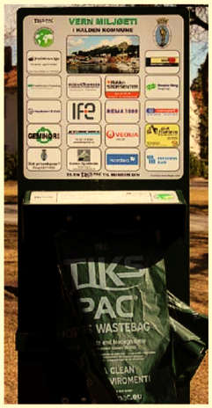
Halden was the first municipality in Norway to introduce a free-of-charge dog-waste bag scheme for the general public. There are 25 such stations placed strategically around the town.

