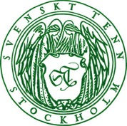

News Release
Stockholm, August 17, 2016

Svenskt Tenn demonstrates local craftsmanship in fall exhibition

In its autumn season exhibition ”Local Design”, Svenskt Tenn takes visitors behind the scenes at five Swedish workshops where furniture, glass, carpets and pewter objects are handcrafted for the brand, as they have been for decades. The purpose is to demonstrate the rich craftsmanship practiced in Sweden, and how the selection of materials and manufacturing methods can make a difference for people as well as for the environment.

The exhibition ''Local Design” opens on September 15, and runs through November 6.

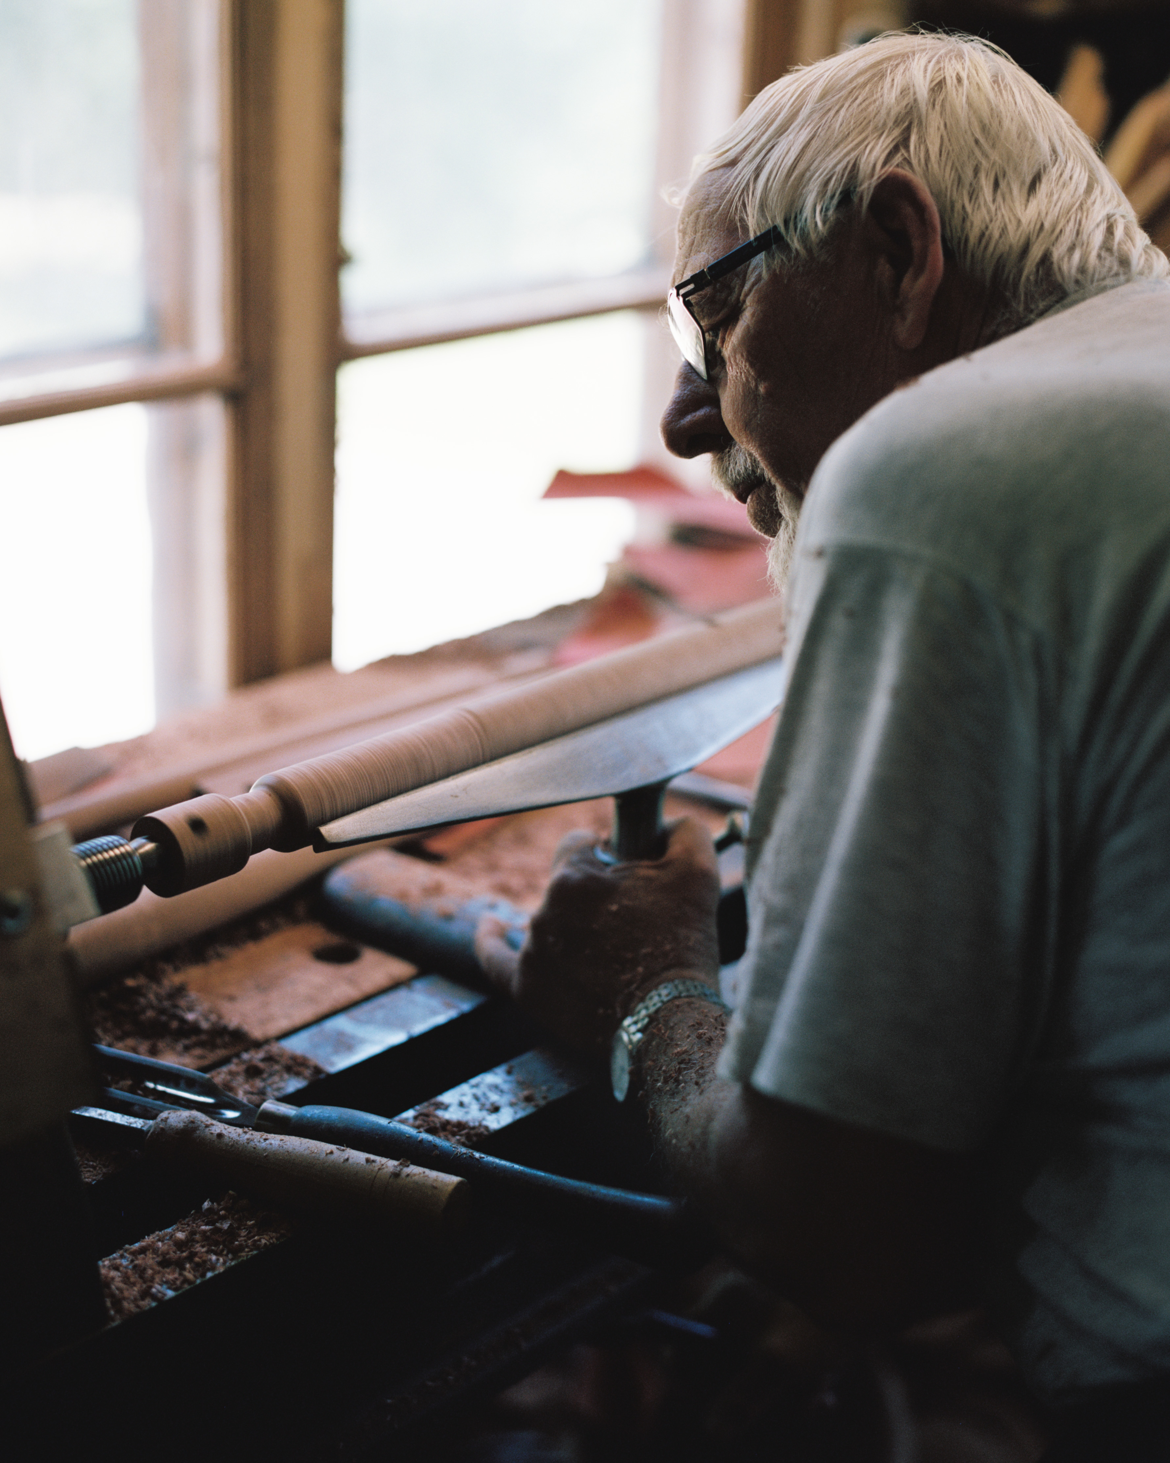
Svenskt Tenn operates with the stated mission to support and develop Swedish handicraft, actively promoting the growth of a new generation of craftspeople to preserve knowledge and arts that would otherwise risk oblivion. This intent is upheld by Svenskt Tenn’s choice to manufacture the major part of its range in Sweden, and through exhibitions where the craftsmanship is highlighted.

”We live in a world that is marked by environmental challenges. How and where we elect to manufacture our products is thus a critical issue,” says Thommy Bindefeld, marketing manager at Svenskt Tenn, and exhibition curator Lisanne Fransen, adding:

”Today, many people, not least youth, strive towards a more sustainable way of life and want to limit their consumption, but they just don’t know how. Naturally, locally made, handcrafted items cost more than mass produced goods from the global market, but the quality products often last for generations, making them less expensive over time. Society and the environment also benefit. You avoid using finite global resources and long haul transports, while contributing to preserve know-how and jobs in Sweden.”

Dutch native Lisanne Fransen works in Sweden as a curator and set designer. She holds a Master of Arts and Arts Management degree from the University of Utrecht, with additional studies at the Stockholm University College of Arts, Crafts and Design and Beckmans College of Design. She was recently the curator of Nationalmuseum’s acclaimed ”Home in the future” exhibition at the Stockholm House of Culture.

Manufacturers featured in the exhibition are the Eriksson och Söner joinery, which makes a large share of Svenskt Tenn’s furniture; the Humstorp metal workshop, producer of part of the brand’s classic pewter products; Reijmyre glassworks, which produces both legacy and newly designed glass items for Svenskt Tenn; carpet makers Kasthall Mattor och Golv, where a broad range of carpets are hand tufted, and basket makers Larsson Korgmakare, which for generations have manufactured Svenskt Tenn’s rattan furniture.

For further information, please contact:

Vicky Nordh, Marketing Assistant: +46 8-670 16 23 or vicky.nordh@svenskttenn.se

Thommy Bindefeld, Marketing Director: +46 8 670 16 02 or thommy.bindefeld@svenskttenn.se

Images can be downloaded from svenskttennpress.se. Username: Press. Password: Tenn

Svenskt Tenn is an interior design company with retail stores at Strandvägen in Stockholm and online. Since 1975, Svenskt Tenn is owned by the Kjell and Märta Beijer Foundation, which provides research grants within ecology, medicine and the preservation of Swedish interior design tradition.

