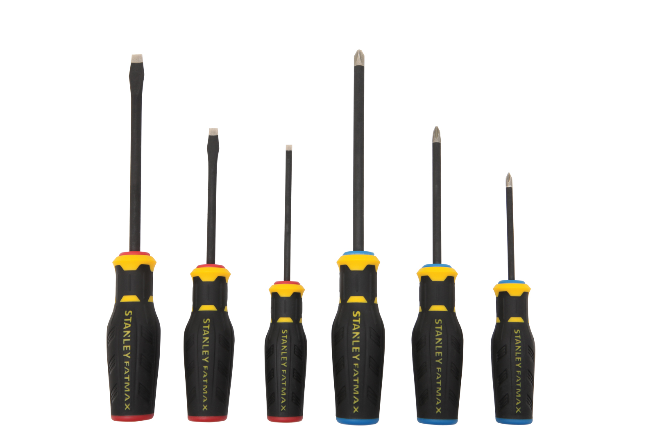
FOR IMMEDIATE RELEASE
Contact: Tiffany Vann
Phone: (860) 839-7548
E-mail: Tiffany.Vann@sbdinc.com

STANLEY® Introduces New
FatMax® Simulated Diamond Tip Screwdrivers

New Britain, CT. (June 1, 2015) — STANLEY® introduces its new line of FatMax® Simulated Diamond Tip Screwdrivers offering longer tip life over standard screwdrivers used by professionals.
Screwdriver tips take a beating and over time become less effective at staying seating in screws. To help reduce slippage and harden screwdriver tips STANLEY® is offering new Screwdrivers with a specialized simulated diamond tip coating for longer tip life.
The new screwdriver tips are encrusted with a simulated diamond sand composite to help bite into screws for easy screwdriving and screw removal, especially of stripped screws.
The coating for the screwdriver tips is an industrial grade simulated diamond grit known as silicon carbide, which is used in different forms throughout various industries. The simulated diamond grit provides better tip life and helps keep the screwdriver tip remain durable while also helping to remove stripped screws because of the grit composite.
The screwdrivers also features black phosphate bars for corrosion resistance. An ergonomic quad lobe design provides maximum tip torque for tough screwdriving applications. Color coded handles make it quick and easy to choose the right screwdriver size for the job at hand.
The new screwdrivers are ideal for electricians, general contractors, HVAC contractors and others professionals. The STANLEY® FatMax® Simulated Diamond Tip Screwdrivers are sold at Lowes and independent retailers and include:
FMHT62051 | FATMAX 4PC SIMULATED DIAMOND TIP SCREWDRIVER SET | $14.98
FMHT62052 | FATMAX 6PC SIMULATED DIAMOND TIP SCREWDRIVER SET | $24.98
FMHT62053 | FATMAX 8PC SIMULATED DIAMOND TIP SCREWDRIVER SET | $29.98

Summary:
STANLEY® introduces its new line of FatMax® Simulated Diamond Tip Screwdrivers offering longer tip life over standard screwdrivers used by professionals. Screwdriver tips take a beating and over time become less effective at staying seating in screws. To help reduce slippage and harden screwdriver tips STANLEY® is offering new screwdrivers with a specialized simulated diamond tip coating for longer tip life. The new screwdriver tips are encrusted with a simulated diamond sand composite to help bite into screws for easy screwdriving and screw removal, especially of stripped screws.

About Stanley®:

STANLEY®, a brand of Stanley Black & Decker, Inc. is a diversified manufacturer of innovative tools and engineered solutions for professional, industrial, woodworking, construction, automotive repair, organizational, and do-it-yourself- use. Since 1843 Stanley has consistently provided solutions that make life easier with reliable hand tools. Headquartered in New Britain, CT, STANLEY® is committed to manufacturing tools in the USA with global materials. Annually, Stanley® produces a large variety of hand tools including tape rules, knives, blades, hand saws, screwdrivers, plastic storage, and accessories in multiple manufacturing locations in North America. STANLEY® can be found internationally wherever tools are sold and has helped build America with a breadth of quality hand tools people can trust for over 170 years. For more information visit www.stanleytools.com or follow STANLEY® on Facebook and Twitter.

###

