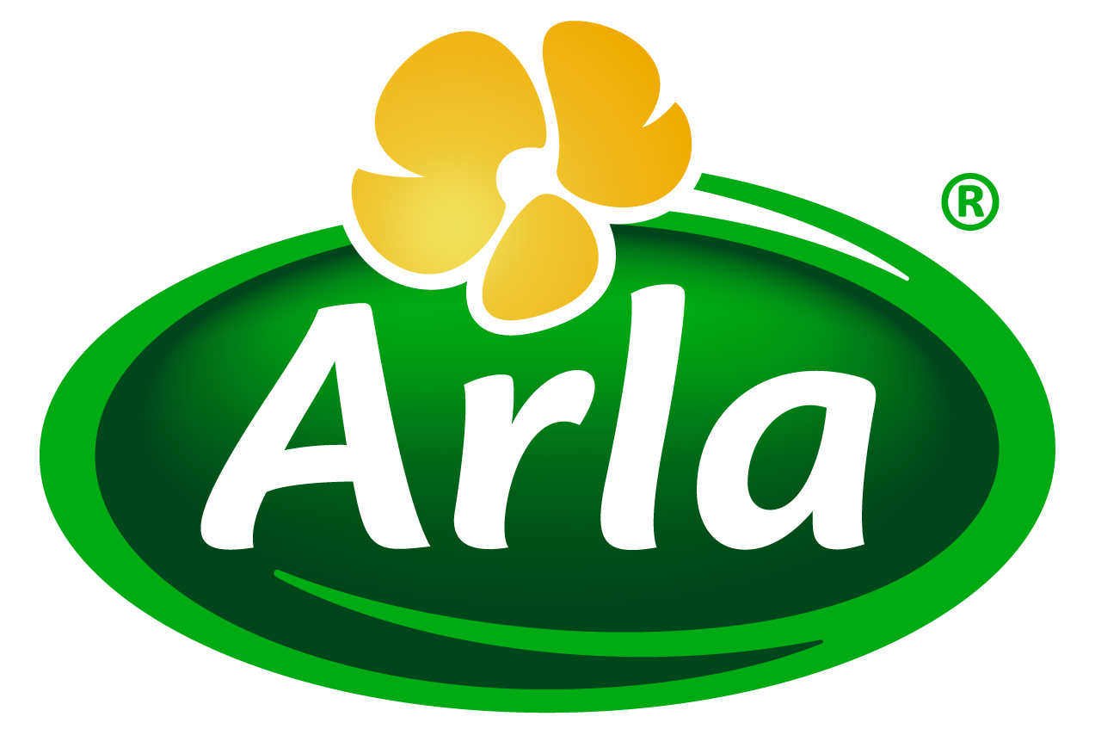
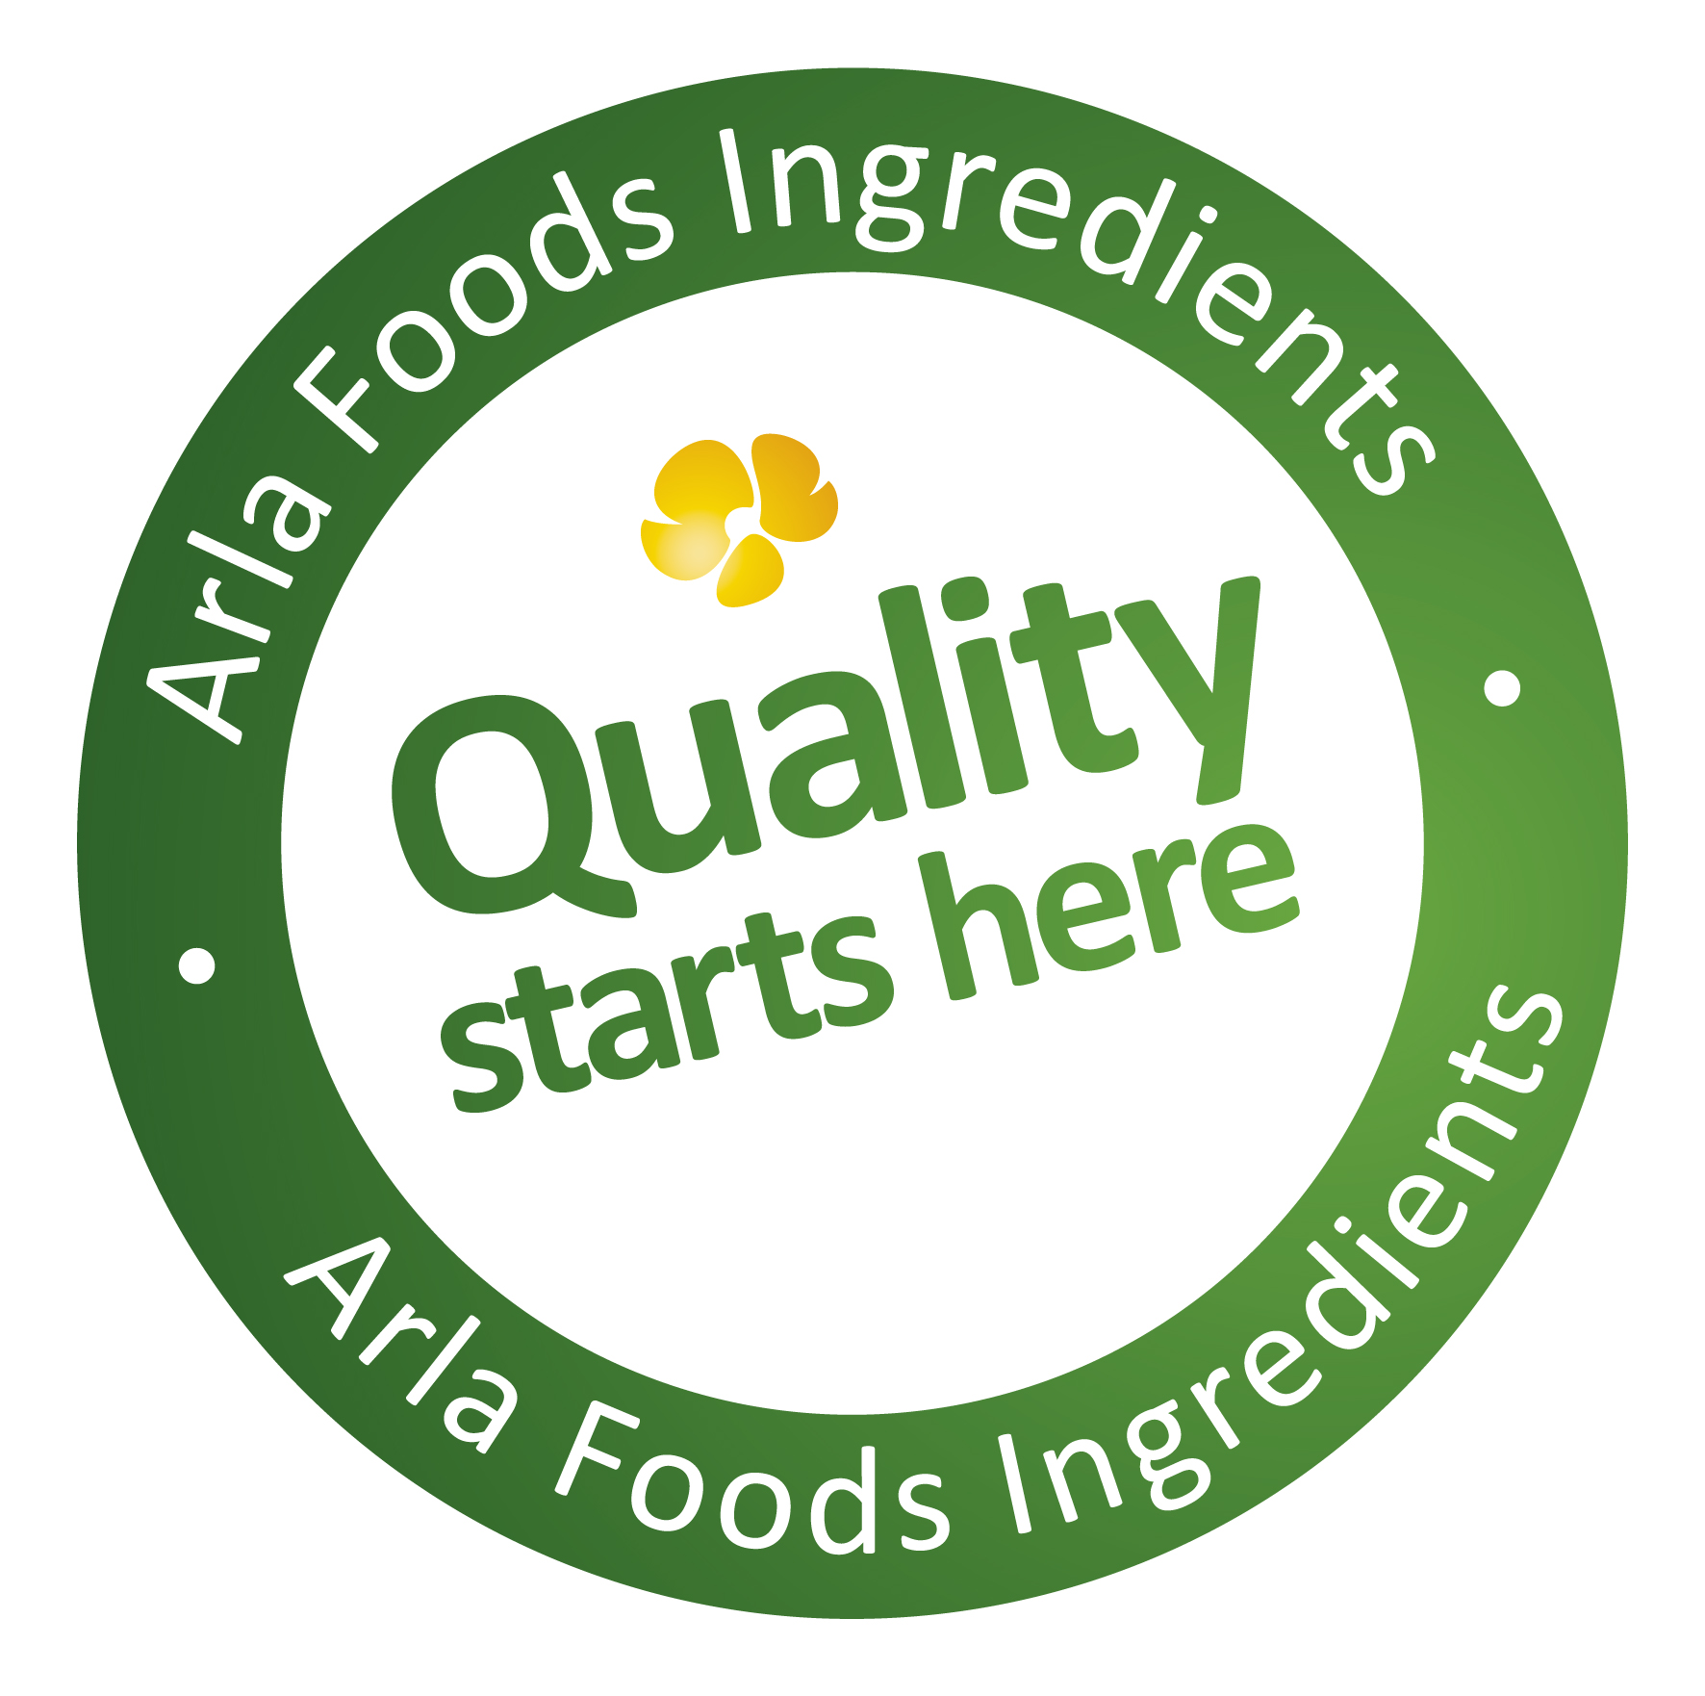

19 August 2014

PRESS RELEASE – SUPPLY SIDE WEST 2014

Cutting edge proteins set to take center-stage
for Arla Foods Ingredients

Arla Foods Ingredients (Basking Ridge, NJ) will showcase its flagship proteins for the booming sports nutrition and lifestyle categories at the forthcoming Supply Side West expo.

Supply Side West takes place from 8-9 October 2014 in Las Vegas. Exhibiting on Booth 37112, Arla Foods Ingredients will highlight the benefits of its cutting edge Lacprodan® HYDRO.365 whey protein hydrolysate. This is a ‘gold standard’ dairy protein that is absorbed more quickly by the body, resulting in significantly faster muscle recovery after exercise, cutting recovery time from days to hours and enabling elite athletes to compete at their best.

HYDRO.365 is suitable for inclusion in a wide range of sports nutrition products, including beverages, gels, bars, powders and tablets. It is fully soluble, providing manufacturers with an excellent opportunity to create completely clear ready-to-drink sports nutrition beverages that will appeal to a wider proportion of consumers than ever before. In addition, HYDRO.365 is UHT stable, pH neutral and has a low bitterness profile.

Arla Foods Ingredients will also highlight its Lacprodan® DI-7017, a 100% whey protein concentrate that is UHT-stable, offers neutral pH and tastes good. These attributes make it especially attractive to manufacturers wishing to develop long shelf life products designed for weight management and the increase of muscle mass.

Lacprodan® DI-7017 is rich in the essential and branched chain amino acids that are scientifically proven to optimize the body’s muscle-building and satiety response mechanisms. It offers a quicker digestion time than casein, and is suitable for use in a range of great-tasting food and beverage applications.

Visit Arla Foods Ingredients at Supply Side West 2014 on Booth 37112.

ENDS

For more information, please contact:

Miranda Mills, Ingredient Communications
Tel: +44 207 193 4167
Email: Miranda.mills@ingredientcommunications.com

About Arla Foods Ingredients
Quality starts here: Arla Foods Ingredients is a global leader in natural whey ingredients for products in a range of categories – from bakery, beverages, dairy and ice cream to clinical, infant and sports nutrition.
The cornerstones of our business are innovative ingredients, world-class facilities and a staff of dedicated experts. Drawing on our portfolio of functional and nutritional whey proteins, milk minerals, lactose and permeate, our expert team delivers solutions that bring new food products quickly and efficiently to market. Our application centres run hundreds of customer product trials every week. All ingredients are produced using state-of-the-art processing technology at our plant in Denmark, or by one of our joint ventures in Argentina, Germany and the UK.
Arla Foods Ingredients Group P/S is a 100% owned subsidiary of Arla Foods, a global dairy company and cooperative owned by dairy farmers in Denmark, Sweden, the UK, Germany, Belgium and Luxemburg.

RSS Feed
Visit our website at http://www.mynewsdesk.com/arla-foods-ingredients and sign up to our News RSS feed for all the latest developments – updated regularly.

Twitter
Follow us on twitter for all the latest updates @ArlaIngredients

