CLAIM by Brännland Cider – new generation ice cider

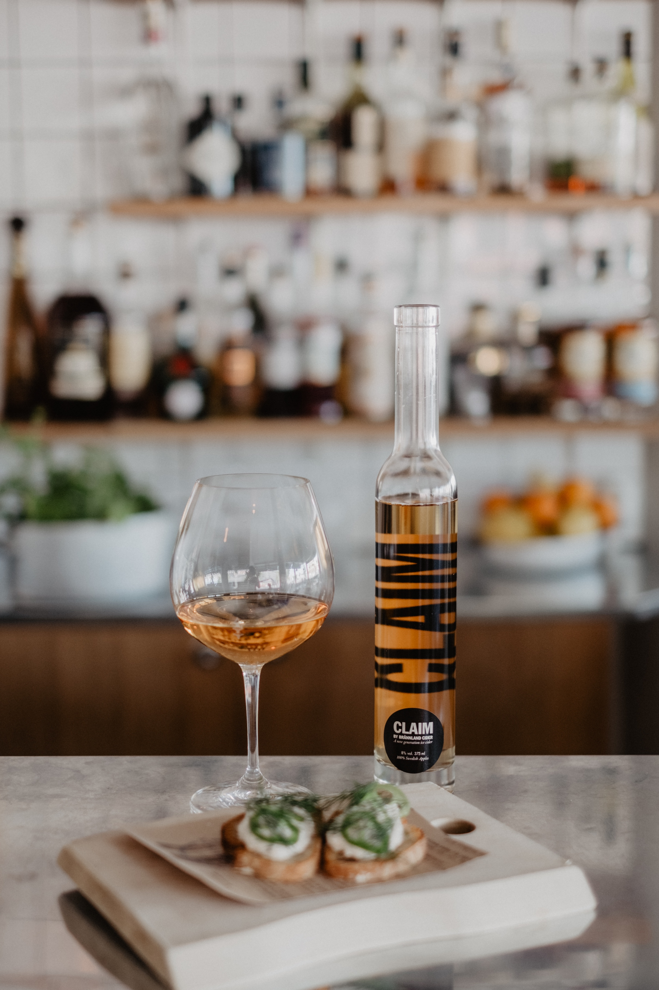
Photo Matilda Audas Björkholm

Claim by Brännland Cider might the truest and original expression of Swedish apples that we’ve yet to come upon since it doesn’t model itself or conform to any appellation other than that of the country, apples and family of ciders from which it was born.

Every year since its inception the final blend of Brännland Iscider has held a wide variety of juices and fermentations. Different apple varieties, sugar levels, harvest and weather conditions has meant that each barrel and tank ferments differently. Blending is always a conversation with the apples, the raw juice and finally the cider itself on how to best represent a specific year.
A few years ago we discovered that there were always a few tanks in our blend that fermented into a different character, driven by lower sugar levels and floral notes, as opposed to the traditional ice cider which is a power house of bold flavors and characteristics.
- Growth isn’t just defined by numbers. With experience growth can also be defined as the ability to listen. In working closely and intensely with our ciders we’ve gradually become better listeners, to, with time, hear other voices within what we do. And we’ve heard a new voice, an unexpected one. A voice that softly but persistently demands to come into its own, says Andreas Sundgren Graniti, founder of Brännland Cider.
Claim is grown out of the respect that we have for the origins of ice cider and at the same time, a step beyond it. We call it Claim because it claims new territory. Like finding a new seam when digging for precious metals. Staking a Claim.
It is still an ice wine made of 100% apples, no additives and, like our traditional ice cider, elevated using the natural winter cold of our landscape and our accumulated artisanal knowledge and experience. Claim by Brännland Cider evokes lightness and light, spring and summer, juicy, sweet and fresh.
An expression of the joy of discovering a soft-spoken person hiding out in a boisterous crowd, of rest in the middle of a long and demanding journey, the first light in spring and of our will and ability to evolve and Claim ourselves anew.
- We are very proud to present Claim by Brännland Cider. A New Generation ice cider. Drink it now or lay it down, we have a feeling that this is a cider with wonderful ageing capabilities, like many of the things in life that take a little time to reveal themselves.
CLAIM by Brännland Cider is available from the end of June through our international distributors as well as through a select number of restaurants in Sweden.
Claim ambassadors
Luleå
Hemmagastronomi
Restaurang CG
Piteå
Restaurang Tages
Umeå
Köksbaren
DUÅ
Open/Closed
Gotthards krog
Tapas Bar Deli
Hunger och törst
Harlequin
REX
Örnsköldsvik
Linnea och Peter
Östersund
Jazzköket
Stockholm
Matbaren
Rutabaga
Folii
Åby, Bråviken
Villa Fridhem
Göteborg
Skärets Krog

