Jotun and KONGSBERG partnership delivers innovative, proactive and sustainable fouling control
Jotun HullSkater is part of a revolutionary climate friendly robotics-based solution
that introduces proactive hull cleaning with remotely operated technology
to achieve optimal running performance

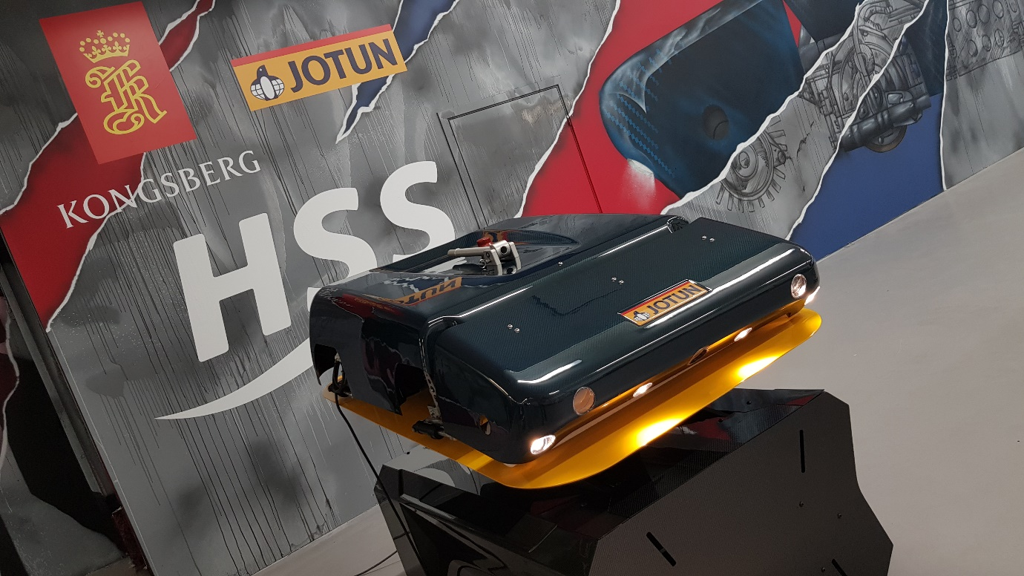The revolutionary Jotun HullSkater, developed in partnership with Kongsberg Maritime

Kongsberg, Norway, 13th March 2020 – Jotun and Kongsberg Maritime have joined forces to develop a game-changing proactive hull cleaning solution designed to provide full operational flexibility and an unbeatable environmental footprint. Called Jotun HullSkater, this new lean, green cleaning machine is part of Jotun Hull Skating Solutions. This is the first solution developed for proactive bio-fouling control on ships and offers the potential to reduce fuel costs by around US$3.6 million and CO₂ emissions by 12.5% annually, on a typical vessel.
As Jotun’s strategic partner on the HullSkater project since 2015, Kongsberg Maritime has contributed to the technology and know-how including development of secure remote control, cloud-based data storage, battery technology, acoustics and composite materials. HullSkater also uses KONGSBERG’s global communications infrastructure and Kognifai cloud ecosystem, both of which contribute to its ability to abolish significant performance losses caused by fouling and negate the need for waste collection.
Already established as the market’s leading marine robotics manufacturer, Kongsberg Maritime is responsible for the industrialisation and manufacturing of HullSkater, which will take place at a new facility located close to its Sensors & Robotics campus in Horten, Norway. HullSkater will be supported by extended performance and service level guarantees, with global technical support from Jotun and Kongsberg Maritime.

Alfie Ong, Vice President, Jotun Marine Coatings, said: “Kongsberg Maritime’s expertise in subsea robotics, remote communications and data management, allied with their dedication to sustainability, makes them a perfect fit to partner with us in the development of HullSkater. Together, we have devised a truly innovative solution, which we believe will revolutionise the shipping industry, moving away from traditional, reactive methods of managing fouling to a proactive approach which will ensure that vessels are always operating efficiently and sustainably.”
HullSkater can inspect a 10,000m² hull in approximately two hours. As a permanent member of crew, it is always on station, ready to clean all known fouling from the hull, which if left to accumulate causes increased drag leading to extra fuel consumption and emissions to air (GHG and CO₂).
Egil Haugsdal, President, Kongsberg Maritime, commented: “We are delighted to offer our 70 years of underwater technology experience as partner with Jotun to develop a solution that can help customers make their businesses safer, more sustainable and more efficient. Conserving our ocean environment and enabling sustainable marine operations is a priority for KONGSBERG, and HullSkater offers a uniquely proactive way to solve the difficult problem of fouling growth.”
Visit www.jotunhullskater.com and www.kongsberg.com/maritime/campaign/hullskater to find out more about the revolutionary Jotun Hull Skating Solutions.

For further information, please contact:

Gunvor Hatling Midtbø, VP Communication
Kongsberg Maritime
Tel: +47 9921 4209
gunvor.hatling.midtbo@km.kongsberg.com

Siri Moldestad Sanna, Global Customer Engagement Manager
Jotun A/S
Tel: +47 9013 2780
siri.sanna@jotun.no
David Pugh
Saltwater Stone
Tel: +44 (0)1202 669244
d.pugh@saltwater-stone.com

About Kongsberg Maritime
Kongsberg Maritime is a global marine technology company providing innovative and reliable ‘Full Picture’ technology solutions for all marine industry sectors including merchant, offshore, cruise, subsea and naval. Headquartered in Kongsberg, Norway, Kongsberg Maritime has manufacturing, sales and service facilities in 34 countries.
Kongsberg Maritime solutions cover all aspects of marine automation, safety, manoeuvring, navigation, and dynamic positioning as well as energy management, deck handling and propulsion systems, and ship design services. Subsea solutions include single and multibeam echo sounders, sonars, AUV and USV, underwater navigation and communication systems.

Training courses at locations globally, LNG solutions, information management, position reference systems and technology for seismic and drilling operations are also part of the company’s diverse technology portfolio. Additionally, Kongsberg Maritime provides services within EIT (Electro, Instrument & Telecom) engineering and system integration, on an EPC (Engineering, Procurement & Construction) basis.
Kongsberg Maritime is part of Kongsberg Gruppen (KONGSBERG), an international, knowledge-based group that celebrated 200 years in business during 2014. KONGSBERG supplies high-technology systems and solutions to customers in the oil and gas industry, the merchant marine, and the defence and aerospace industries.
Web: Kongsberg Gruppen | Kongsberg Maritime
Social media: LinkedIn | Twitter | Facebook

