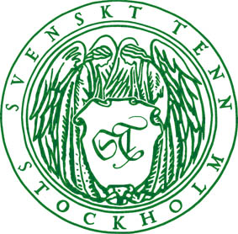
Press Release
Stockholm, November 14, 2014

Svenskt Tenn relaunches star-studded textile ’’Zodiaken’’ by Josef Frank

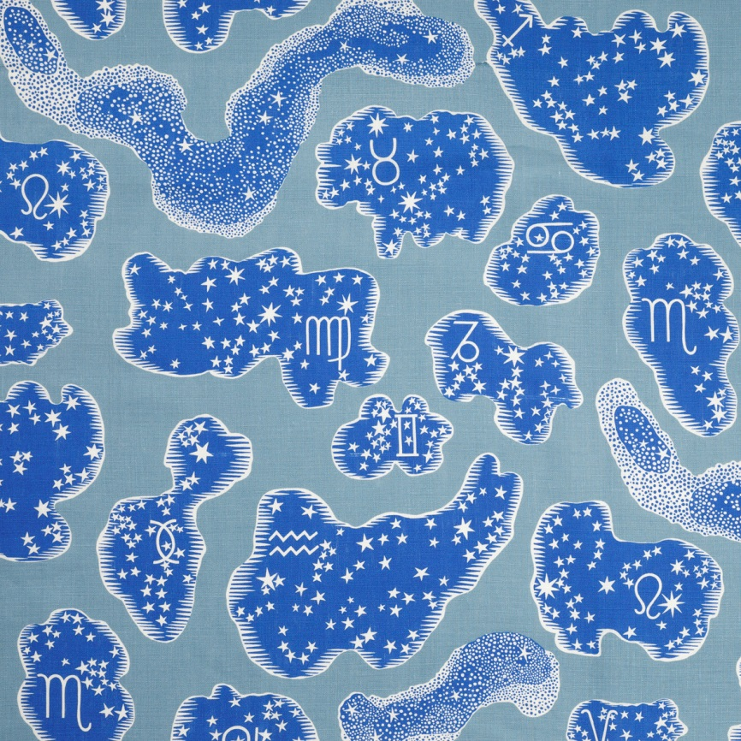
During his time at Svenskt Tenn, Josef Frank created a large number of textile prints. The originals, with Frank’s own handwritten notes and instructions, are all kept in Svenskt Tenn’s archive until the time is right for a textile to be taken into production. Now the time has come for ’’Zodiaken’’.
The print was designed in 1936.
’’With the Zodiac constellations beaming at the viewer in bright blue formations, the print complements our textile range both in color and style wise,” says Thommy Bindefeld, Marketing Director at Swedish Tenn.
The centre of the pattern features the Milky Way with its many veiled star clusters. The constellations are from the ancient Babylonian star catalogue. At the top you find Pisces, Aquarius, Scorpio, Libra, Sagittarius and Aries. Below are Leo, Taurus, Cancer, Virgo, Gemini and Capricorn.
The Zodiaken is printed onto textile with the designation 315 Lin, a quality selected for curtains, pillows and furniture that are not exposed to excessive wear.
Price: SEK 1,450 per meter.

For further information, please contact:

Vicky Nordh, Marketing Assistant: +46 8-670 16 23 or vicky.nordh@svenskttenn.se

Thommy Bindefeld, Marketing Director: +46 8 670 16 02 or thommy.bindefeld@svenskttenn.se

Image bank: www.svenskttennpress.se User name: Press Password: Tenn

Svenskt Tenn was founded in 1924 by designer and drawing teacher Estrid Ericson (1894-1981). In 1934, she began her lifelong collaboration with Josef Frank, already an internationally well-known architect, urban planner and designer, who had recently left Austria to take up residence in Sweden. Together, the two laid the foundations for the interior design philosophy that Svenskt Tenn has since come to represent, combining Estrid Ericson's artistic talent and entrepreneurial spirit with Josef Frank's inspired and timeless designs to form what was soon to become a highly successful concept. Svenskt Tenn is owned by the Kjell and Märta Beijer Foundation.

