14th December 2015

**Virgin Trains puts Christmas spirit into Euston First Class Lounge**

*Virgin Trains to offer high-quality spirits sourced from local distilleries*

Virgin Trains has teamed up with suppliers from along the West Coast Mainline to serve locally-produced, premium spirits to its First Class customers in time for Christmas. Forest Gin and vodka and whisky from the Lakes Distillery will become part of the train operator’s First Class customer offer this month.

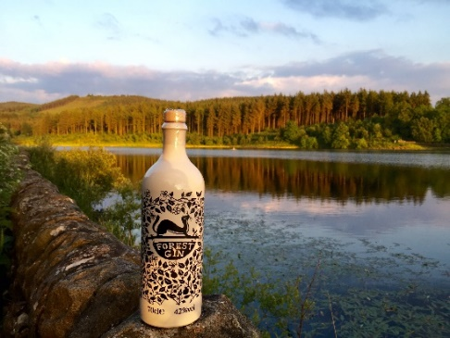

Forest Gin is made by the Bond family in very small batches with botanicals foraged from nearby Macclesfield Forest and locations within the Cheshire Peak District. The resulting gin is then blended with cool water from forest springs to produce a fresh, herbaceous London dry gin.

Virgin Trains joins Britain’s finest restaurants and bars in serving the gin, including Heston Blumenthal's Hinds Head in Bray, and Jason Atherton's multi-award winning restaurant in Soho.

Karl Bond, Owner of Forest Gin said ‘‘We are so excited and proud to have our gin behind the bar in Virgin’s First Class Lounge at Euston. We launched the gin at the start of the year and it has already won numerous awards so this is great way to round off our year.’’

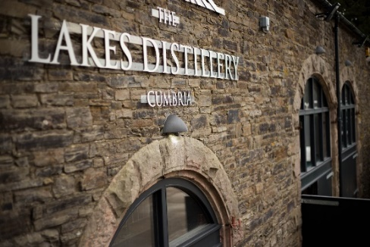The Lakes Vodka and The ONE, a blend of British whiskies, are award-winning products from the Lakes Distillery, which is located about 25miles from both Penrith and Carlisle. The distillery is listed amongst Cumbria’s Top 50 icons and is the largest whisky distillery in England.

Made from water taken directly from the River Derwent just 150 metres away, The ONE blends whisky from each of the British Isles, while Lakes Vodka boasts a rich aroma with a hint of wheat.

Paul Currie, founder and managing director of The Lakes Distillery, said: “Virgin Trains has a reputation for providing its customers with only premium products so it is a testament to the quality of our spirit that we are being offered to first class customers. We have invested £7m into our distillery to ensure we produce the highest quality spirits in our handmade copper stills and have enjoyed an outstanding first year in business attracting over 20,000 visitors to our site in Cumbria. We look to working with Virgin Trains into the future.”

Amanda Smit, Head of Catering at Virgin Trains said: “Here at Virgin Trains, we‘re committed to offering our customers premium products while also supporting local businesses along our route. We’re delighted that we’re able to do both with these superb spirits. It’s great to introduce these products into our First Class portfolio at the end of a year which has seen us launch fresh milk from local supply on our services, as well as Tea from Manchester, cheese from a small farm in Goosnargh near Preston, biscuits from Glasgow and a bespoke sugar bowl designed by a local potter in Stoke on Trent.”

The spirits will be available in Virgin Trains’ First Class lounge in Euston from December 14.

ENDS

**About Virgin Trains**

Virgin Trains is the brand name of Virgin Rail Group (VRG), which is owned by Virgin Group (51%) and Stagecoach (49%). Virgin Trains has operated the West Coast passenger train franchise since 1997, serving key UK cities including London, Birmingham, Manchester, Liverpool and Glasgow. In June 2014 the Department for Transport (DfT) awarded VRG a new franchise until at least April 2017.

Virgin Trains is committed to delivering a high speed, high frequency service, offering shorter journey times, more comfortable travel and excellent customer service. We provide the most frequent long-distance rail service in Europe (London - Manchester and London – Birmingham, both every 20 minutes).

Since 1997, Virgin Trains has introduced over 70 new trains at a cost of £1.5 billion. The service carries more than 32 million passengers a year and Virgin Trains employs approximately 3,290 staff.

Virgin Trains customers consistently rate the company as one of the top long-distance rail franchise operators in the National Passenger Survey (NPS) commissioned by industry watchdog “Passenger Focus”.

Visit the Virgin Trains Media Room - [www.virgintrains.co.uk/mediaroom](http://www.virgintrains.co.uk/mediaroom) - for the latest news, images and videos. To receive new content, as it is published, go to [**Follow Virgin Train**](http://www.mynewsdesk.com/follow/47939)**s** and click on ‘Create account’.

Press Office: 0845 000 3333. Company website: [www.virgintrains.co.uk](http://www.virgintrains.co.uk).