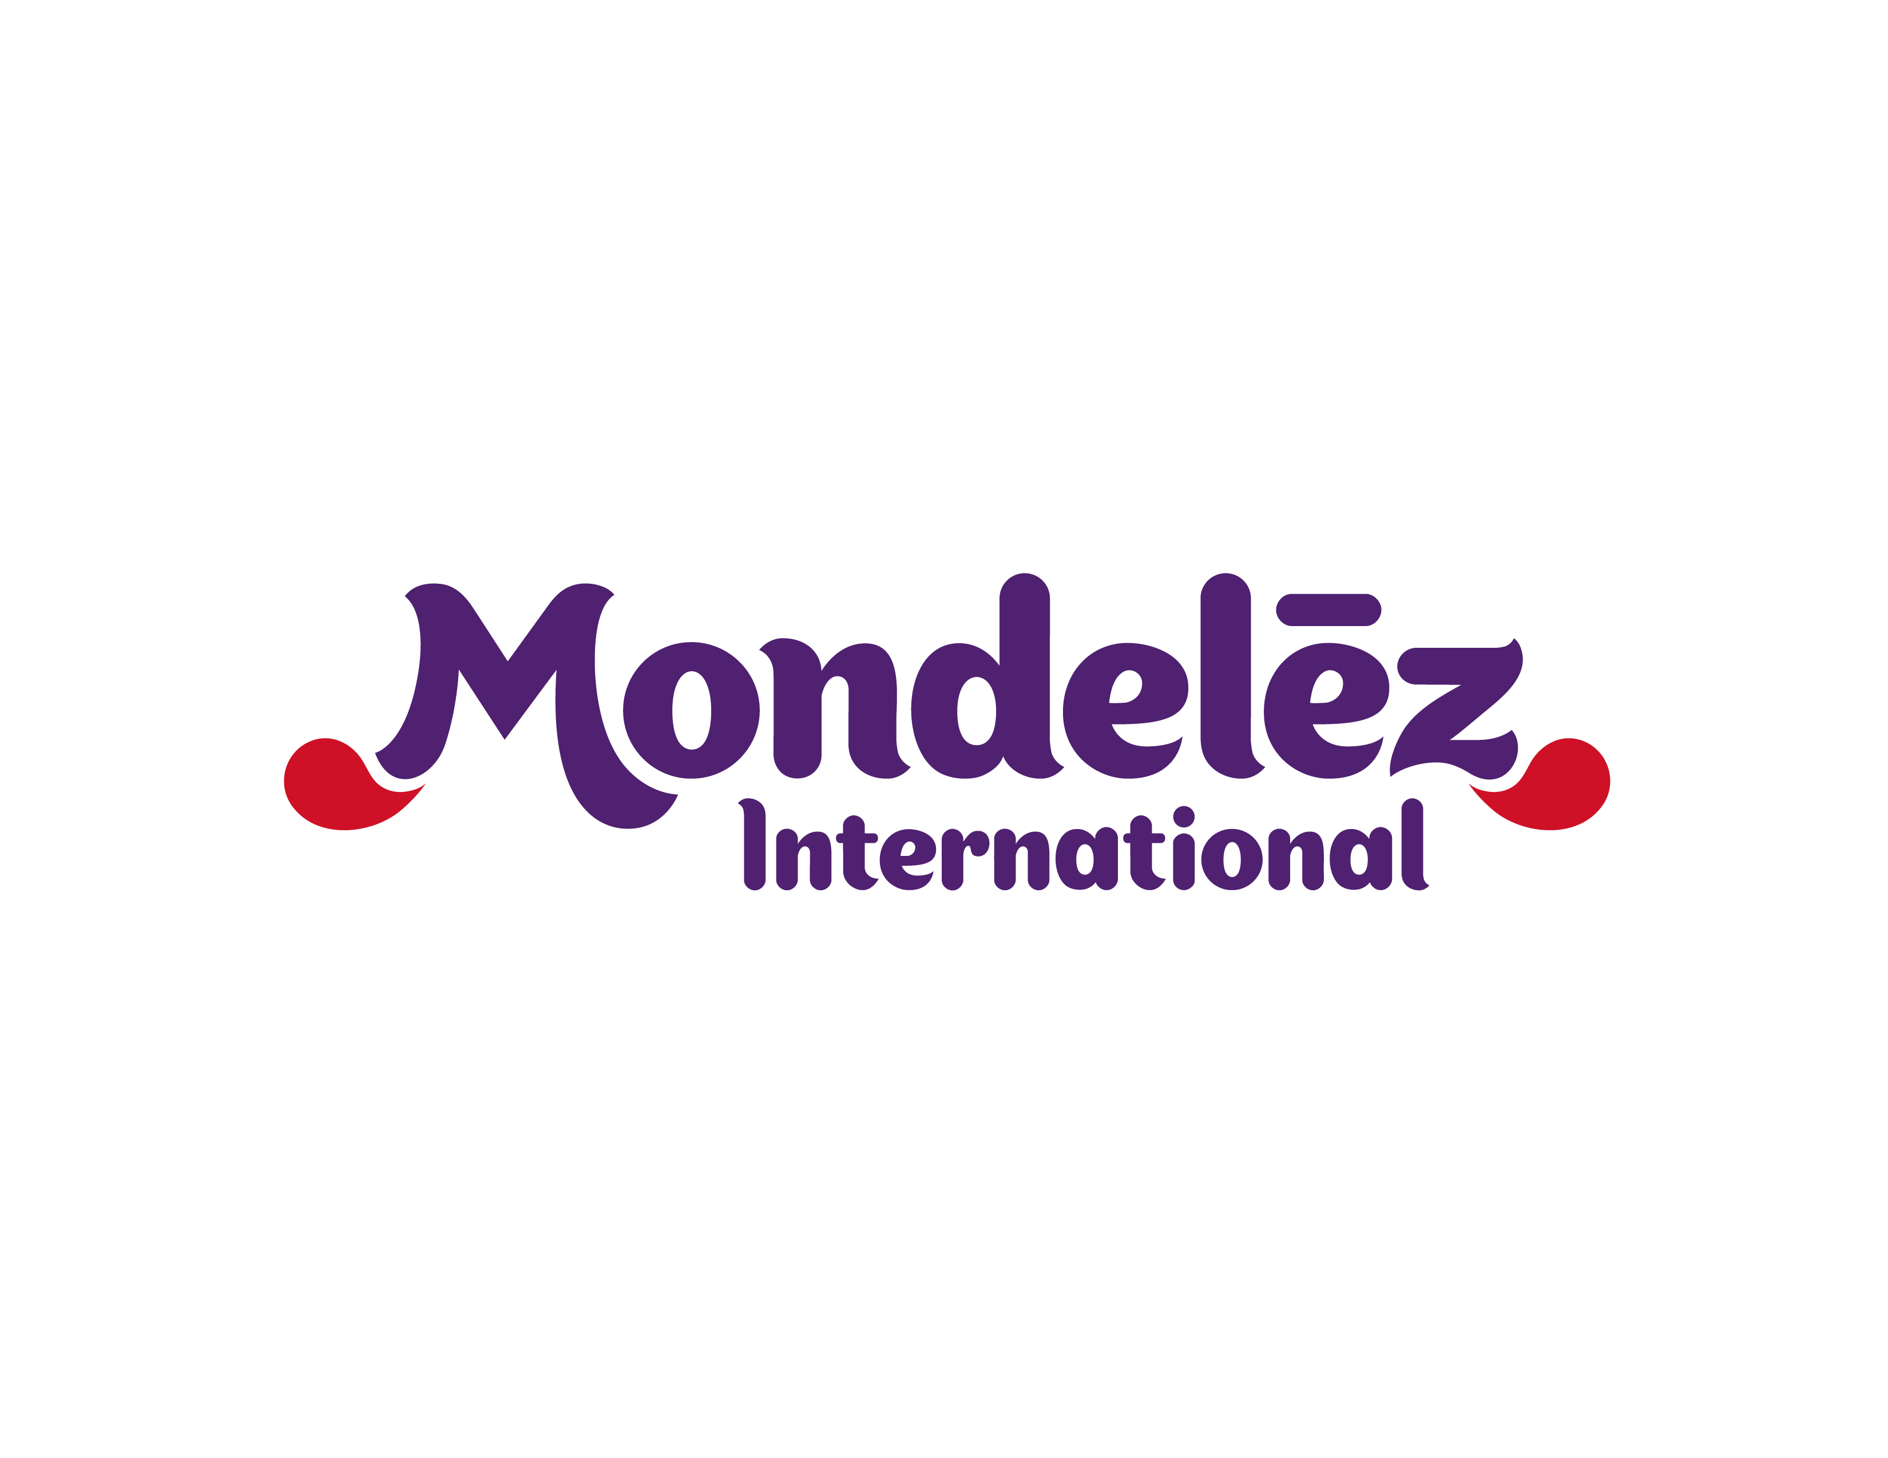

|  |  |  |
| --- | --- | --- |
| **Contact:** | Virginie Mahin |  |
|  | +41-58-440-6400 |  |
|  | media.europe@mdlz.com |  |

**Mondelēz International scales up its Cocoa Life program in Côte d’Ivoire in partnership with Barry Callebaut and Solidaridad**

* **World’s Largest Chocolate Company Expands “Cocoa Life” Sustainability Effort**
* **Will Contribute to Doubling Farmers Reach to 26,000 in Côte d’Ivoire by 2016**
* **Supplier and Development NGO Work Side by Side on the Ground**
* **By 2022, $400 Million Investment to Benefit 200,000 Farmers in Six Cocoa Origins**

DEERFIELD, Ill. – Oct. 15, 2015 – Mondelēz International, Inc. (NASDAQ: MDLZ), the world's largest chocolate company, today announced the expansion of its Cocoa Life program in Côte d’Ivoire. In line with its commitment to empower 200,000 farmers and invest $400 million in Côte d’Ivoire and five other cocoa origins by 2022, Mondelēz International will partner with the world’s leading manufacturer of chocolate and cocoa products Barry Callebaut and international development NGO Solidaridad to scale up the implementing capacity of its holistic program Cocoa Life.

“This new partnership will allow us to quickly double the number of farmers we reach in Côte d’Ivoire in just two years from 2014” said Cathy Pieters, Director of Cocoa Life at Mondelēz International. “Their complementary expertise will support our objectives of creating thriving cocoa communities while ensuring sustainable cocoa production.”

Barry Callebaut and Solidaridad will work hand in hand on the ground. Barry Callebaut will provide farmers with agricultural training and access to inputs to improve cocoa productivity and incomes, while Solidaridad will work together with the cocoa communities to design tailored community action plans and implement actions to strengthen livelihoods, empower women and promote children’s rights.

“We have had a long-time commitment to sustainability and as a long-term partner of Mondelēz International, we are extremely pleased to have been selected to support the implementation of their cocoa sustainability programs” said Antoine de Saint-Affrique, CEO of Barry Callebaut. “We will use our strong presence on the ground to help Mondelēz International transform the lives and livelihoods of cocoa farmers and their communities.”

Cocoa Life’s holistic approach is already making progress in Côte d’Ivoire. Innovative actions like the setting up of Village and Loans Associations promote women’s practical financial literacy and access to lending, while farmer trainings support cocoa productivity and farmers’ incomes.

**About Cocoa Life**

Cocoa Life aims to reach more than 200,000 farmers across six countries, benefitting more than a million people. Mondelez International's ultimate goal is to sustainably source all the company's cocoa supply, mainly via Cocoa Life.  By working in partnership with farmers, NGOs, suppliers and government institutions, Cocoa Life answers Mondelez International's Call For Well-being, which urges employees, suppliers and community partners to join together to develop new approaches that can have a positive impact on the planet and its people. The Call For Well-being focuses on four key areas where the company can make the greatest impact: mindful snacking, sustainability, community and safety.  Follow our progress on [www.cocoalife.org/progress](http://www.cocoalife.org/progress)

**About Mondelēz International**

Mondelēz International, Inc. (NASDAQ: MDLZ) is a global snacking powerhouse, with pro forma 2014 revenue of more than $30 billion. Creating delicious moments of joy in 165 countries, Mondelēz International is a world leader in biscuits, chocolate, gum, candy and powdered beverages, with billion-dollar brands such as Oreo, LU and Nabisco biscuits; Cadbury, Cadbury Dairy Milk and Milka chocolate; Trident gum and Tang powdered beverages. Mondelēz International is a proud member of the Standard and Poor’s 500, NASDAQ 100 and Dow Jones Sustainability Index. Visit [www.mondelezinternational.com](http://www.mondelezinternational.com) or follow us on Twitter at [www.twitter.com/MDLZ](http://www.twitter.com/MDLZ)

**About Barry Callebaut Group**

With annual sales of about CHF 5.9 billion in fiscal year 2013/14, the Zurich-based Barry Callebaut Group is the world’s leading manufacturer of high-quality chocolate and cocoa products – from the origination and processing cocoa beans to producing the finest chocolates, including chocolate fillings, decorations and compounds. The Group runs more than 50 production facilities worldwide and employs a diverse and dedicated global workforce of over 9,300 people. The Barry Callebaut Group serves the entire food industry, from industrial food manufacturers to artisanal and professional users of chocolate, such as chocolatiers, pastry chefs, bakers, hotels, restaurants or caterers. The two global brands catering to the specific needs of these Gourmet customers are Callebaut® and Cacao Barry®. The Barry Callebaut Group is committed to sustainable cocoa production to help ensure future supplies of cocoa and improve farmer livelihoods. It supports the Cocoa Horizons Foundation in its goal to shape a sustainable cocoa and chocolate future. [www.barry-callebaut.com](http://www.barry-callebaut.com/)

**About Solidaridad**

Solidaridad is an international civil society organization with more than 45 years of global experience in facilitating the development of socially responsible, ecologically sound, and profitable supply chains. Solidaridad works across 12 supply chains and operates through 10 Regional Expertise Centres on 5 continents. We bring together supply chain actors and engage them in innovative solutions to improve production, ensuring the transition to a sustainable and inclusive economy that maximizes the benefit for all. Solidaridad envisions a world in which everything we produce and consume can sustain us all, while respecting the planet, each other and future generations. [www.solidaridadnetwork.org](http://www.solidaridadnetwork.org) [www.solidaridad.nl](http://www.solidaridad.nl)

###