BIKE CAMP MELCIOR MAURI – COSTA DAURADA

Cambrils, 9-13 March 2017

Cycle with Mauri, Indurain and Chiappucci through the landscapes of
Costa Daurada, an international cycling destination!

Enjoy four days of pure cycling by the hand of some of the most recognised personalities of the cycling world at the Bike Camp Melcior Mauri. It consists on a 4-day trip in Costa Daurada (Catalunya) that will blow you away.

Further than Melcior Mauri and Claudio Chiappucci, as a special guest for 2017, Miguel
Indurain – winner of five consecutive Tours de France – will join this unique event.

Discover the breath-taking landscapes of Priorat, Montsant and Muntanyes de Prades in Costa Daurada next to some of the most outstanding professional cyclists. You will be able to choose among several routes, all of them with provisioning points and roadside assistance.

The accommodation will be at Cambrils Park Sport Village.

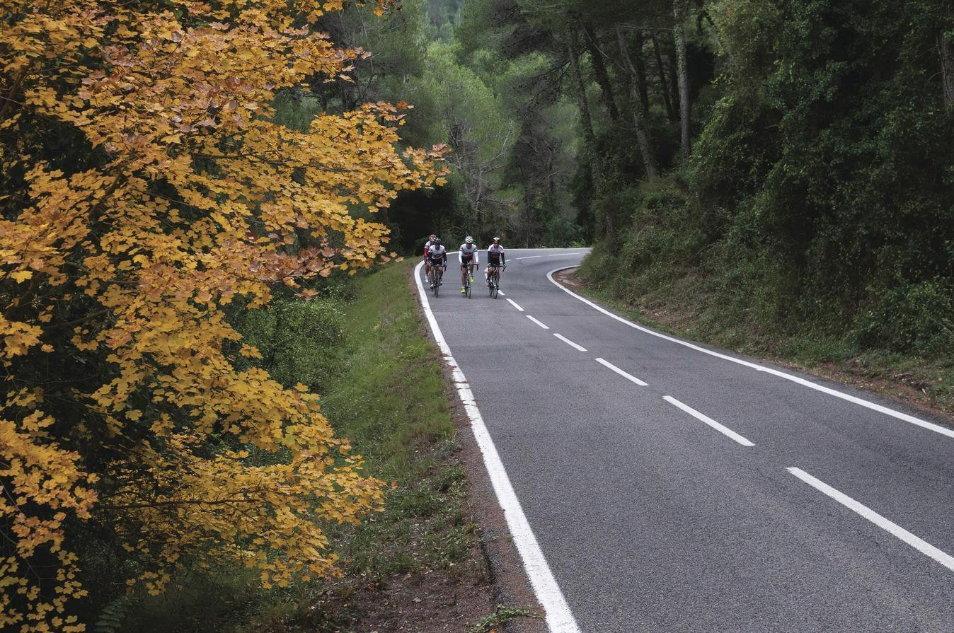

Thursday 9th March
Programme

Afternoon
Check-in at Cambrils Park Sport Village
Welcome with the professional ex-cyclist Miguel Indurain
Introduction to the campus, program, routes and activities

21.00 h Dinner
Accommodation at Cambrils Park Sport Village

Friday 10th March

7.00 h  8.30 h  9.00 h | Breakfast  Route Briefing  Cycling: El Priorat
14.00h | Lunch
17.00 h | Workshop with Catalan companies: travel agents, DMC,  accommodations, bike businesses, etc.
21.00 h | Dinner  Accommodation at Cambrils Park Sport Village

Saturday 11th March

7.00 h  8.30 h  9.00 h | Breakfast  Route Briefing  Cycling: Muntanyes de Prades
14.00h | Lunch
18.00 h | Seminars
21.00 h | Dinner  Accommodation at Cambrils Park Sport Village

Sunday 12th March

7.00 h
8.30 h
9.00 h
Breakfast
Route Briefing
Cycling: El Montsant

14.00h Lunch
17.00 h Farewell Party

Monday 13th March
Departures

Route 1: El Priorat
Track Routes

> Option A: Short Route https://www.strava.com/routes/6817494
• Distance: 85,8km
• Positive Elevation: 1.330m

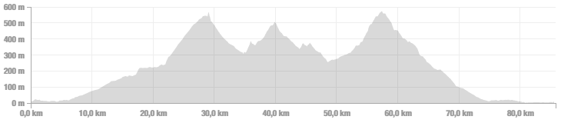

> Option B: Long Route https://www.strava.com/routes/6817500
• Distance: 115km
• Positive Elevation: 2.019m

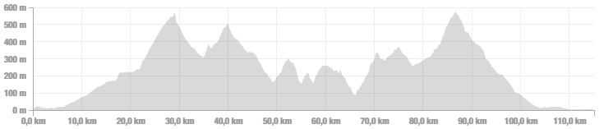

Route 2: Muntanyes de Prades

> Option A: Short Route https://www.strava.com/routes/6833069
• Distance: 78,5km
• Positive Elevation: 1.275m

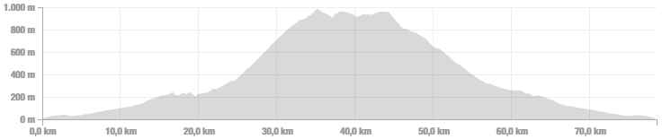

> Option B: Long Route https://www.strava.com/routes/6816983
• Distance: 108,8km
• Positive Elevation: 1.931m

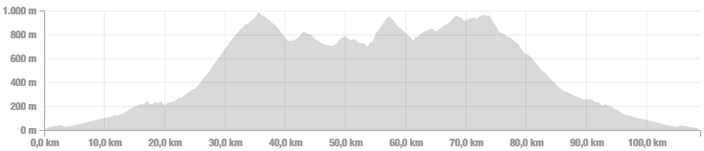

Route 3: Montsant

> Option A: Short Route https://www.strava.com/routes/6817416
• Distance: 96,8km
• Positive Elevation: 1.547m

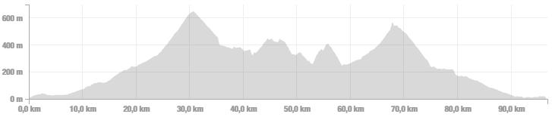

> Option B: Long Route https://www.strava.com/routes/6817429
• Distance: 104,2km
• Positive Elevation: 1.705m

