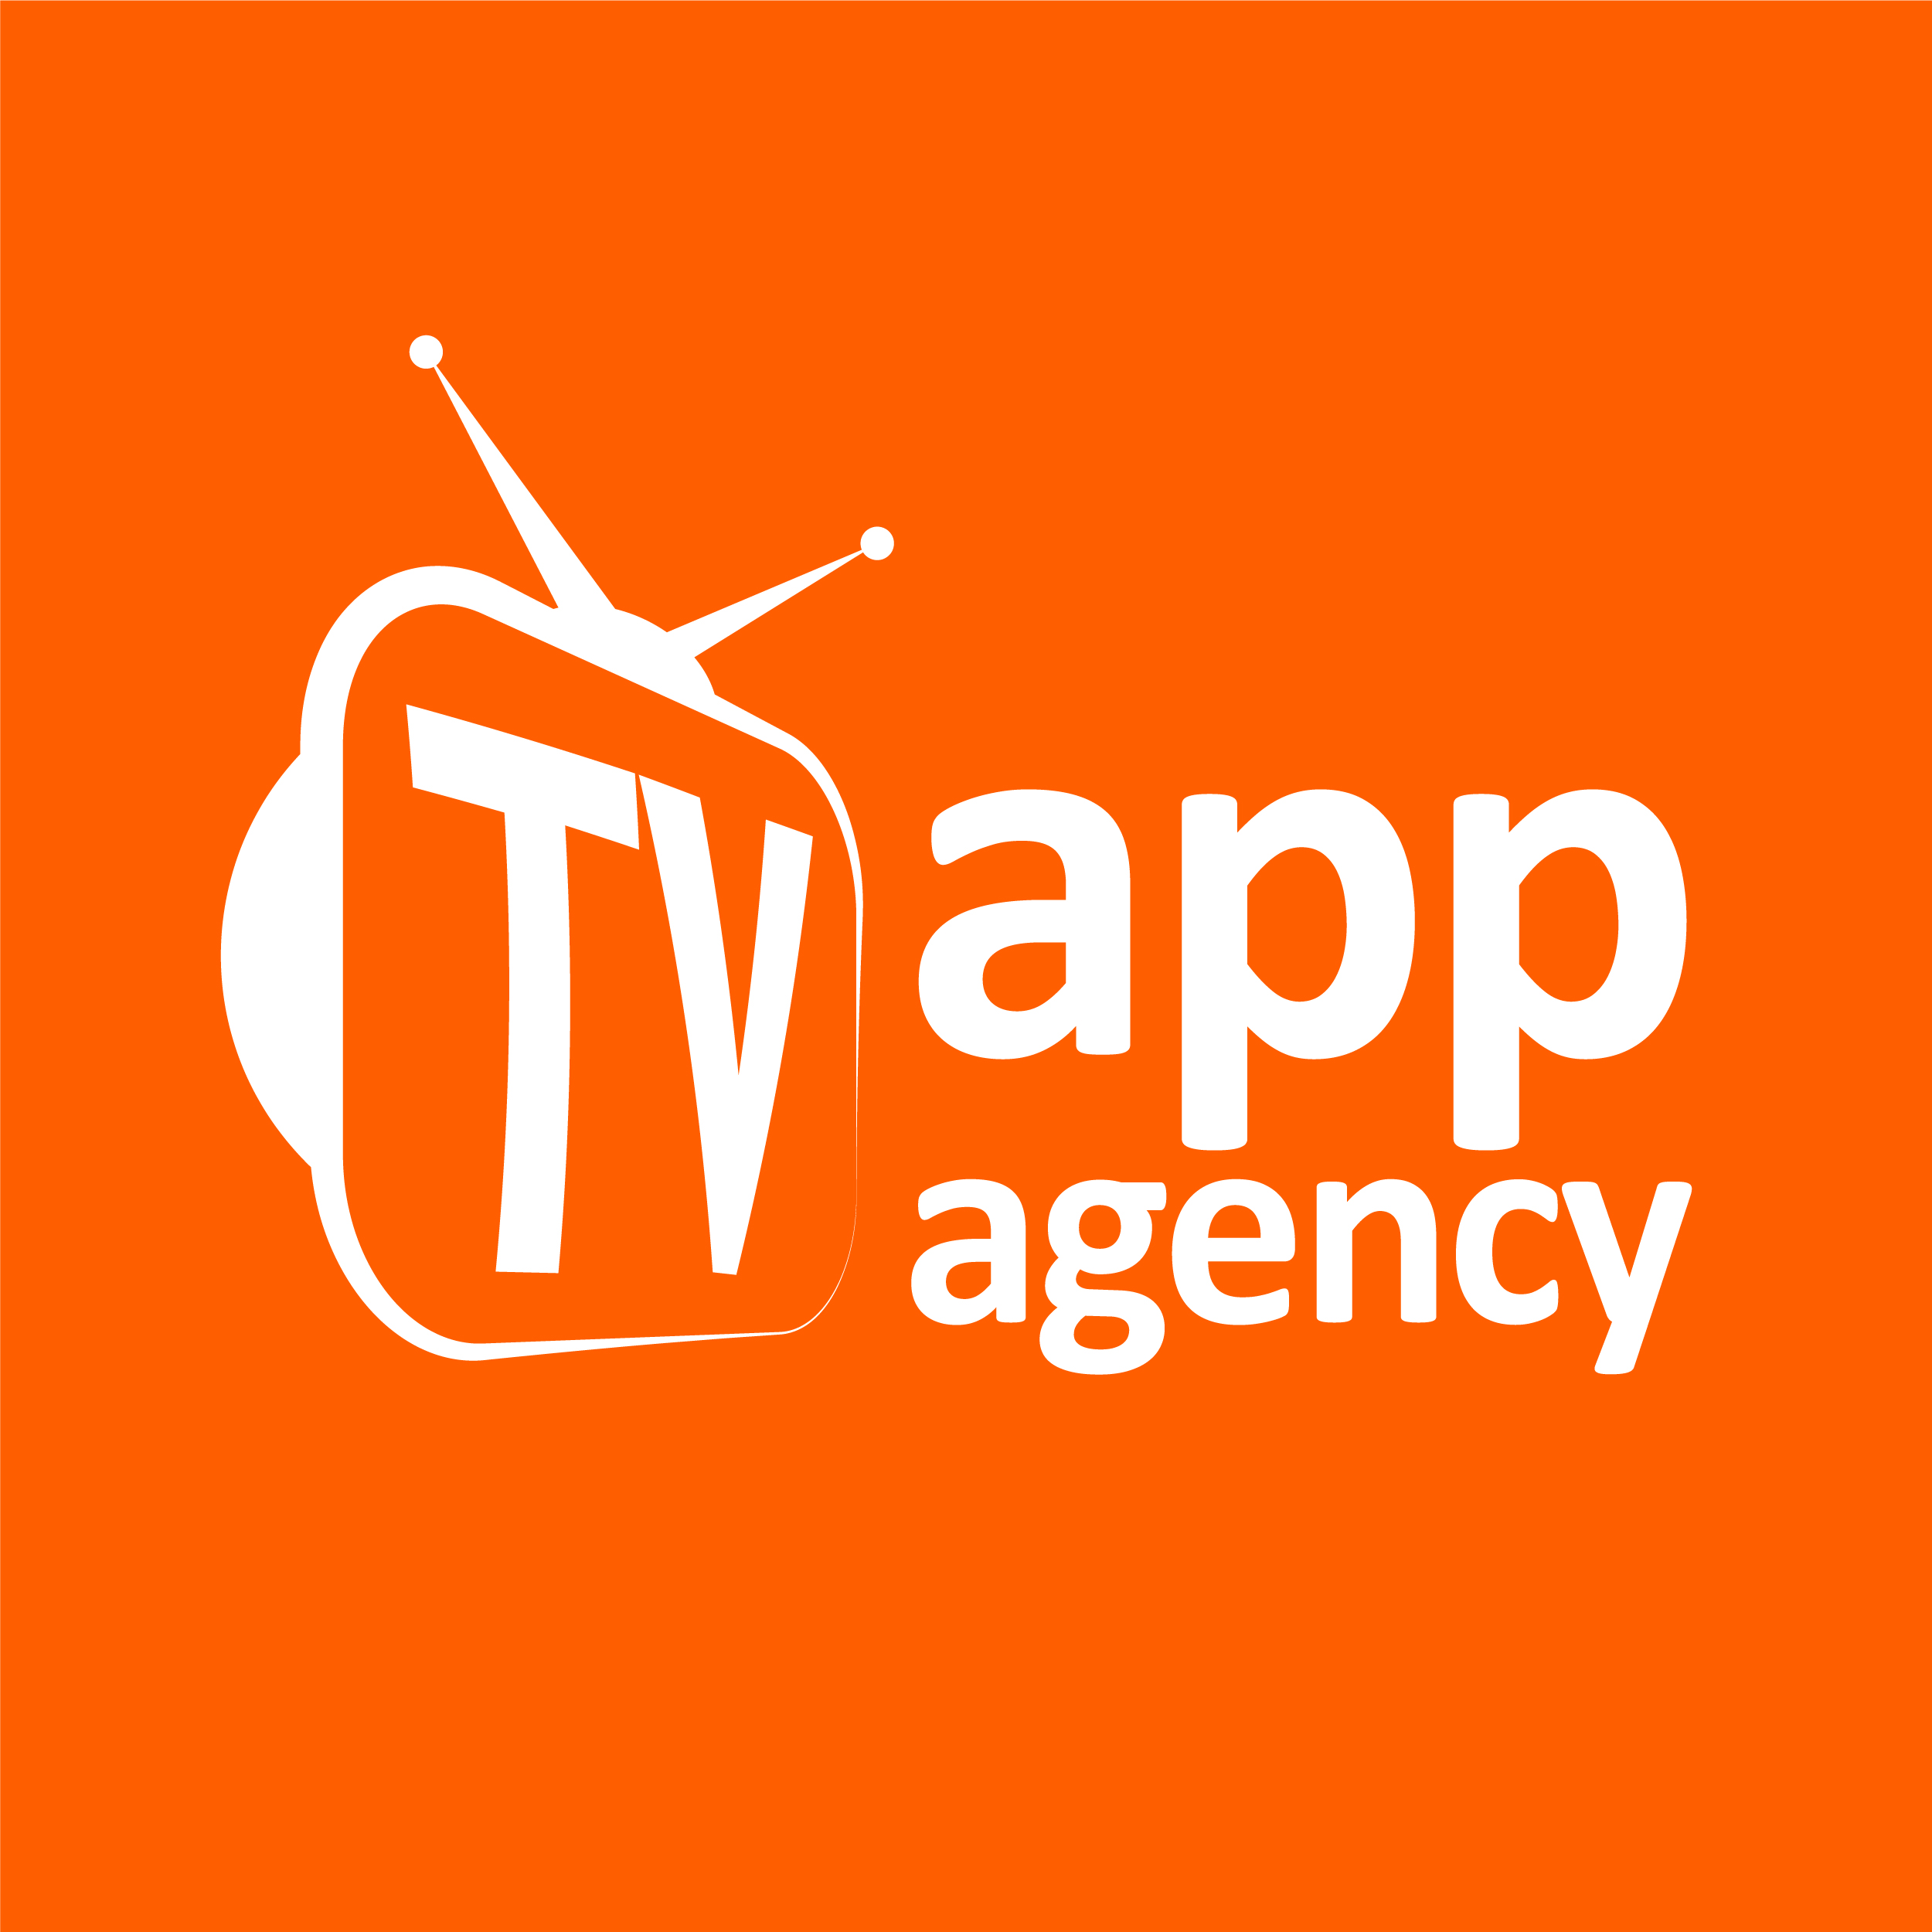
For immediate release

UK business brings multi-channel Olympics to Spain
The UK’s TV App Agency has built and deployed an Olympics app for Spanish broadcaster RTVE. The app will allow RTVE’s viewers to watch TV as it’s meant to be seen, while still having access to live social media at their fingertips. It will provide access to 12 channels of live sport, and enabling viewers to continue to interact with their friends.

This year’s London Olympics are some of the most ambitious in media terms, and is the first Olympics to be truly multi-channel. The BBC will cover every event from every venue via 24 separate live HD streams and 2,500 hours of coverage will be made available on the BBC Sport website. They’ve even built their own Smart TV app. Yet RTVE will be providing their Smart TV access through an app built by a UK based company, TV App Agency, which they built and sent live to the Samsung marketplace in less than three weeks.
Never before has a global event been so extensively covered via so many different media channels, meaning there are a range of new alternatives to attract an audience. That multichannel experience means that viewers can watch the Games in the way that suits them best. And given the Olympics is being held in the UK, it’s only fitting that it should provide a boost to UK industry.
Smart TV is a new growth opportunity for digital. A TV is the ultimate shared device for watching videos and viewing large images from the comfort of the living room, rather than hunched over a 15” laptop. Sports content is best viewed on a TV and there are already several million smart TV’s in the UK – globally, the market is forecast to reach 119 million smart TVs by 2014. Post Olympics, we’ll be able to see how viewers consumed the majority of sports coverage but for now, at least we know that the UK, TV App Agency has brought the world the first truly interactive and multichannel Olympics.

Ends

About TV App Agency
TV App Agency was founded in 2011 to enable the delivery of cross-platform content across smart TV. The convergence of hardware devices - mobile, tablets and TV - and the delivery of cross-platform content made efficient by software is the next wave in the digital industry.
TV App Agency provides expertise across software development, user experience, multi-screen devices, TV app development and app store submission to enable brands, content providers, agencies and broadcasters to get onto smart TV. Since its launch, TV App Agency has developed apps for a range of leading European brands, including RTVE, Rightmove, Prime Location, Find a Property, Daft, La Liga BBVA, National Rail, Food Network and Absolute Radio.
The company has also developed a technology engine which enables brands to develop apps and submit them across a range of connected devices including Samsung, LG, Philips and Sharp, and platforms including Google TV, Opera and set-top boxes.

Follow us on Twitter: @tvappagency

LinkedIn: TV App Agency

Press contacts:
Simi Dhillon, Mixing Digital: mobile 07800 890 224, simi@mixingdigital.com
Davina Lines, Mixing Digital: mobile: 07976 665 094, davina@mixingdigital.com

