**Soluno launches MyAcademy to accelerate growth and customer satisfaction**

**Soluno, one of the leading European UCaaS Providers, announces the launch of MyAcademy, a new interactive learning platform.**

The launch of MyAcademy forms an essential part of Soluno's overall strategy. The UCaaS service provider is expanding in Europe with a wholesale-first concept and innovates heavily to stay ahead in a competitive market. MyAcademy makes it easier to work with Soluno, who also gets the possibility to offer faster distribution of new and relevant information into different channels. Soluno believes an open mind to training will increase all parties' opportunities.

All training programs are available free of charge to channel partners with knowledge, best practices, and skill development as Soluno intends to contribute to partners' success.

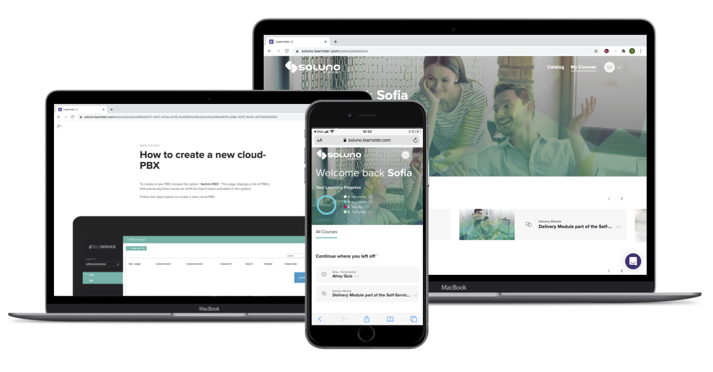"The launch of MyAcademy is another step in simplifying our industry. We want to help partners rediscover the joy of learning. Knowledge and best practice are often critical reasons for deals tipping in your favor or creating the necessary efficiency. Participants will learn how to make the best use of our products in the shortest possible time. I am confident that this platform will prove to be an invaluable resource for both partners and staff over the coming years," said Christian Hed, Chief Marketing Officer Soluno.

MyAcademy enables partners to familiarize themselves with Soluno's product portfolio at their own pace and at a time of their choosing. Users have direct access to practical information and expert content, clearly conveyed in an interactive e-learning format, combined with traditional classroom sessions. In addition to detailed instructions and useful tips, users can easily search for topics and keywords.

**Available to Partners in February 2021**

In the last eight months, Soluno has worked intensively to produce course catalogs containing all Soluno products and services and will continue to develop, update, and add new courses ahead. Partners will have access to relevant material and specific courses adjusted to their propositions and markets.

Soluno sees future success in its partner strategy and the importance of working with the most well educated and progressive teams and partners in Europe.

Partners will have access to the platform in February 2021.

For more information, contact details:

Christian Hed, CMO Soluno, +46(0)8-562 696 03, [Christian.hed@soluno.com](mailto:Christian.hed@soluno.se)

**About Soluno**

Soluno is one of the leading UCaaS providers in Europe with +200.000 users in the cloud. Driving the future of Business Communications by offering a mobile-first concept through wholesale partners in Europe.

For more information about Soluno, visit [www.soluno.com](http://www.soluno.com) and follow us on [LinkedIn](https://www.linkedin.com/company/solunobc).