Kongsberg Maritime signs over NOK 400 million in Shuttle Tanker orders during 2020
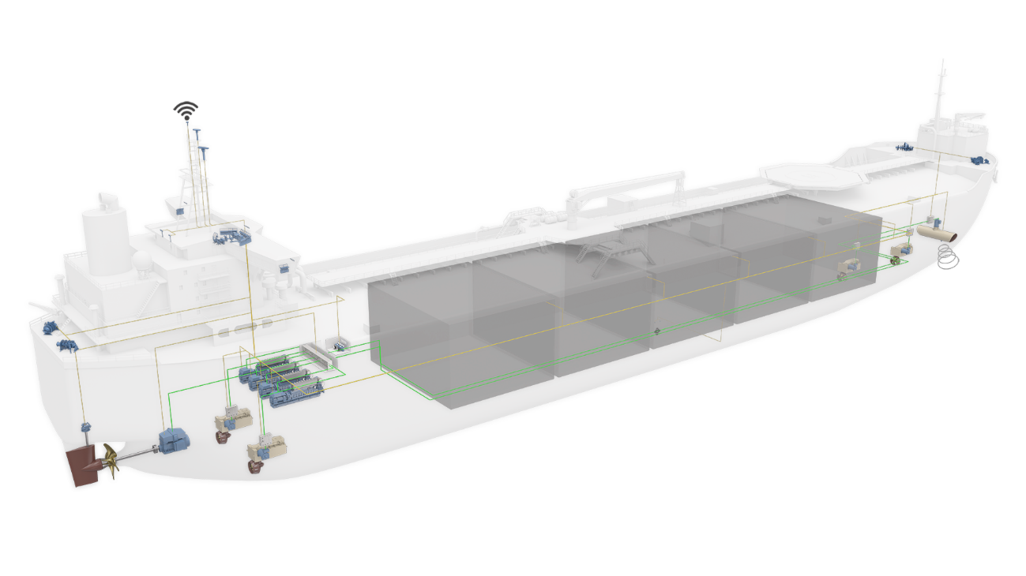Business has been buoyant for Kongsberg Maritime in the shuttle tanker market, despite global disruption
Kongsberg, Norway, 13th November 2020 – Kongsberg Maritime has revealed that during 2020 it won contracts for 12 of its highly advanced Shuttle Tanker concepts, with a value totalling over NOK 400 million.
Shipyards in South Korea and China are building the vessels, which are destined to operate between offshore installations and onshore plants in Norway, Brazil, Canada and China. Common to all vessels is the integration of advanced, fault-tolerant, automated onboard systems and solutions to optimise operational efficiency, safety, reliability and sustainability. To this end, the new vessels will be equipped with a full complement of products from all divisions within Kongsberg Maritime, including Dynamic Positioning & Manoeuvring, Propulsion & Engines, Sensors & Robotics and Deck Machinery.
“This abundance of shuttle tanker orders would be good news at any time,” said Brynjulv Standal, Vice President Offshore Global Sales and Marketing, Kongsberg Maritime. “To achieve these figures in 2020 with the additional challenges posed by the coronavirus pandemic is nothing short of remarkable. We are delighted to support what is clearly an active and growing market, whose specific demands we are uniquely placed to address.
“Investing now in our integrated shuttle tanker concepts, encompassing smart energy management strategies and fewer service requirements, will greatly improve fleet performance, leading to an ongoing, long-term reduction of OPEX and a simultaneous reduction in emissions.”
Ends

For further information, please contact:
Gunvor Hatling Midtbø, VP Communication
Kongsberg Maritime
Tel: +47 9921 4209
gunvor.hatling.midtbo@km.kongsberg.com
David Pugh
Saltwater Stone
Tel: +44 (0)1202 669244
d.pugh@saltwater-stone.com

About Kongsberg Maritime
Kongsberg Maritime is a global marine technology company providing innovative and reliable ‘Full Picture’ technology solutions for all marine industry sectors including merchant, offshore, cruise, subsea and naval. Headquartered in Kongsberg, Norway, Kongsberg Maritime has manufacturing, sales and service facilities in 34 countries.
Kongsberg Maritime solutions cover all aspects of marine automation, safety, manoeuvring, navigation, and dynamic positioning as well as energy management, deck handling and propulsion systems, and ship design services. Subsea solutions include single and multibeam echo sounders, sonars, AUV and USV, underwater navigation and communication systems.
Training courses at locations globally, LNG solutions, information management, position reference systems and technology for seismic and drilling operations are also part of the company’s diverse technology portfolio. Additionally, Kongsberg Maritime provides services within EIT (Electro, Instrument & Telecom) engineering and system integration, on an EPC (Engineering, Procurement & Construction) basis.
Kongsberg Maritime is part of Kongsberg Gruppen (KONGSBERG), an international, knowledge-based group that celebrated 200 years in business during 2014. KONGSBERG supplies high-technology systems and solutions to customers in the oil and gas industry, the merchant marine, and the defence and aerospace industries.
Web: Kongsberg Gruppen | Kongsberg Maritime
Social media: LinkedIn | Twitter | Facebook

