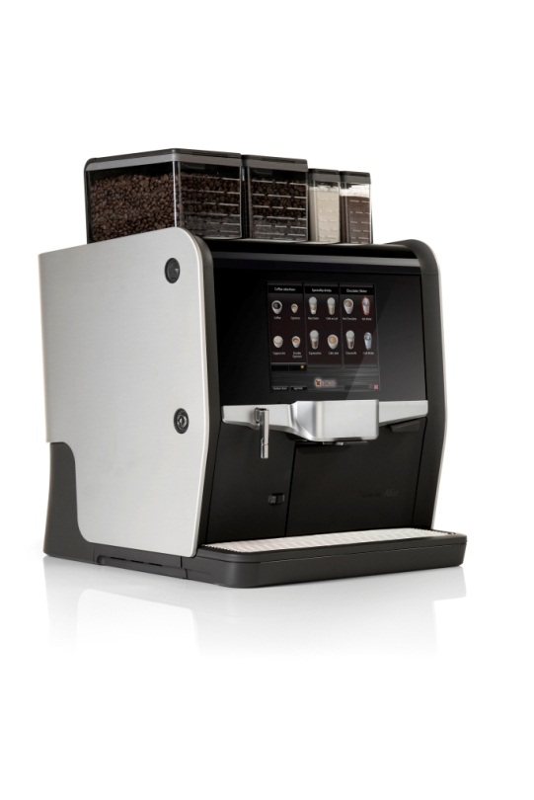

**Nio has now been awarded yet another prestigious design award!**

We can proudly announce that de Jong NIO has been awarded the internationally recognized iF DESIGN AWARD! Since 1953, iF has been dedicated to organizing fair, independent and reputable design awards and has thus gained a top position in the international award spectrum. Representing excellent design and outstanding design achievements, the iF seal of quality is recognized the world over, with registrants ranging from automotive companies to individual design studios.

 

**Red Dot Design Award**

During 2014, de Jong NIO was rewarded the RED DOT DESIGN AWARD, an internationally recognized design prize with a renowned distinction for high quality and is one of the most sought-after quality marks for excellent design. The 40 experts from all over the world evaluate products against the highest standards and include aspects like functionality, ergonomics, durability and ecological compatibility in the adjudication process.

In a reaction to the news of receiving the Red Dot Design Award, Maurits JC de Jong, managing director of de Jong DUKE commented: *“We consider the award to be a recognition of and compliment to the work and effort put into the NIO by our engineers, designers, suppliers and all people who contributed to the project. It is also a confirmation of our product development philosophy that focuses on adding value while at the same time maintaining a clear view on the performance and reliability without compromising on design or customer experience.”*

**Kaffeknappen in the reference gruop**

What makes us extra proud is the fact that Kaffeknappen played a big part in the development of de Jong NIO. We were part of the reference group in a process led by dutch design company Scope. Our experience has played a significant role in this process which, of course make us really happy and proud.