February 14, 2014

PRESS RELEASE

Zuperman, the 180-knot boat, is coming to Allt för sjön - the Stockholm International Boatshow

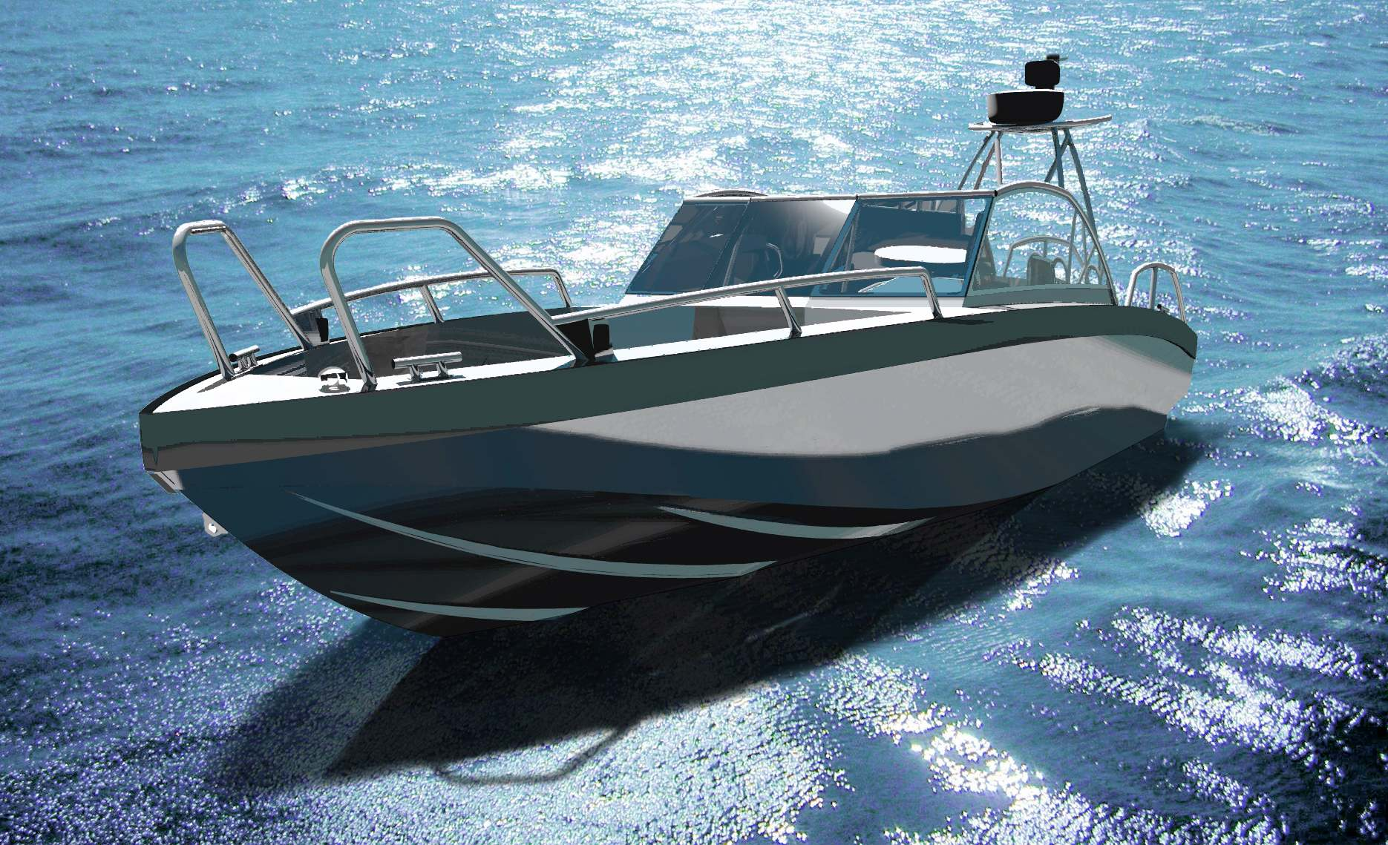
Over 40 of the approximately 300 motor boats to be shown at Stockholmsmässan from March 1–9 are new. Zuperman, a super-racing boat that attains speeds over 180 knots is one of them and the aluminum boat Viggo X8 is one of several boats to have its world premiere at the show.
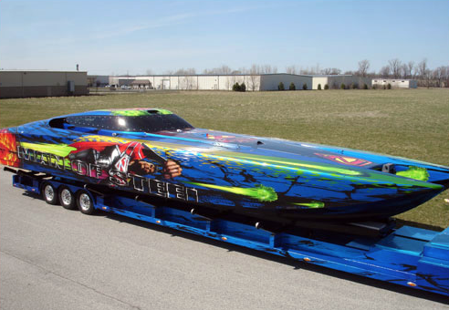

Scandinavia’s largest boat show, Allt för sjön, the Stockholm International Boat Show, will feature an unusually large number of new motorboats. The biggest attraction, at least for speed-lovers, will certainly be the monster boat Zuperman, a 50-foot super-racer powered by two gas turbines, that will top out at just under 200 knots.

But for those more interested in new utility boats of more normal size and performance, there will also be an unusual number of new things to see. Everything from luxury yachts in 50-foot class, fast aluminum rib boats, day cruisers and working and transportation boats to newly built wooden boats will be on display.

“Cool! Boating interest is on the rise again. After five fairly lean years in the business, we hadn’t thought there would be any significant change this year. But we've actually had to increase the exhibition space from last year in order to accommodate all the boats, which is really fun. Moreover, we have more interesting new items than in recent years. And hopefully they will attract more visitors than during the last few years”, said Allt för sjön project manager Thomas Sandberg.

Among the more than 40 new motor boats to be shown are the Anytech 860 SPD, Bavaria Virtess 420, Nimbus Nova 21, Chris Craft Corsair 32, Sealine F380, Arronet 245 sxt, Jeanneau NC9, Bella 630 RC, Flipper 600 DC, Aquador AQ 30 DC, Forbina 42 CC, RydsF468 and Nivado G650.

“Another novelty this year is that we have divided the fair into different themes so that visitors will be able to easily find their favorite areas. The motor boats fill most of the large Hall A. There is also the Grand Large Section, housing all of the larger motor boats. Grand Large also features a bubble and rosé bar, where visitors can rest their feet and relax with a glass of something good. Hall A also includes the large Finnish Collection booth, showing some 30 boats from Finnish manufacturers.

“Motor boats are even plentiful in the Classic Boat section, where they are lined up – rarities from bygone days, smelling of tar and varnish. This year's theme is The Beloved Gig. It is a hand-built masterpiece that bears witness to the days when the boat was a working tool for those who lived in the archipelago and good seamanship was shaped by hand. It will be a real nostalgia rush for many, especially those who may have been around in those days.”

For more information, please contact:

Thomas Sandberg, project manager, thomas.sandberg@stockholmsmassan.se, tel: 08-749 44 94
Mats Hagman, press officer, mats.hagman@informedia.se, tel: 070-628 12 10

