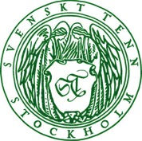
Press Release
Stockholm, April 19, 2016

Svenskt Tenn introduces exclusive bags collection

Svenskt Tenn extends its line of personal accessories by introducing a collection of leather bags. The new collection was co-developed with the Italian design firm IVORY and is now available at Svenskt Tenn’s store in Stockholm, and online.

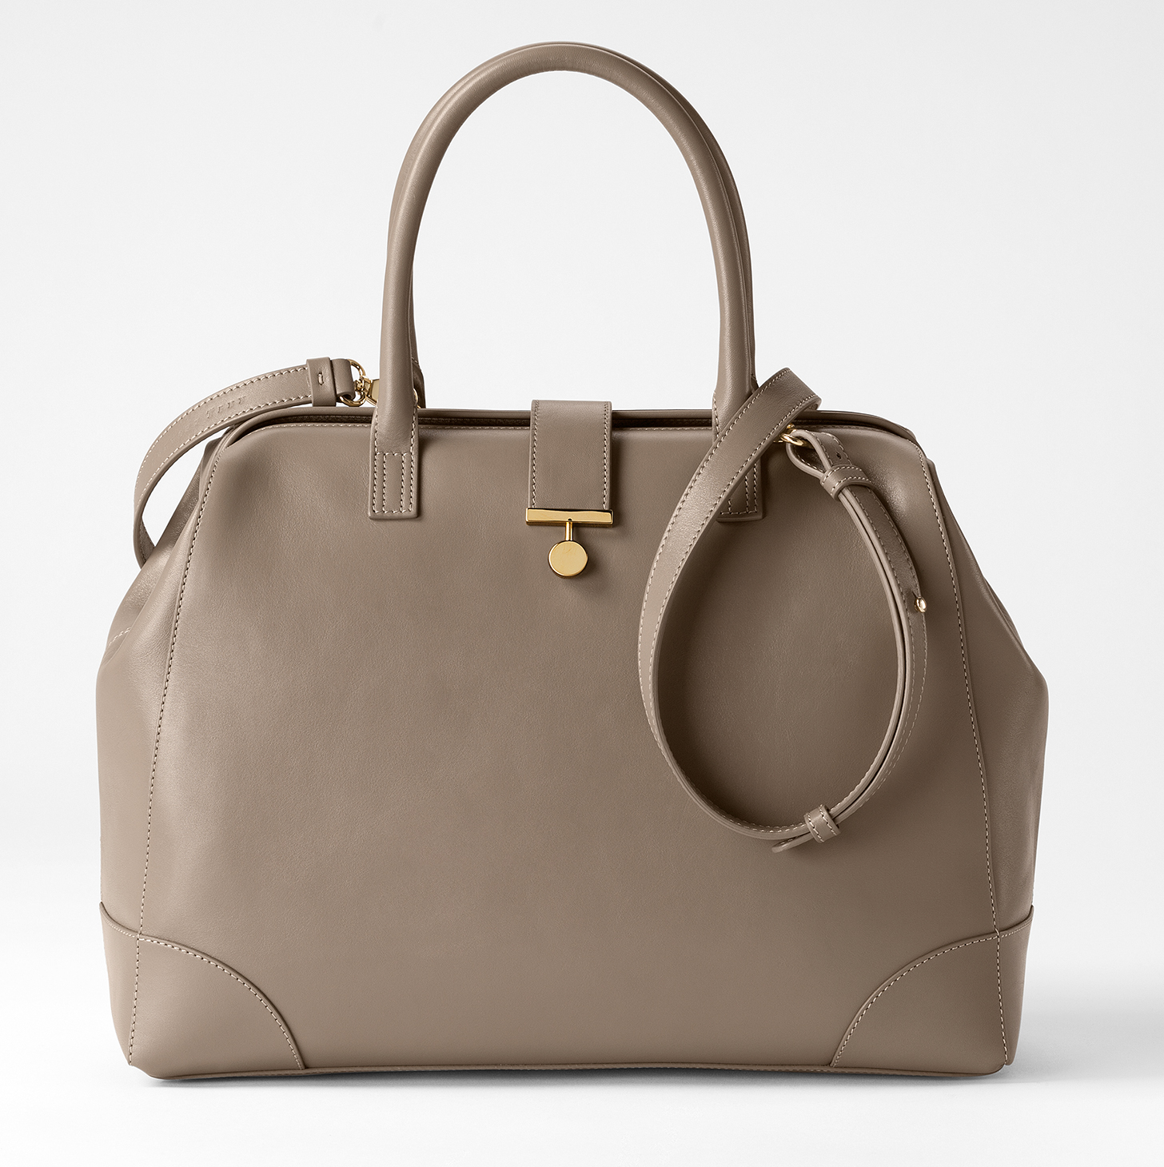
The new bags collection comprises a handbag, tote bag, evening bag, briefcase, and a purse – all made, from soft calfskin with brass details inspired by Svenskt Tenn’s founder Estrid Ericson.

IVORY has a legacy of collaboration with many leading international brands.

”Our intent for Svenskt Tenn’s first collection of leather bags is to create timeless designs using premium quality leather and distinguished by premium craftsmanship,” says Thommy Bindefeld, Marketing Director at Svenskt Tenn. ”Building on their know-how and experience, IVORY has greatly contributed this mission.”

As part of this initiative, there is now a dedicated area for bags in the store, with larger space than previous displays. Here you also find Svenskt Tenn’s popular textile bags, now updated with new design features. Additionally, Svenskt Tenn is renewing its further range of leather items, which includes a card holder, a toiletry bag, a pen holder and a jewellery box. These are made from the same quality leather as the bags, and embossed with a classic pattern designed by Estrid Ericson.

Prices: Handbag SEK 7,500, Evening bag SEK 4,200, Tote bag SEK 5,500, Briefcase SEK 9,800, Purse SEK 2,500, Toiletry bag SEK 2,800, Card holder SEK 680, Jewellery Box SEK 3,500, Tote bag in embossed leather SEK 4,500.

For further information, please contact:

Vicky Nordh, Marketing Assistant: +46 8-670 16 23 or vicky.nordh@svenskttenn.se

Thommy Bindefeld, Marketing Director: +46 8 670 16 02 or thommy.bindefeld@svenskttenn.se

Images are available for download from svenskttennpress.se. Username: Press. Password: Tenn

Svenskt Tenn is an interior design company with retail stores at Strandvägen in Stockholm and online. Since 1975, Svenskt Tenn is owned by the Kjell and Märta Beijer Foundation, which provides research grants within ecology, medicine and the preservation of Swedish interior design tradition.

