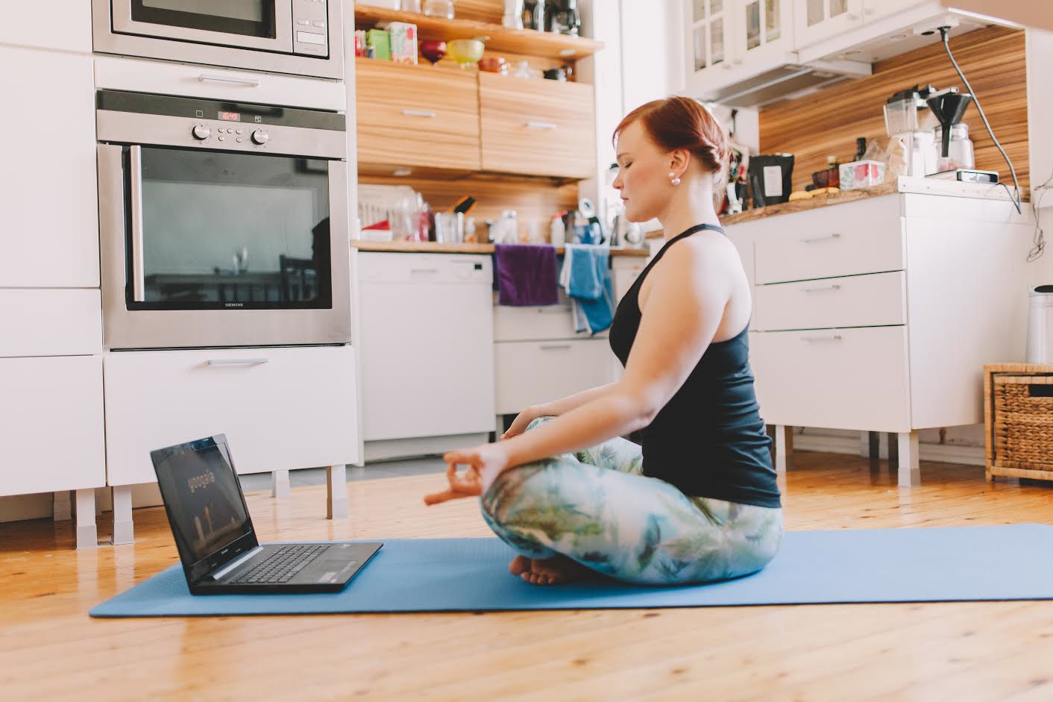

Yoga, but more flexible…

- The world’s first truly interactive Yoga/Pilates/Barre service with studios in London, Helsinki & Hong Kong

- Over 100 Real time classes each week with live interaction/instruction via your laptop

- Many different varieties of Yoga, Pilates and Barre in the comfort of your home or hotel room

- Yoga Your Way – join the online training revolution

Yoogaia.com is a Finnish company that has been offering interactive yoga from its Helsinki studio for over two years and has now launched in the UK and Hong Kong, broadcasting over 100 live classes a week in English and Finnish.

As well as live, real time classes, it has a huge selection of pre-recorded classes covering a whole range of Yoga, Pilates and Barre workouts and meaning you can now train whenever and wherever via your tablet/laptop/mobile phone.

Yoogaia.com launched in Finland in 2013 and has a huge following both within Finland and globally, growing through crowd funding investment which shows the huge uplift in remote/virtual training via the Internet.

Future plans include expansion into America, and classes are added each week. Guest teachers include co-founder of Broga, Matt Miller and Curvy Girl Yoga specialist Charlie Merton.

Weekly and monthly subscriptions are available from £7.50

For more information and press trial codes please contact sig@fitpr.co.uk 07595 984476

Ends

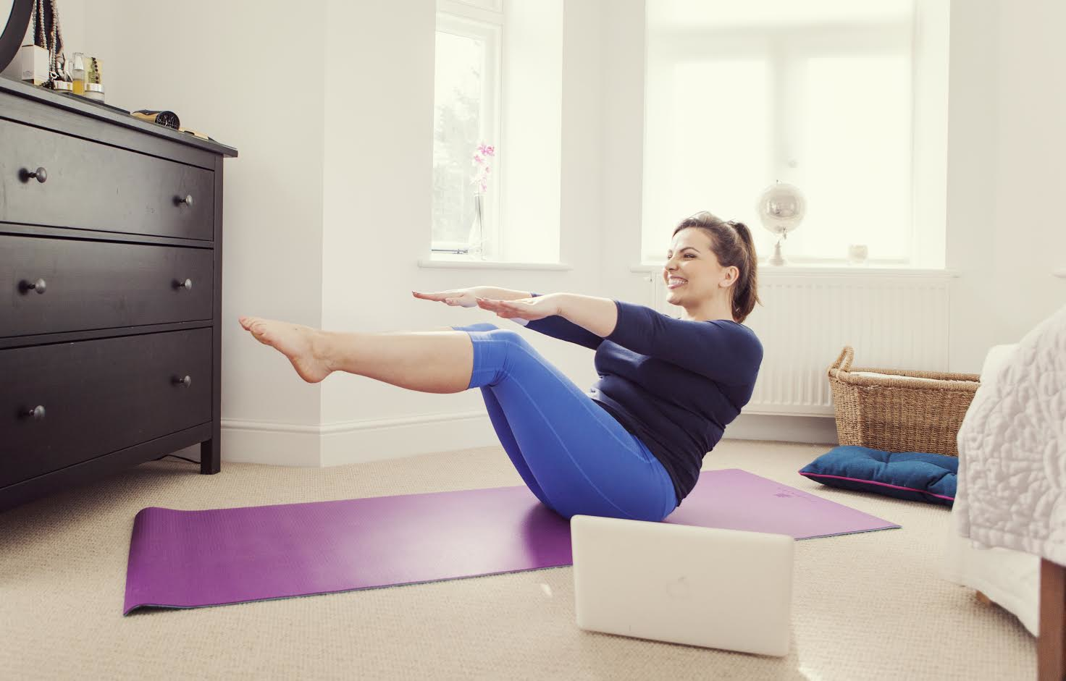

www.yoogaia.com

