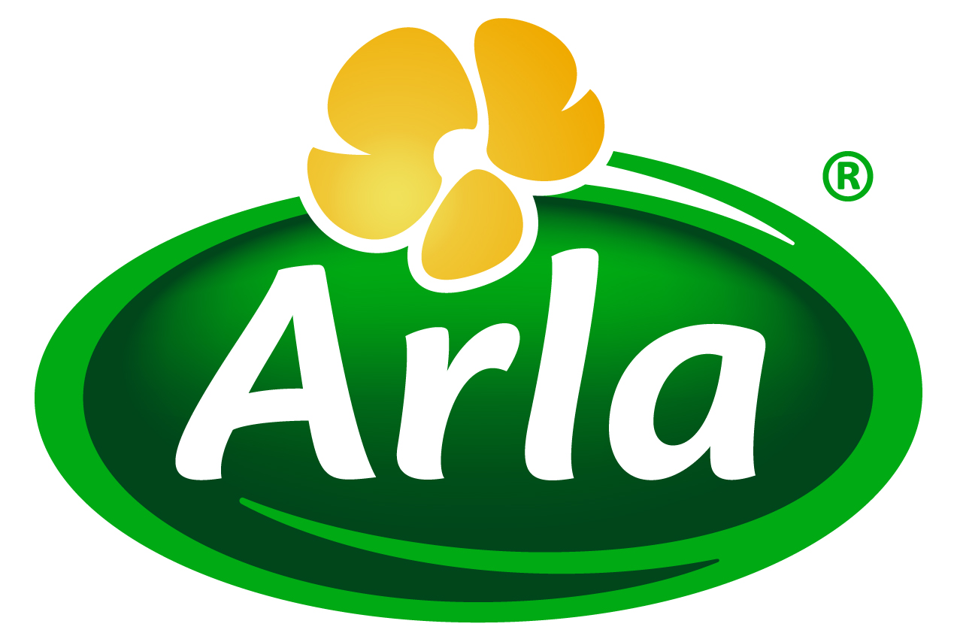


16 June 2016
PRESS RELEASE
CrossFit craze set to drive demand for
gold standard sports nutrition products

The growing popularity of CrossFit will boost the market for premium sports nutrition solutions that offer significantly faster recovery than mainstream products, according to Arla Foods Ingredients.

CrossFit involves daily workouts – known as ‘WODS’ (workouts of the day) – that are a combination of aerobic activity, weight-lifting and gymnastics. It can be followed as an exercise philosophy that is practised in more than 10,000 affiliated gyms worldwide, half of which are in the US. Its methodology is also used by fire departments, law enforcement agencies and military organisations.

However, in addition it is increasingly popular as a competitive sport. The CrossFit Games have now been held every summer since 2007, and are a serious business. There were 273,000 entrants in the 2015 event, competing for a total prize pot of $2 million – with $275,000 going to each of the winners in the male and female categories.

Because of the frequency and intensity of exercise involved in CrossFit, great demands are placed on the muscles. As a result, Arla Foods Ingredients predicts that participants will increasingly seek out sports nutrition products that enable them to recover fast enough to maintain the intensity of their WODS day after day.

In turn this will drive demand for premium sports nutrition ingredients, such as Arla Foods Ingredients’ Lacprodan® HYDRO.365. This is a gold standard whey protein hydrolysate that is absorbed rapidly by the body, which means it gets to work on helping muscles recover more quickly after intense exercise.

There is a growing body of scientific evidence demonstrating that whey proteins such as HYDRO.365 can enhance recovery after performing the type of exercises commonly carried out in CrossFit. In recent studies, it was found that supplementation with whey protein hydrolysate after resistance training resulted in increased muscle and tendon growth and stimulated the muscle stem cells (satellite cells) that are essential in the repair and maintenance of muscle. In another study, researchers found that supplementation with whey protein helped to maintain muscle strength following the type of exercise that causes muscle damage.

Peter Schouw Andersen, Head of Science & Sales Development at Arla Foods Ingredients, said: “CrossFit is a fun, exciting and varied approach to exercise but it also places great demands on the body. Ideally it should be practised daily, so it means there is only a small window for muscle recovery between WODs. HYDRO.365 helps reduce muscle recovery times from days to hours, supporting people in their efforts to stay in perfect shape to maintain their CrossFit regime.”

To help communicate the benefits of HYDRO.365 to CrossFitters, Arla Foods Ingredients has appointed a new brand ambassador, Filip Yang Fisker, who is one of the rising stars of the competitive CrossFit scene. Danish-born Filip, 25, has participated in CrossFit for seven years, three of them competitively. He specialises in snatch, clean & jerk and handstands, and is an expert in heavy barbell work.

Filip said: “To succeed in CrossFit competitions I need to train hard every day, which means fast recovery is a priority. With its rapid absorption, HYDRO.365 whey protein hydrolysate provides the maximum opportunity for my muscles to recover between sessions, helping me to perform at my best.”

ENDS

For more information, please contact:
Richard Clarke, Ingredient Communications
Tel: +44 7766 256176 Email: richard@ingredientcommunications.com
Twitter: @ingredientcomms

About Arla Foods Ingredients
Quality starts here: Arla Foods Ingredients is a global leader in natural whey ingredients for products in a range of categories – from sports, clinical and infant nutrition to beverages, bakery, dairy and ice cream.
The cornerstones of our business are innovative ingredients, world-class facilities and a staff of dedicated experts. Drawing on our portfolio of functional and nutritional whey proteins, milk minerals, lactose and permeate, our expert team delivers solutions that bring new food products quickly and efficiently to market. Our application centres run hundreds of customer product trials every week. All ingredients are produced using state-of-the-art processing technology at our plant in Denmark, or by one of our joint ventures in Argentina, Germany and the UK.
Arla Foods Ingredients Group P/S is a 100% owned subsidiary of Arla Foods, a global dairy company and cooperative owned by dairy farmers in Denmark, Sweden, the UK, Germany, the Netherlands, Belgium and Luxemburg.

RSS Feed
Visit our website at http://www.mynewsdesk.com/arla-foods-ingredients and sign up to our News RSS feed for all the latest developments – updated regularly.

Twitter
Follow us on twitter for all the latest updates @ArlaIngredients

LinkedIn
http://www.linkedin.com/company/arla-foods-ingredients

Farup et al., Scand J Med Sci Sports 2014, 24: 788–798. ’ Whey protein hydrolysate augments tendon and muscle hypertrophy independent of resistance exercise contraction mode’
Farup et al., Amino Acids Amino Acids 2014, 46:2503–2516. ‘Whey protein supplementation accelerates satellite cell proliferation during recovery from eccentric exercise’
Cooke et al., Journal of the International Society of Sports Nutrition 2010, 7:30. ‘Whey protein isolate attenuates strength decline after eccentrically-induced muscle damage in healthy individuals’.

