Brorsoft Video Converter released with CUDA support
Brorsoft Video Converter has recently taken full advantages of NVIDIA CUDA technology
that enables to accelerate video conversion process by many times dramatically.

Chris, China, July 11, 2011- Brorsoft Video Converter has recently integrated CUDA technology.
CUDA is NVIDIA's parallel computing architecture. It enables dramatic increases in computing
performance by harnessing the power of the GPU. As a result, it allows users to finish converting
task at a speed of 5x faster compared with other similar converting tools without CUDA technology. The CUDA acceleration has been tested and proved to work great even with older and
slower CPUs.

Brorsoft Video Converter features much higher conversion speed and significant gains in performance due to CUDA technology. Thus, Brorsoft Video Converter with the best video conversion software and updated CUDA technology meets with most of the needs of customers and provides customers with high availability.

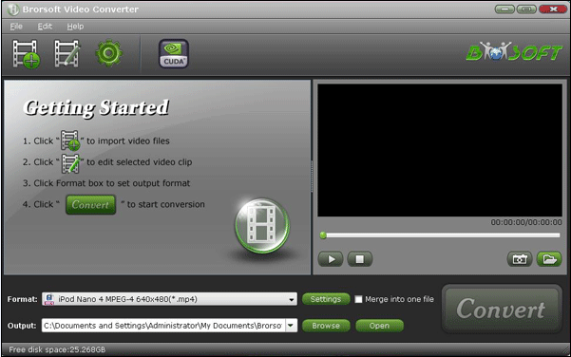

Moreover, Brorsoft Video Converter has other key features. Brorsoft Video Converter is specially developed for users to convert among various video and audio formats. The users are able to convert Tivo recordings, common video files like MKV,VOB,WMV, AVI,F4V, etc. and AVCHD, MTS/M2TS, MOD, TOD, VRO, MOV videos shot by Sony, Canon, JVC, Panasonic, Nikon camcorders or DSLR cameras. The output files created by Brorsoft Video Converter are compatible with lots of popular devices, media players and video editing programs, including iPad/iPad 2, Motorola Xoom, Dell Streak, Galaxy Tab, iPhone 4, Motorola ,Droid X/2, HTC Desire/EVO 4G, Apple TV, WD TV, Windows Movie Maker, Adobe Premiere, Sony Vegas, Avid, Ulead VideoStudio Plus, Pinnacle Studio, CyberLink PowerDirector, VLC Media Player, MPCHC, etc.

Working as a video editor, Brorsoft Video Converter also offers several simple but useful video editing options, like cropping video size, merging several videos into one file, trimming video clips and setting special effects.

Brorsoft Video Converter features much higher conversion speed and significant gains in performance due to CUDA technology. Thus, Brorsoft Video Converter with the best video conversion software and updated CUDA technology meets with most of the needs of customers and provides customers with high availability.

System requirements:
Operating System: Windows XP/ Vista, Windows 7
Windows Home Sever
DirectX Version: 9.0 or above
Memory: 64MB at least
Processor: Intel Pentium 3 processor at 500 MHz
Hard Disc Space: 512 MB or above

Price and Availability:
The price of Brorsoft Video Converter is $35. It is free of charge for future upgrade.

About company:
Brorsoft Company is a professional multimedia software provider for personal entertainment and public entertainment with the brilliant conversion products which can convert Blu-ray, DVDs and Videos to numerous video and audio formats for most popular portable devices such as iPad, iPhone 4, Apple TV, PS3, Xbox 360, WD TV, Android Phones including Motorola Droid X2, Samsung Galaxy S2, HTC EVO 4G, etc. and other video and audio players. Besides, Brorsoft stuio are constantly trying to provide all users the best products and best service.

Contact Information:
Name: Florence Brorsoft
Address: Suzhou Industrial Park, Linglong Street, Suzhou, China
Zip code: 2150000
E-mail: pr@brorsoft.com
Tell: 86-0512-50358826
Website: http://www.brorsoft.com/

