Bäckman ready for GT4 European Series at Hockenheim
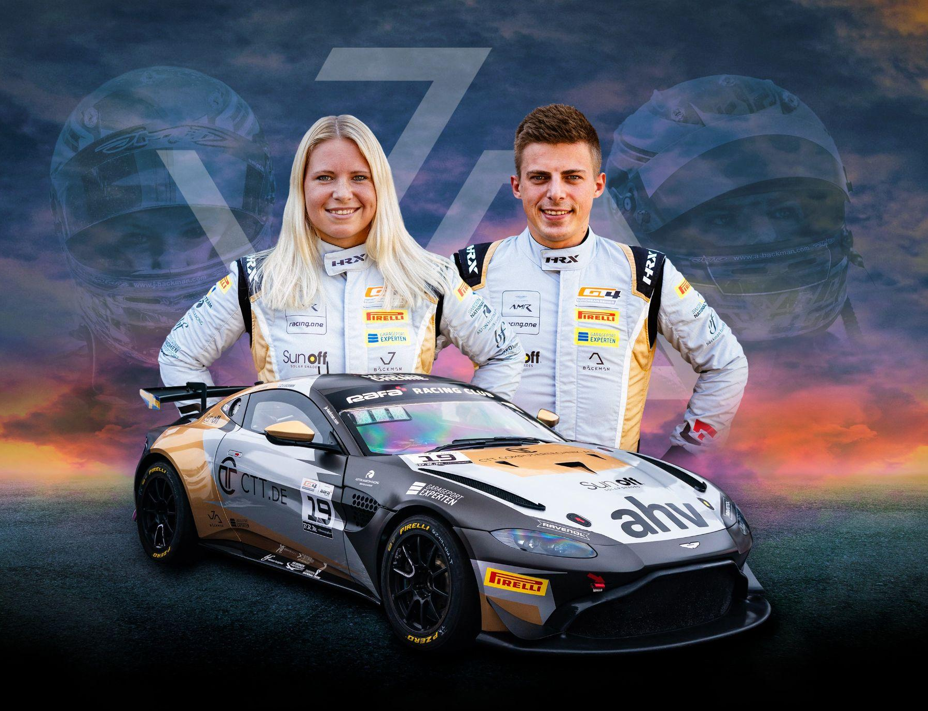
Andreas and Jessica Bäckman are ready for the fifth round of the GT4 European Series in Hockenheim, Germany in their Aston Martin AMR Vantage GT4.
Photo: Private (Free rights to use the image)
Next weekend, August 31st-September 3rd, it's time for Andreas and Jessica Bäckman to take on the Hockenheimring track in Germany after the long summer break. It's the fifth round of the GT4 European Series where the siblings are hungry for revenge after the previous messy races.
- Hockenheim is one of my favourite tracks and I have many good memories from there. It will be fun to compete again and I hope we can find some speed for this weekend so we can fight for the top positions, Jessica Bäckman says.
This weekend, August 31st-September 3rd, it's time for the fifth round of the GT4 European Series at the Hockenheimring track in Germany, which will be the siblings' sixth race together in GT4.
- It will be fun and exciting to race again after the long summer break, we have both raced a lot at the Hockenheim track so it will be fun to try it in a GT4. We are hungry for revenge and will give everything we have against this weekend's 47-car strong grid, Andreas Bäckman says.
The structure of the GT4 European Series
The GT4 European Series consists of six races around Europe. The series is considered one of the toughest GT4 series in the world and has a high status among the drivers who come from several different countries around Europe. The start of the season went on the well-known Monza circuit in Italy, which is also called "The Temple of Speed" and will end on the well-known Formula 1 circuit Barcelona in Spain. In addition to Barcelona and Monza, the world-famous Formula 1 tracks Spa, Paul Ricard and Hockenheim where Bäckman will drive this weekend will also be on the 2023 calendar.

Each competition consists of two free practice sessions, two time qualifying’s and two races of 60 minutes each where drivers are changed halfway through the race. Points are awarded to the fastest cars in the time qualifying’s and the top 10 in each race. The drivers in the car with the most points after the final race at Barcelona will take home the driver's title together "GT4 European Series Drivers Title" in the GT4 European Series.
Time schedule for this weekend’s races (GT4 European Series Round 5):
(all times in CEST)
Friday September 1st:
12:10 Free Practice 1 (60 min) – LIVETIMING
17:00 Free Practice 2 (60 min) – LIVETIMING
Saturday September 2nd:
11:10 Q1/Q2 – Qualifying 1 & 2 (2 x 20 min) - LIVE TV QUALIFYING
16:55 Race 1 (60 min) – driver change in the middle of the race - LIVE TV RACE 1
Sunday September 3rd:
11:35 Race 2 (60 min) – driver change in the middle of the race - LIVE TV RACE 2

About the track (Hockenheimring):
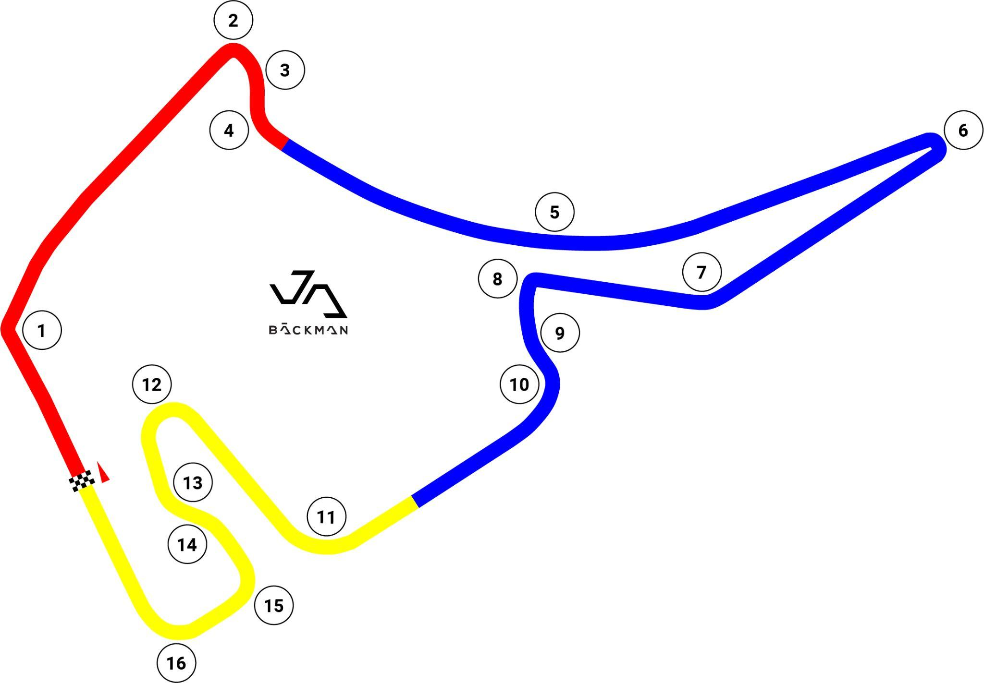
Location: Hockenheim, Germany
Length: 4,574 km
Corners: 16

GT4 Europe Calendar 2023:
April 22nd-23rd - Monza, Italy
June 2nd-4th - Paul Ricard, France
June 29th-July 2nd - Spa, Belgium
July 14th-16th - Misano, Italy
September 1st-3rd - Hockenheim, Germany
September 29th-October 1st - Barcelona, Spain

Free rights to use the images.
Download press-photos here:
http://bit.ly/jabaeckman-photos
https://www.mynewsdesk.com/se/ja-backman/images

