Press Update
April 2021
April 2021 - Prime Gaming Monthly Update
Welcome to the April Prime Gaming press update! Prime Gaming is leaping into Spring with a diverse library of games and content for top titles, including:

- Exclusive content for Fall Guys: Ultimate Knockout
- New content for popular Ubisoft titles including Rainbow Six Siege and For Honor
- The April Games with Prime lineup, featuring Move or Die and Aces of the Luftwaffe – Squadron

All of these offers can be claimed by visiting: gaming.amazon.com. As always, Prime Gaming offers are available for a limited time, so be sure to act fast before they disappear!

Read on below for a look at all of the great content and games coming in April, including a brand new Prime Gaming sizzle highlighting the biggest offers of the month.

Information on this month’s lineup, as well as the latest and greatest Prime Gaming news can be found on the Prime Gaming blog, and assets can be downloaded here.

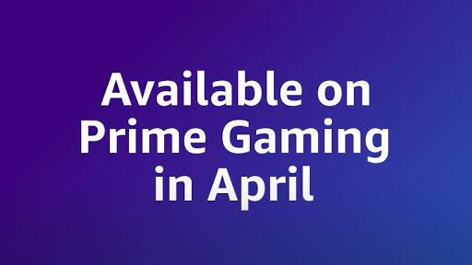
A Look Into Prime Gaming’s April 2021 Offerings
Welcome the newest addition to the Prime Gaming monthly update - a sizzle highlighting some of the most exciting offerings available to Prime members this month! April’s content includes a new selection of Games with Prime, and in-game content for Rainbow Siege Six, For Honor, League of Legends, GTA Online and more. Check out our newly released video here.
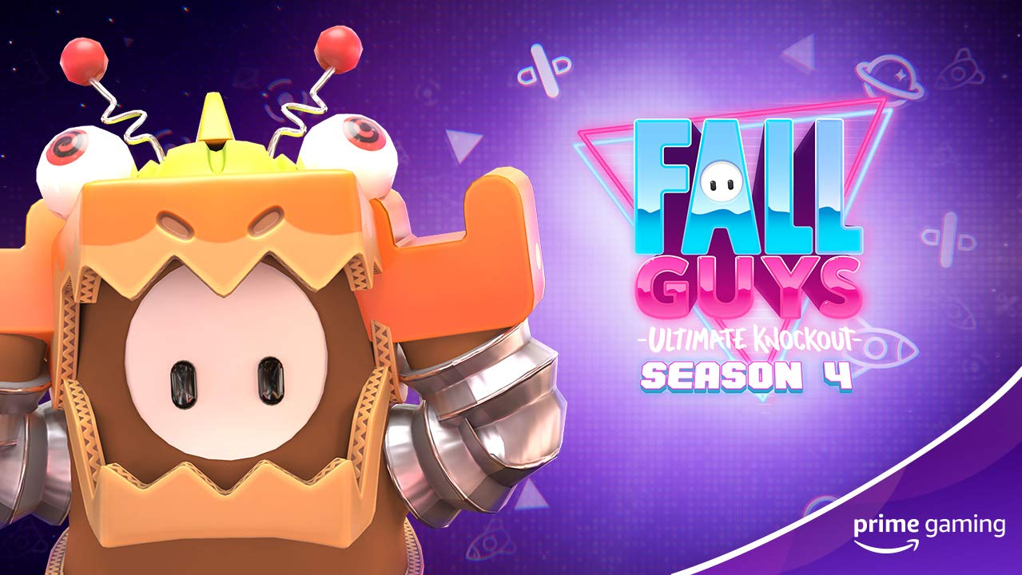
Grab the Latest Fall Guys Bundle with Prime Gaming
Available March 25 at 9am PT Just in time for season 4, Prime Gaming is offering Prime members an exclusive Boxzilla Bundle to help celebrate the success of the hit party game Fall Guys: Ultimate Knockout! Appropriately themed for season 4, the bundle includes:
- An adorable Boxzilla Costume
- 6500 Kudos, to help players fast-track their way to the next in-game goodie
Be sure to grab the bundle before it’s too late, and stay tuned for more coming soon!
Drop 4 of 6
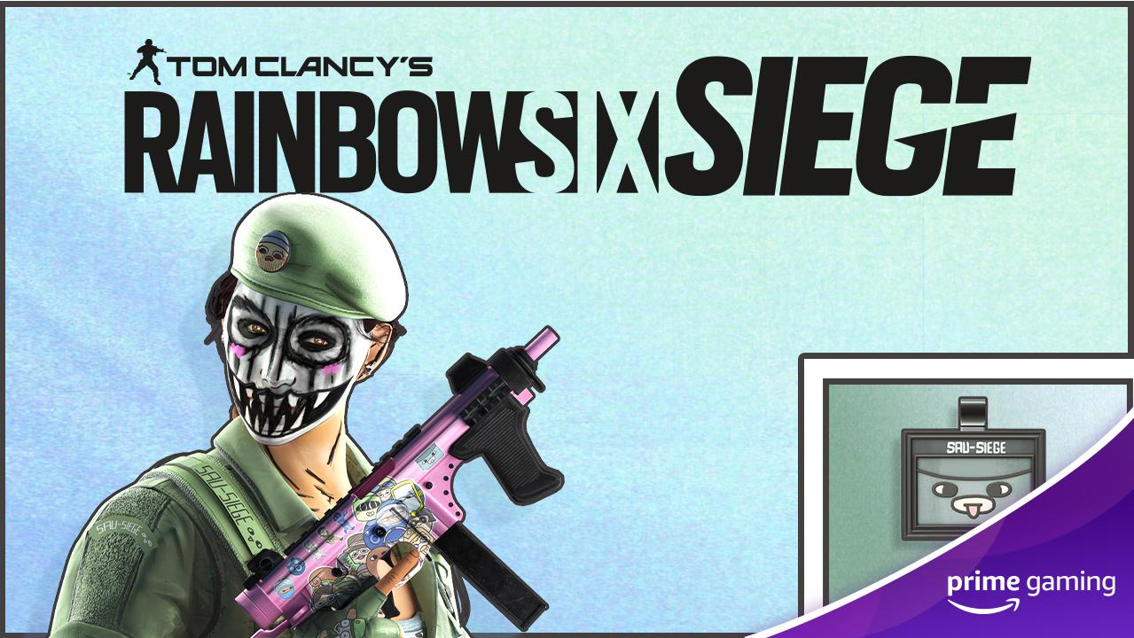
Spring Into Exclusive Loot Available in Rainbow Siege Six
Available Now April brings special loot for Ubisoft’s online tactical shooter video game. Secure the exclusive Caveira Bundle designed by community artist SAU_SIEGE, including new headgear, uniform, weapon skin and charm.
Drop 4 of 4
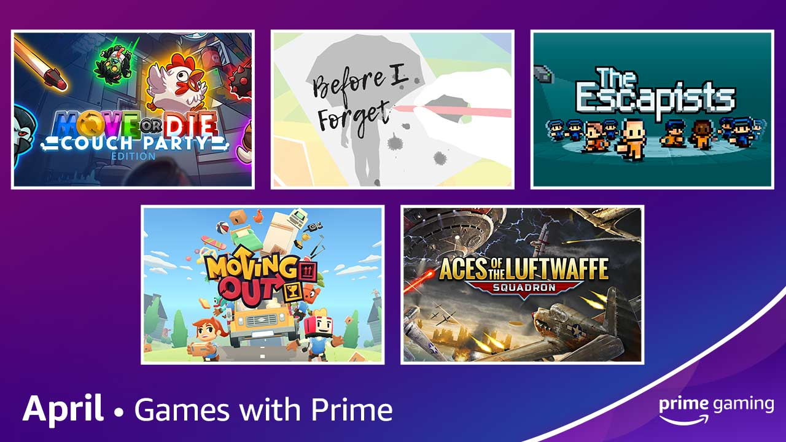
Celebrate Spring with More Games!
Add games including Aces of the Luftwaffe – Squadron and Moving Out to your library
Available April 1 Prime Gaming is adding FIVE games to our library beginning April 1! The lineup includes something for everyone, ranging from mystery and romance in Before I Forget to the prison-escape thriller The Escapists.
- Move or Die - Couch Party Edition - Enjoy this absurdly fast-paced, 4-player local and online party game where the mechanics change every 20 seconds.
- The Escapists - Explore in this unique prison sandbox experience, with lots of items to craft and combine in your daring quest for freedom.
- Moving Out - Indulge in the ridiculous physics-based moving simulator that brings new meaning to "couch co-op."
- Aces of the Luftwaffe – Squadron - Face fearsome war machines in bombastic air battles and boss fights in this vertically scrolling shoot ‘em up game.
- Before I Forget - Explore the present to uncover the past in a short story of love, loss, and a life well-lived in this emotional narrative exploration game.
We rotate our collection to keep titles fresh, so be sure to grab these games before they’re gone. As always, all games are yours to keep forever.
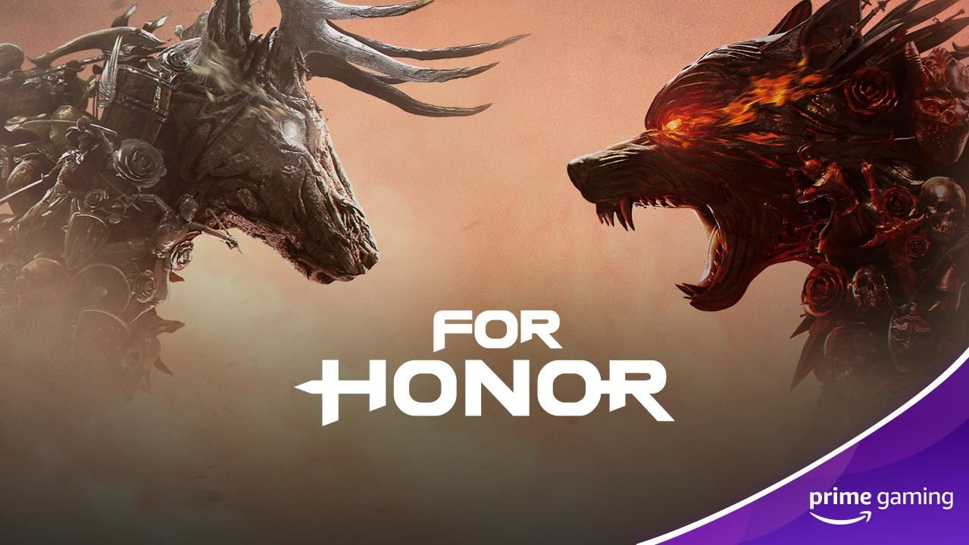
Claim A Week’s Worth of Champion Status in For Honor
Available Now Players can look forward to unlocking seven days of Champion Status, which includes XP boosts and more, as well as two Scavenger Crates. Take your heroes to the next level in For Honor, the melee action fighting game set during a medieval, fantasy setting, where the week’s worth of champion status is available until April 24!
Drop 1 of 1
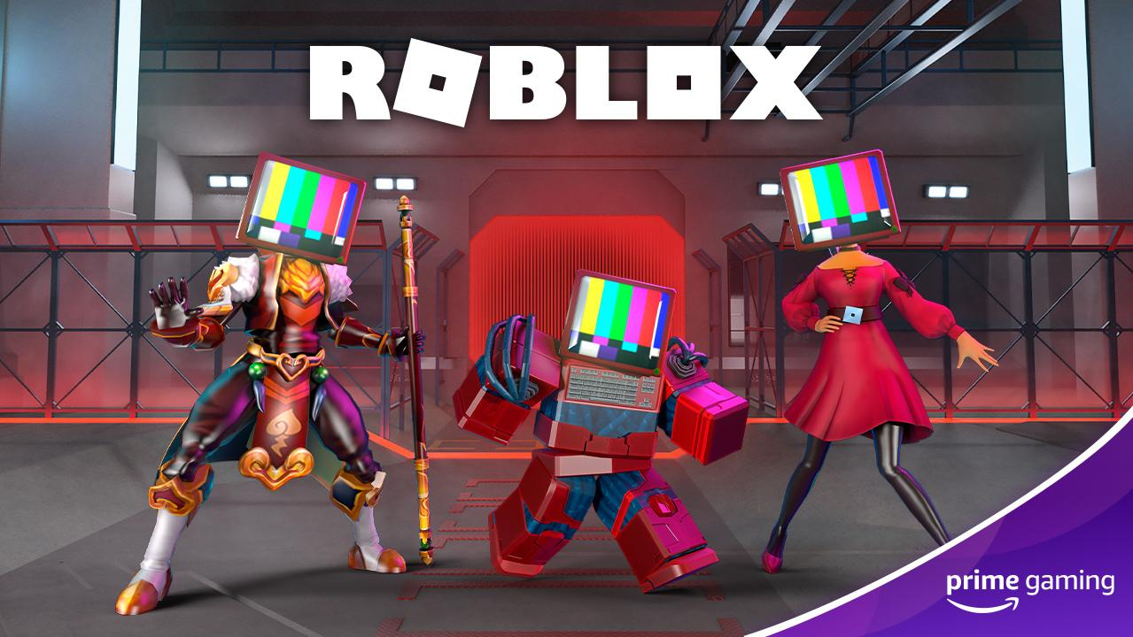 | 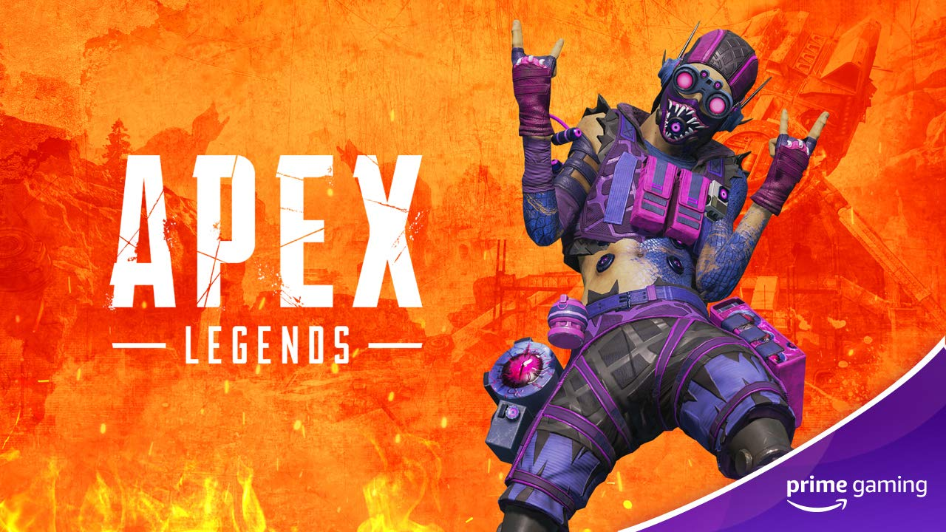 | 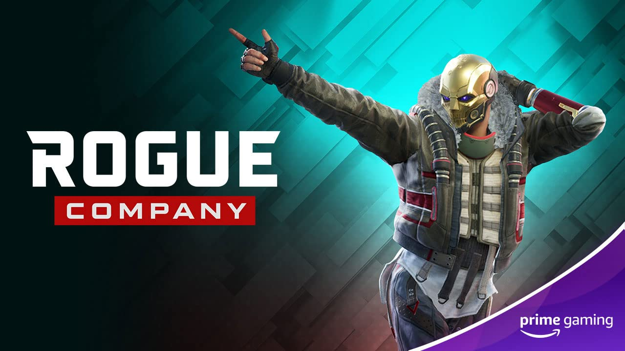
Roblox  Now Available  Prime members can gear up their Roblox avatar with a new Tech Head, and an exclusive bonus skin in Arsenal. Be sure to act fast as this offer expires on April 16!  Drop 8 of 8 | Apex Legends  Now Available  Show everyone what Legends are made of with the Adrenaline Affliction skin for Octane!  Drop 3 of 12 | Rogue Company  Now Available  Battle in style in the 4x4 team-based multiplayer shooter with the “The King” emote. Be sure to claim this offer before it expires on April 4!  Drop 6 of 12
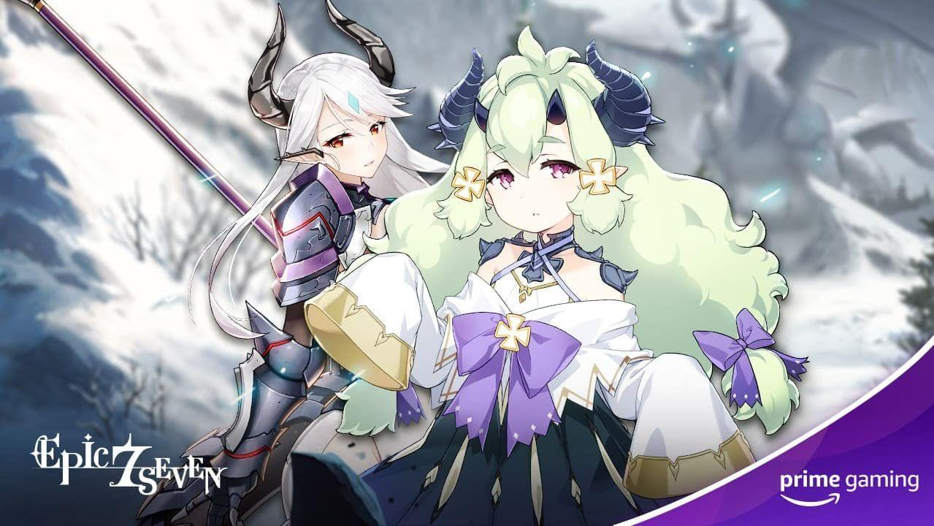 | 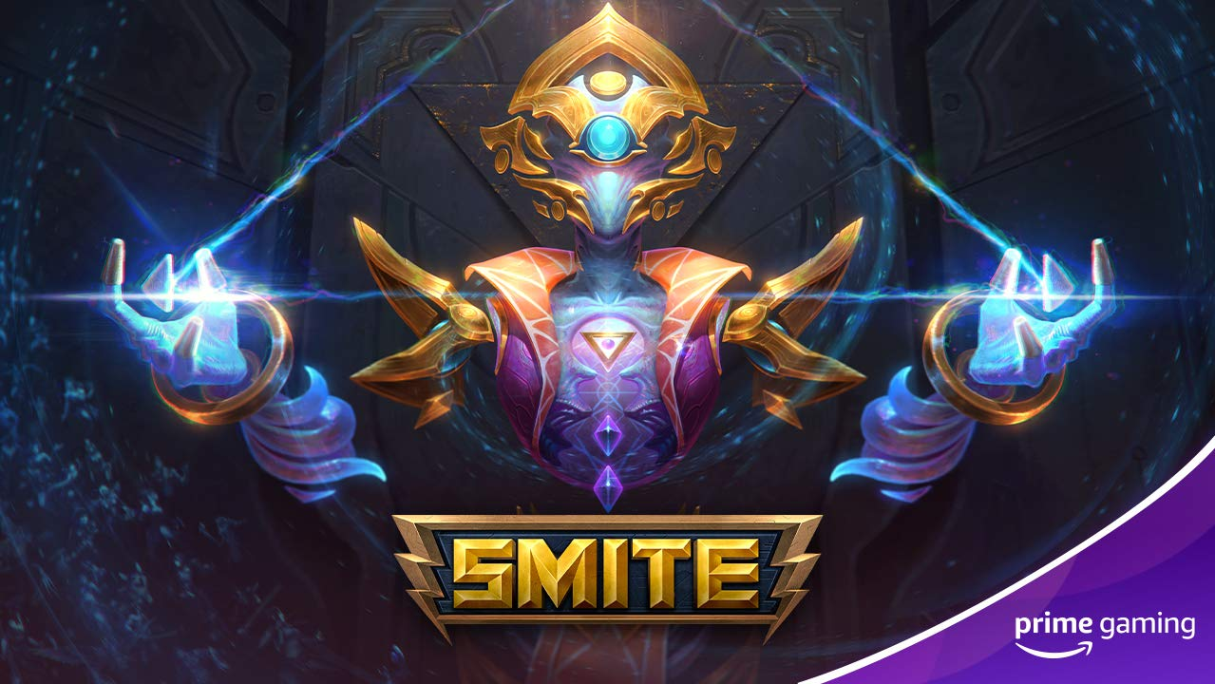 | 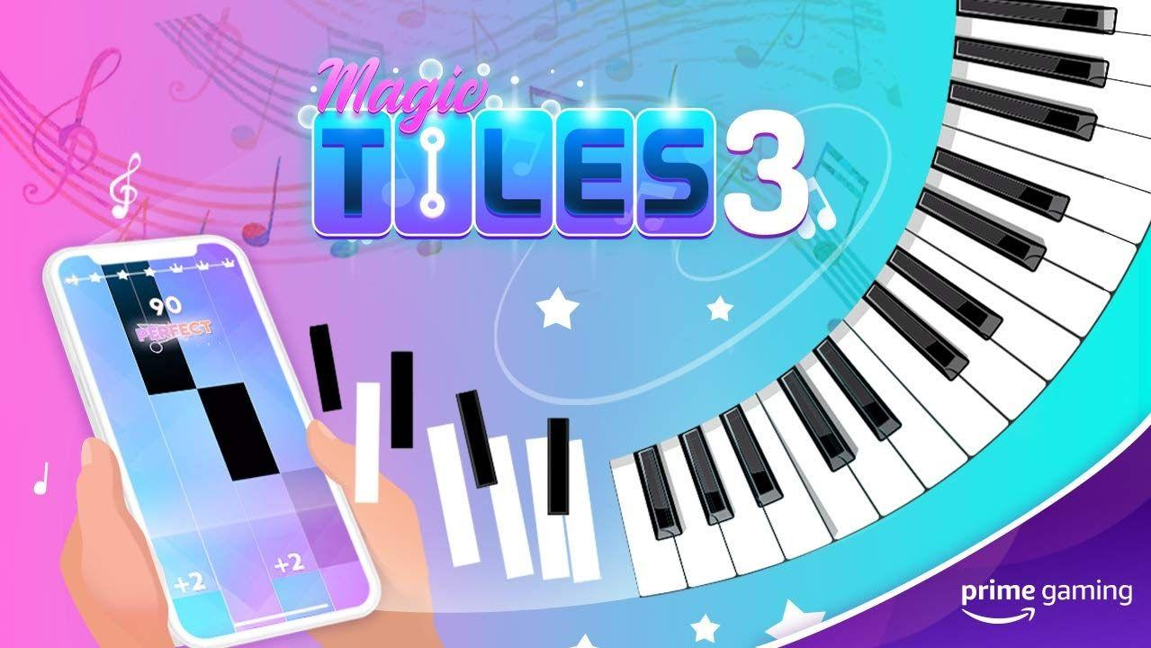
Epic Seven  Drop 4: Now Available  Drop 5: April 7  Drop 6: April 21  Help begin your journey with the help of:  Drop 4 - 20x Leif until April 7  Drop 5 - 1x Lvl 85 Epic Equipment Set (Speed, 4 parts, Excluding Accessories) through April 21  Drop 6 - Leif x 20 before May 5  Drop 4-6 of 18 | SMITE  Now Available  Be sure to claim the exclusive Infinite Seer Ah Puch skin in the free-to-play, third-person multiplayer online battle arena video game!  Drop 7 of 9 | Magic Tiles 3  Now Available  This month, players can unlock a one-Day VIP pass and five additional songs, every week!  Drop 17
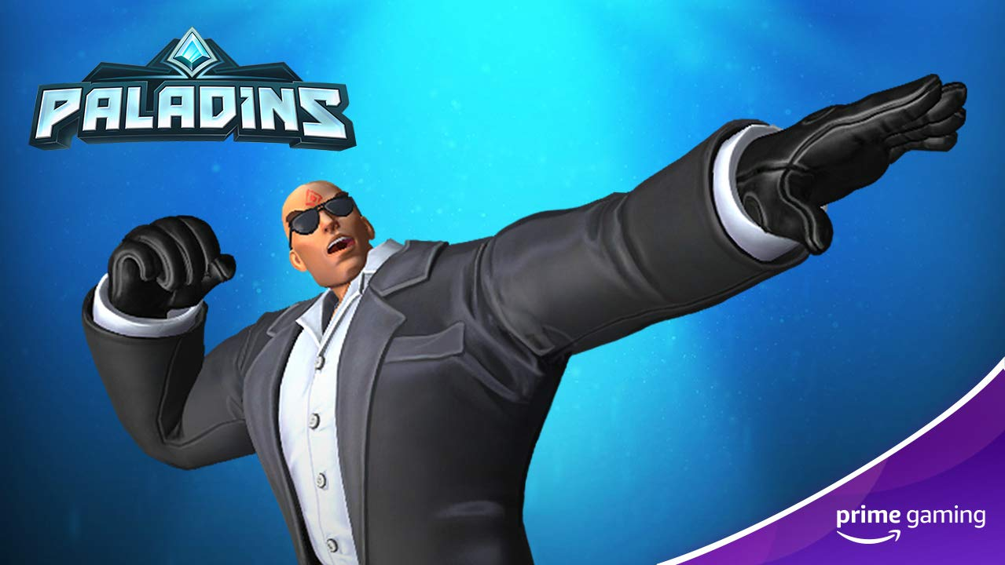 | 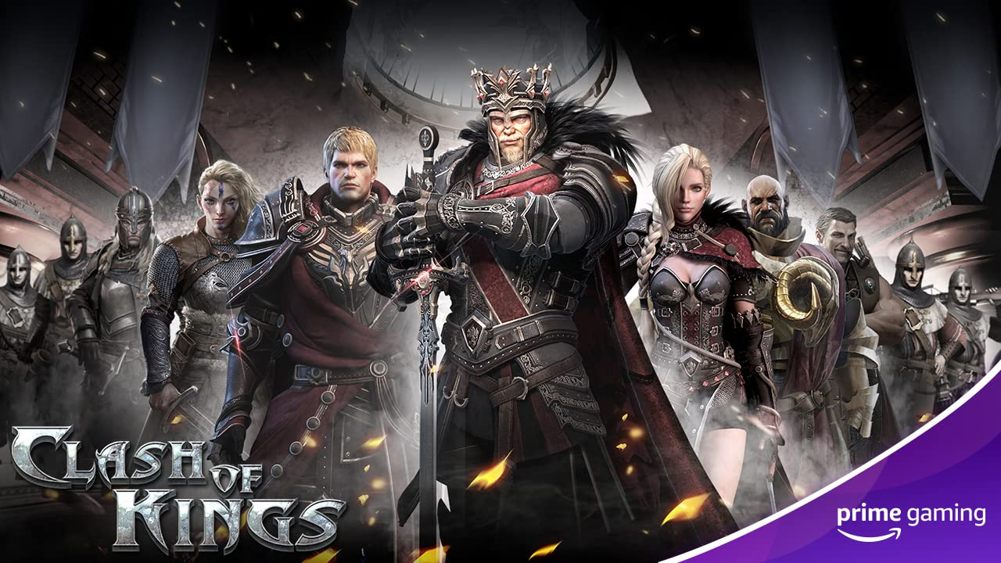 | 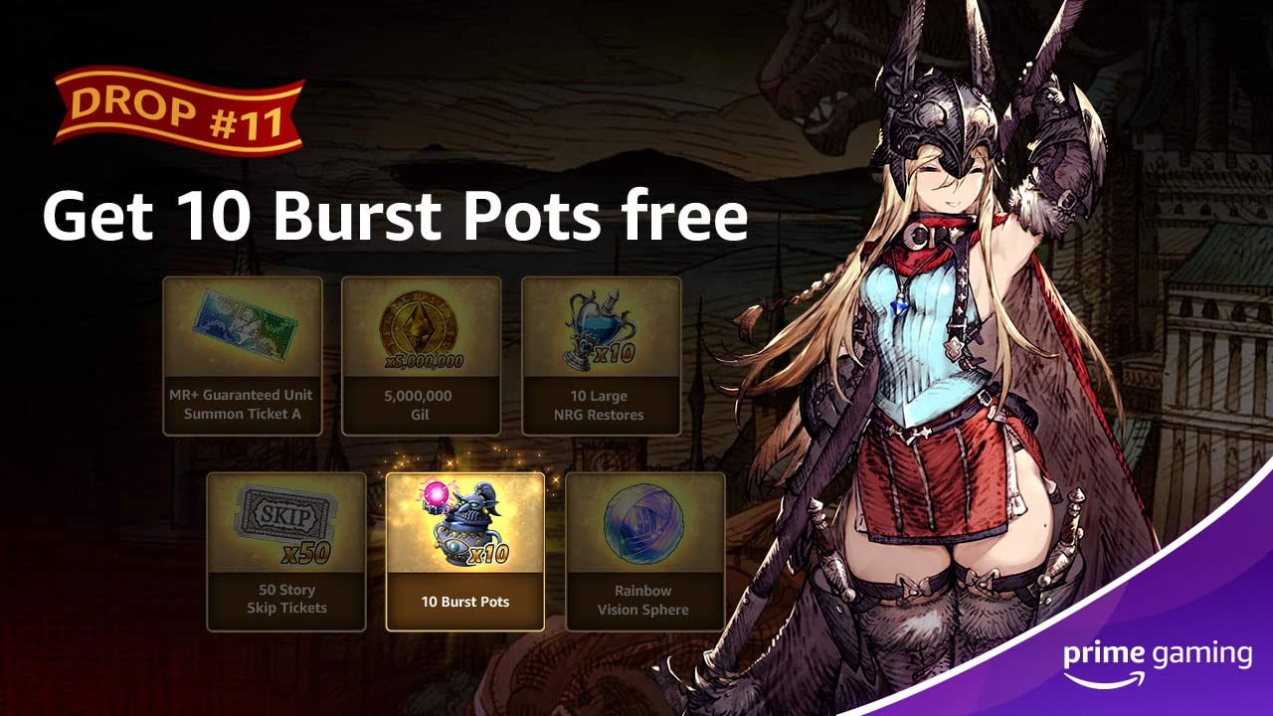
Paladins  Available April 29  Unlock the epic Triggerman Buck Skin in the popular online hero first-person shooter game!  Drop 7 of 9 | Clash of Kings  Available April 5  Pick up a Building Enhancement Pack which includes 2-Hour Building Speedup x1000, 500,000 Food x500 and500,000 Wood x500 though April 6!  Drop 1 of 13 | WAR OF THE VISIONS FINAL FANTASY BRAVE EXVIUS  Drop 11: April 14  Drop 12: April 28  Prime members can look forward to claiming Burst Pot x10 through April 28 and Rainbow Vision Sphere x1 until May 12 for WAR OF THE VISION FINAL FANTASY BRAVE EXVIUS.  Drop 11-12 of 12
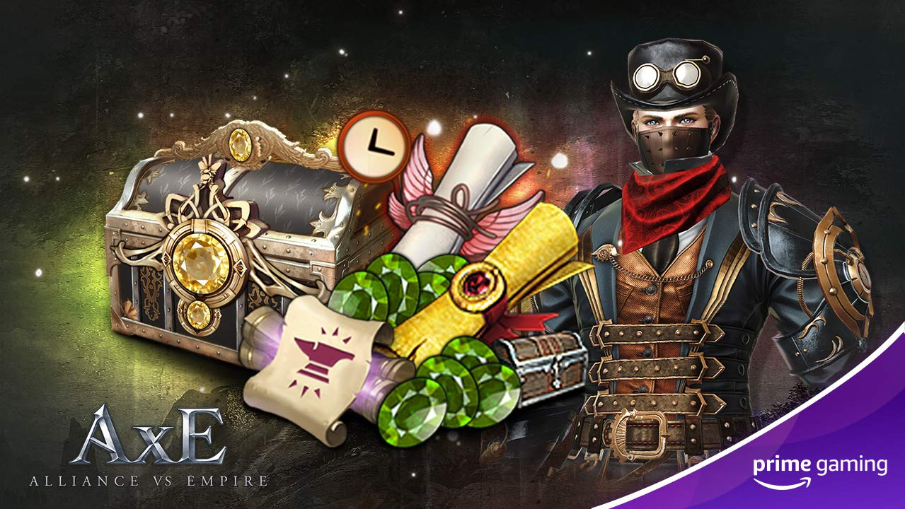 | 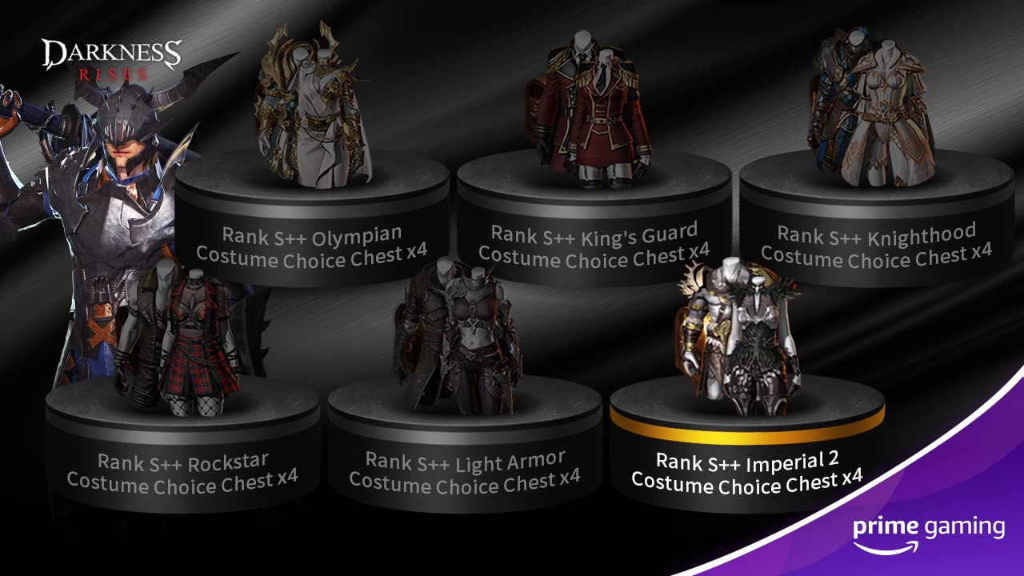 | 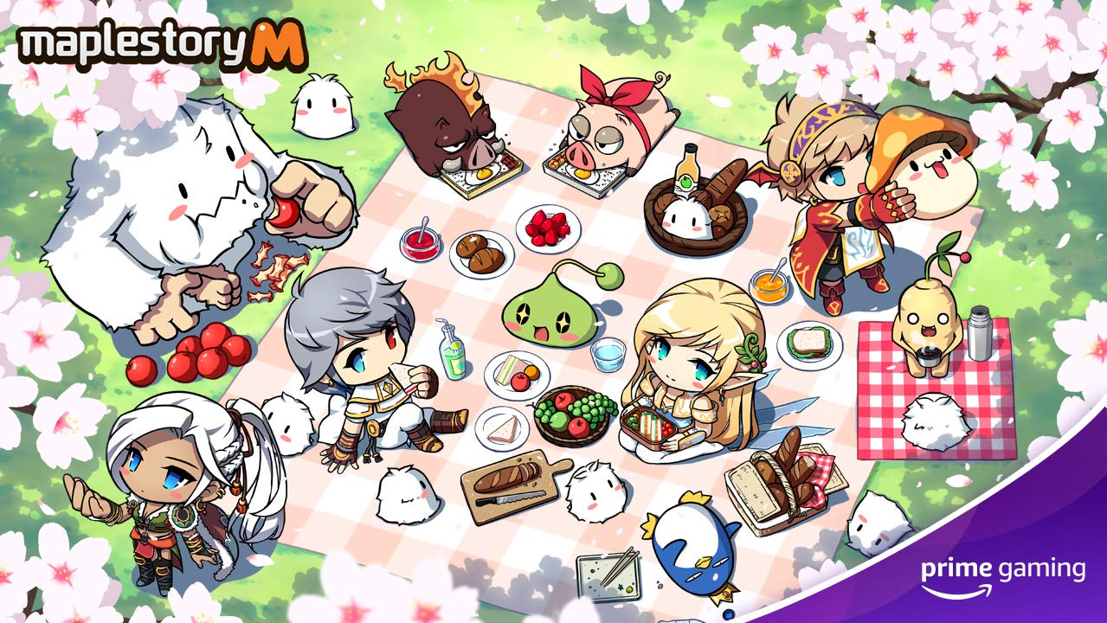
Alliance vs. Empire  Drop 4: April 14  Drop 5: April 28  April brings lots of Alliance vs. Empire content, including White Diamond x500, Enhancement Guard Ticket x50! On April 14, Prime Members can also also claim a Hero’s and Treasure’s blessing, and on April 28, players can claim a King’s Blessing and Benuv’s blessing.  Drop 4-5 of 12 | Darkness Rises  Drop 6: April 8  Drop 7: April 22  Players can look forward to redeeming the following items:  - Drop 6: Rank S++ Costume Choice Box x4: Imperial 2 Costumes  - Drop 7: Rank S++ Costume Choice Box x4: Olympian Costumes  Drop 6-7 of 12 | MapleStory M  Drop 5: April 7  Drop 6: April 21  Starting April 7 through April 21, Prime Members can claim the Cube box (Red Cube x10, Black Cube x5). Also starting on April 21, be sure to claim an Auto-Battle Charge Ticket (1 hour) x 10 this month!  Drop 5-6 of 12
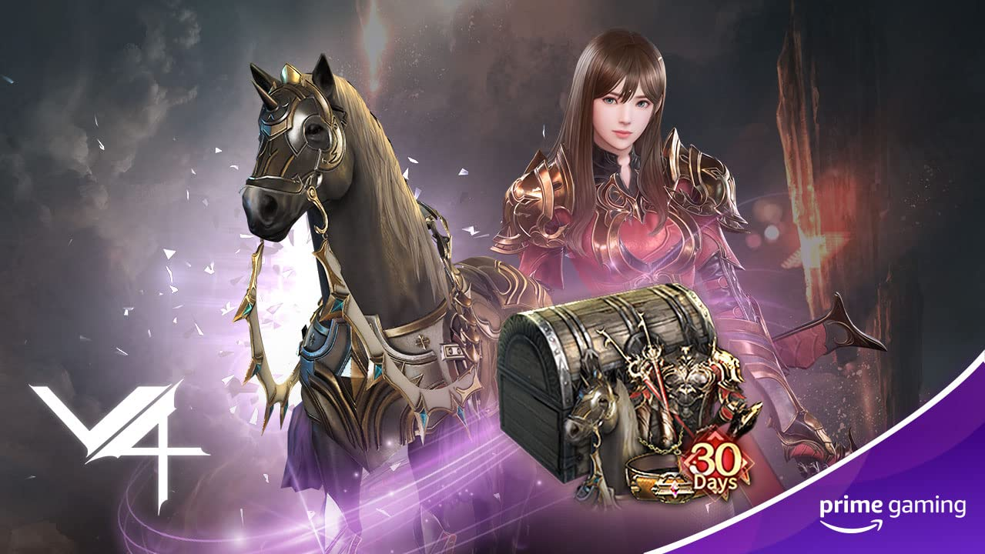 | 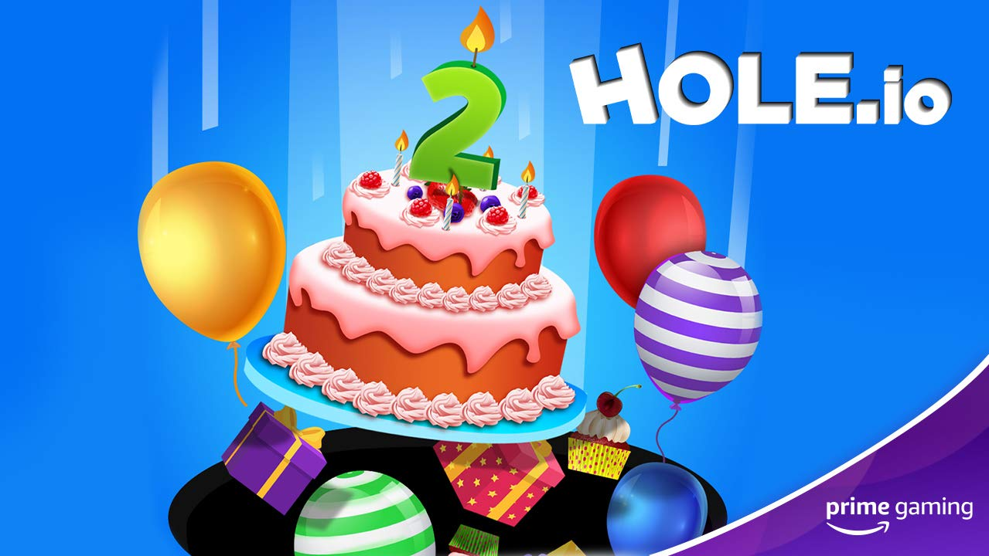 | 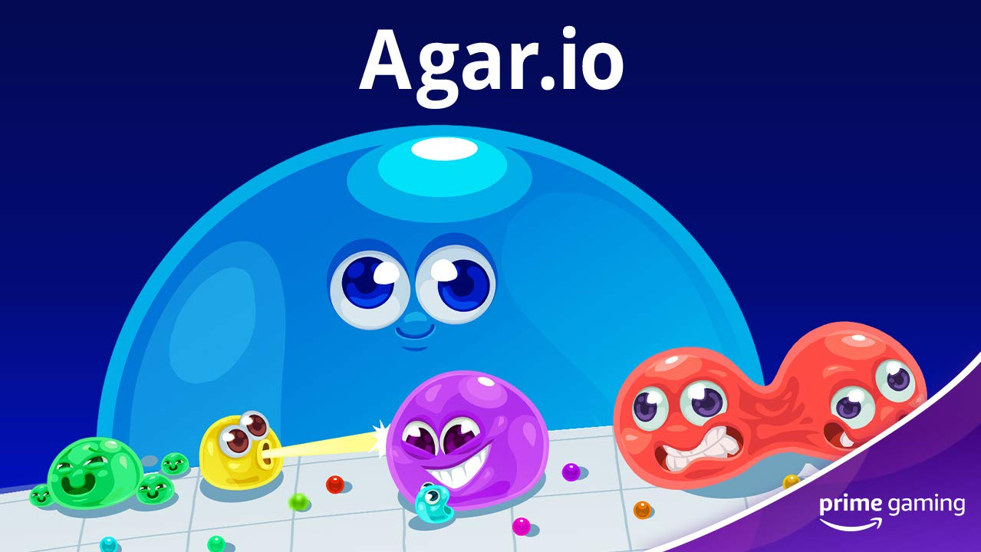
V4  Drop 2: April 1  Drop 3: April 15  Drop 4: April 29  All through the month of April, players can claim various Special Support Packages in Nexon’s cross-platform MMORPG for both PC and mobile devices.  Drop 2-4 of 12 | Voodoo mobile games  Enjoy ad-free play in some of Voodoo’s popular and addicting mobile titles.  - Available April 1 – 7 days of ad-free play in Hole.io  - Available April 5 – 7 ad-free days in Aquapark.io  - Available April 8 – 7 ad-free days for Cube Surfer  - Available April 15 – 14 days of ad-free play in Helix Jump | Agar.io  Now Available  Be sure to claim an Easter Potion + 150 DNA in the massively multiplayer online action game!  Drop 10 of 12
Calendar April 2021
Now Available Games With Prime - Move or Die Couch Party Edition, The Escapists, Moving Out, Aces of the Luftwaffe - Squadron, Before I Forget
Now Available Agar.io
Now Available Apex Legends Drop 3
Now Available Epic Seven Drop 4
Now Available Fall Guys Drop 4
Now Available For Honor Drop 1
Now Available Magic Tiles 3
Now Available Rainbow Six Siege Drop 4
Now Available Roblox Drop 8
Now Available Rogue Company Drop 6
Now Available SMITE Drop 7
Now Available WAR OF THE VISIONS FINAL FANTASY BRAVE EXVIUS Drop 11
March 29 Paladins Drop 7
March 31 Last Chance to Claim 20+ SNK Games
April 1 Last Chance to Claim Bomber Crew Deluxe, Blasphemous, SkyDrift, Boomerang Fu and Tengami
April 1 Hole.io Drop 3
April 1 V4 Drop 2
April 5 Aquapark.io Drop 5
April 5 Clash of Kings Drop 1
April 7 Epic Seven Drop 5
April 7 MapleStory M Drop 5
April 8 Cube Surfer! Drop 5
April 8 Darkness Rises Drop 6
April 14 Alliance vs Empire Drop 4
April 15 Helix Jump Drop 4
April 15 V4 Drop 3
April 21 Epic Seven Drop 6
April 21 MapleStory M Drop 6
April 22 Darkness Rises Drop 7
April 28 Alliance vs Empire Drop 5
April 28 WAR OF THE VISIONS FINAL FANTASY BRAVE EXVIUS Drop 12
April 29 V4 Drop 4
For the latest on content, offers and sweepstakes, follow Prime Gaming on the official Prime Gaming blog, Twitter, Facebook and Instagram.

About Prime Gaming

With Prime Gaming, Amazon Prime members enjoy tons of, exclusive content for their favorite PC, console, and mobile games. Plus, they can claim a collection of PC games for every month that are theirs to keep forever, and a monthly Twitch channel subscription. Prime Gaming’s selection of in-game content and PC games is always growing and rotating to stay fresh, with new items and games added every month.

This is in addition to the many other benefits available with Prime, including the best of shopping and entertainment from Amazon, including fast, free delivery, along with exclusive savings, early access to deals, Prime Day, and so much more. Members enjoy unlimited streaming access to a vast collection of TV shows, movies, sports and more with Prime Video, ad-free listening of 2 million songs plus thousands of stations and playlists with Amazon Music, unlimited access to a rotating selection of more than 1,000 books and magazines with Prime Reading, and unlimited photo storage with Amazon Photos.

