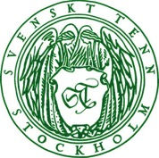
Press Release
Stockholm, November 17, 2016

Svenskt Tenn’s Christmas market opens with new seasonal collection

The annual, abounding Christmas market is now open at Svenskt Tenn. Scents of carnation and cinnamon flow from the Tea Room, and on the tables in the store gallery, a collection of Christmas ornaments for the new season designed by Carina Seth Andersson and Jakob Solgren, is showcased together with Christmas gifts by Eric Ericson, Josef Frank and Eva Schildt.

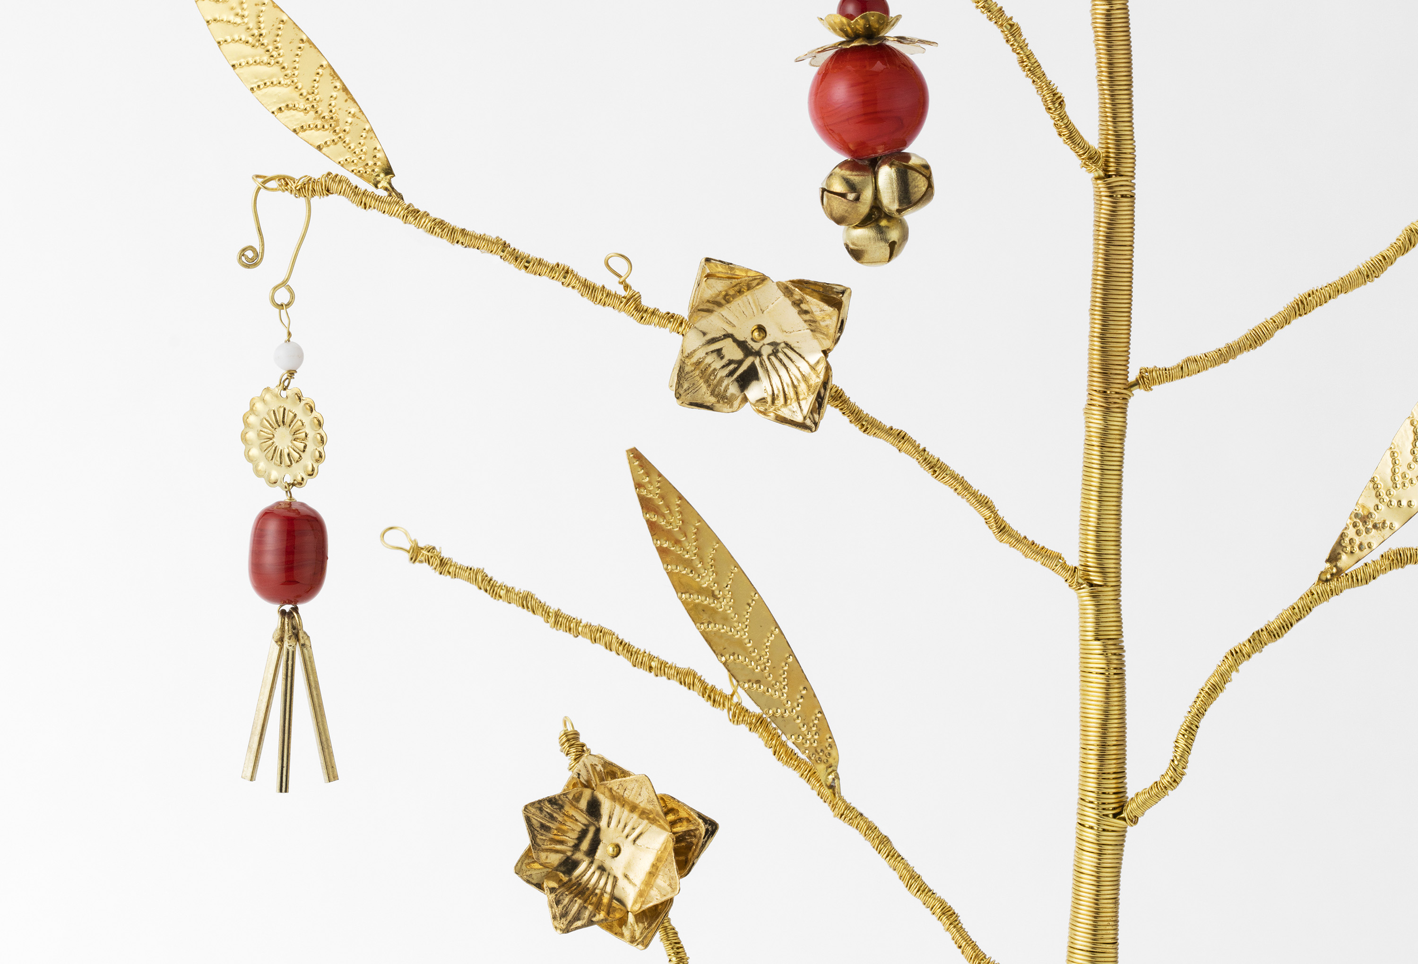
On her visits to places all over the world, Svenskt Tenn’s founder Estrid Ericson was always looking for beautiful objects and textiles to bring home and offer at the store in Stockholm. Her tireless travelling and encounters with different cultures became a source of inspiration for the designers as they worked on this season’s Christmas ornament collection for Svenskt Tenn.

”We wanted to offer a contrast to the big, glittery red decorations which have been in fashion over the past few years,” says Carina Seth Andersson, who has created the new collection together with Jakob Solgren.

The centerpiece of the collection is the ”Tree of Wishes” made of brass. The tree is accompanied by six small pendants, and for each pendant that is attached to the tree, you are entitled to make a wish. The Tree of Wishes will remain in Svenskt Tenn’s range, with the thought that the pendants may become collectibles.

Christmas gift seekers will also be rewarded with news aplenty, for instance the Eric Ericson design “Horse of Spades”, an ingenious deck of cards housed in a sturdy pewter case, or the flower-stand “Hortus” by Josef Frank, which is now reintroduced in green and clear glass. Since earlier production of this item ceased, it has regularly appeared at quality auctions, and now it is positively returning. Those who look for something more sizeable to place under the Christmas tree may discover the new “Vienna” carpet. Eva Schildt has used the classic Svenskt Tenn carpet ”Schackruta” (designed by Margit Thorén in the 1940s) as a model when making her own variant using colors from Josef Frank’s textile pattern ”Aralia”.

For further information, please contact:

Vicky Nordh, Marketing Assistant: +46 8-670 16 23 or vicky.nordh@svenskttenn.se

Thommy Bindefeld, Marketing Director: +46 8 670 16 02 or thommy.bindefeld@svenskttenn.se

Images can be downloaded from svenskttennpress.se. Username: Press. Password: Tenn

Svenskt Tenn is an interior design company with retail stores at Strandvägen in Stockholm and online. Since 1975, Svenskt Tenn is owned by the Kjell and Märta Beijer Foundation, which provides research grants within ecology, medicine and the preservation of Swedish interior design tradition.

