FOR IMMEDIATE RELEASE
Contact: Madeline Loucas
Phone: (410) 821-8220
E-mail: madelinel@imre.com

STANLEY Introduces 2018 STANLEY® FATMAX® Tape Measure
2018 STANLEY® FATMAX® delivers Performance You Can Measure™

NEW BRITAIN, CT (May 31, 2018) – STANLEY today announced the introduction of its longest-lasting, most ergonomic FATMAX tape measure in its 175-year history.

2018 STANLEY® FATMAX® Tape Measure  - A new design with 13-feet of straighter blade stand out and the longest-lasting blade coating ever applied to a FATMAX tape measure.  - An impact-resistant ABS plastic case tough enough to withstand a 50-foot drop onto packed soil.  - Ergonomically-designed case to simulate a baseball-style grip for a great fit, grip and comfort in a user’s hand.  - The 2018 STANLEY FATMAX (FMHT36325) is made in the USA with global materials and became available in 25-foot length in March 2018 in North America where STANLEY products are sold. | 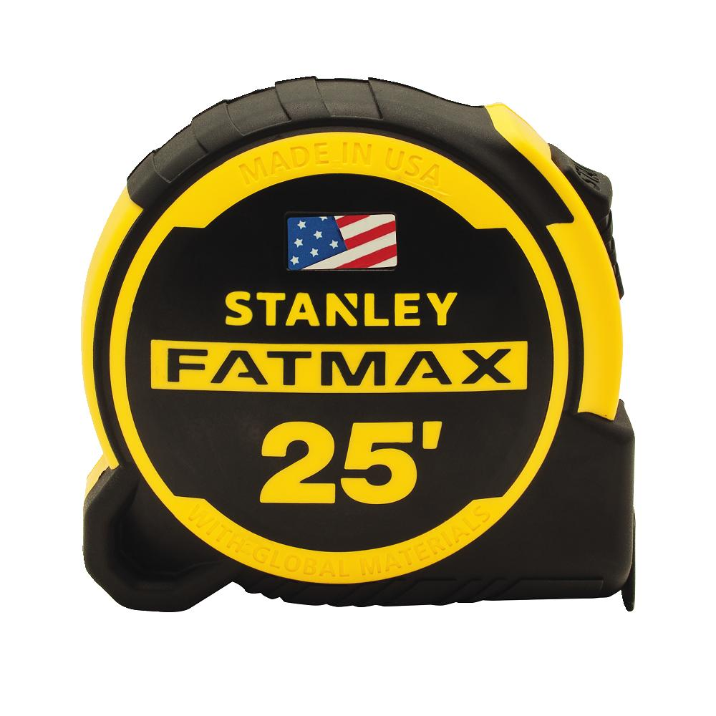

“At STANLEY, we pride ourselves on continuously raising the bar by engineering and delivering innovative tools that meet our customers’ high expectations. We engineered the 2018 STANLEY FATMAX Tape Measure to outlast, outperform and fit comfortably in the palm of your hand,” said Lee McChesney, President, Hand Tools, Accessories & Storage at Stanley Black & Decker.

The STANLEY FATMAX tape measure was first introduced in 1999, and today more than 50 million STANLEY FATMAX tape measures have been sold and used around the globe.

Key features of the 2018 STANLEY FATMAX Tape Measure include:

- 2X the Bladearmor® Coating on the first 6” and a three-rivet fastened hook, ensuring better protection at the most vulnerable part of the tape.

- New MAXSHIELDTM Blade Coating, the longest-lasting blade coating on a FATMAX tape measure, applied to the entire 1 ¼” wide high carbon steel blade and length of the tape, delivering protection against wear, abrasion and rust.

- New patented Twin-CoreTM technology with an advanced internal dual return spring that allows for a small tape case and a comfortable, ergonomic grip.

- Improved, stronger, screw-free belt clip design making the 2018 STANLEY FATMAX Tape easier to fasten and remove from a tool belt, as compared to previous designs.

- An easy-to-use slide lock that engages and disengages with ease while holding the blade strong when locked.

MSRP is $29.99 (US). Additional lengths including 35-foot in May 2018 and 16-foot will be introduced in late 2018. More information, including videos, product specifications and where to buy can be found by visiting www.fatmaxtape.com. Join the social conversation by searching/tagging #FATMAXTape or follow STANLEY on Facebook/Stanley Tools, @officialstanleytools (Instagram) and @stanleytools (Twitter).

About STANLEY:
STANLEY, a brand of Stanley Black & Decker, Inc. is a diversified manufacturer of innovative tools and engineered solutions for professional, industrial, woodworking, construction, automotive repair, organizational, and do-it-yourself use. Since 1843 STANLEY has consistently provided solutions that make life easier with reliable hand tools. Headquartered in New Britain, CT, STANLEY is committed to manufacturing tools in the USA with global materials. Annually, STANLEY produces a large variety of hand tools including tape rules, knives, blades, hand saws, screwdrivers, plastic storage, and accessories in multiple manufacturing locations in North America. STANLEY can be found internationally wherever tools are sold and has helped build America with a breadth of quality hand tools people can trust for over 175 years. For more information visit www.stanleytools.com or follow STANLEY on Facebook, Instagram, and Twitter.
###

STANLEY FATMAX is a registered trademark of Stanley Tools.

