SteelSeries Announces World’s Most Versatile Mechanical Gaming Keyboards with Fully Adjustable Actuation

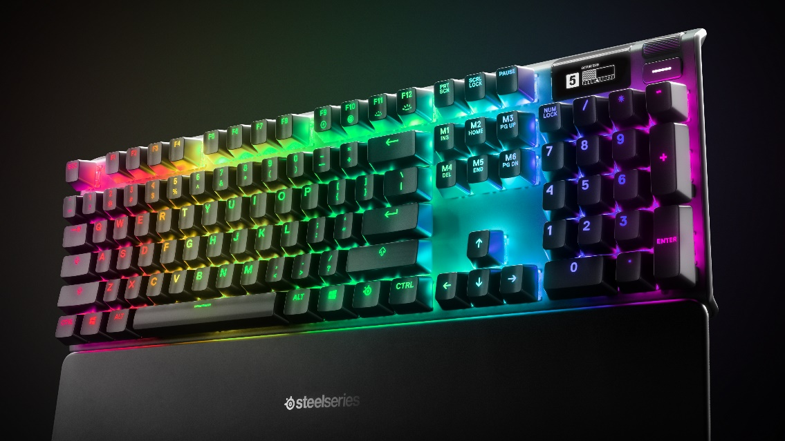

SteelSeries’ new OmniPoint switch with fully adjustable actuation is the biggest leap in gaming keyboard innovation since the creation of the first mechanical switches

COMPUTEX; TAIPEI – May 28, 2019 – SteelSeries, the global leader in gaming peripherals and the makers of the first mechanical gaming keyboard, today announce the world’s most customizable mechanical gaming keyboards with fully adjustable actuation switches – the Apex Pro and Apex Pro TKL. The Apex Pro allows gamers to adjust the distance it takes for each key to register a key press, helping them to play more accurately and quickly. This first-of-its-kind keyboard will automatically change between sensitivities when starting up a game like Counter-Strike: Global Offensive, and another for everyday productivity tasks.

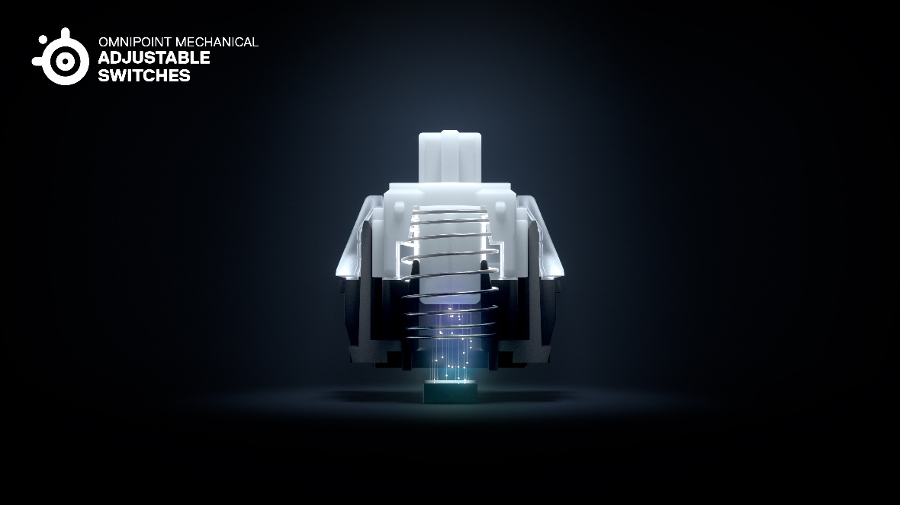

OmniPoint Adjustable Actuation Switches
Generally, typing enthusiasts and some gamers prefer a lower, longer actuation point (3.6mm) for accuracy, while other prefer a higher actuation point as sensitive as 0.4mm for speed. The Apex Pro’s Patented OmniPoint adjustable actuation switches uses magnetic sensors to allow gamers to choose the exact sensitivity of their keys. Powered by SteelSeries Engine, the Apex Pro can automatically change sensitivity when starting up a game like Counter-Strike: Global Offensive, and another for everyday productivity tasks. The magnetic sensors also provide a significantly faster response time than traditional mechanical switches, making the Apex Pro the world’s fastest and most responsive keyboard.

“Innovation in the keyboard switch market has grown dramatically stagnant over the past decade,” said Ehtisham Rabbani, SteelSeries CEO. “With our new, patented technology inside the OmniPoint switches, gamers finally have the option to use a single keyboard for everything from gaming to content creation and more. The Apex Pro is the only keyboard on the market that can adapt to the specific needs and preferences of every gamer.”

OLED Smart Display
Alongside the new OmniPoint switches, the new Apex Pro line sports an integrated OLED Smart Display. The Smart Display not only allows for instant notifications from apps like Discord, Spotify, and games like CS:GO and Dota2, but also allows users to customize their actuation point directly from the keyboard. While users can experience greater customization through SteelSeries Engine software, it is not required to customize the sensitivity of the keyboard.

In addition to the OLED Smart Display, the Apex Pro line also features a clickable metal roller and media key that allows users to adjust volume and settings on the fly. These inputs can be further customized in SteelSeries Engine.

The Apex Pro line is crafted from aircraft-grade aluminum for a lifetime of unbreakable durability and sturdiness and features dynamic per-key RGB lighting that can be synced up with other SteelSeries peripherals. Apex Pro also has five on-board profiles so users can save their settings directly on the keyboard, a USB passthrough port for an easy-to-reach USB connection, three-way cable routing under the frame and both models come with a premium magnetic wrist rest for extra comfort.

The Apex Pro is available in both a full-size and compact ten keyless (TKL) variant. The full-size Apex Pro will be available in the US on June 11 at Best Buy and steelseries.com for $199.99. Available to purchase in Europe and Asia later this fall. The Apex Pro TKL will be available to purchase later this fall for $179.99.

Apex 7 & Apex 7 TKL

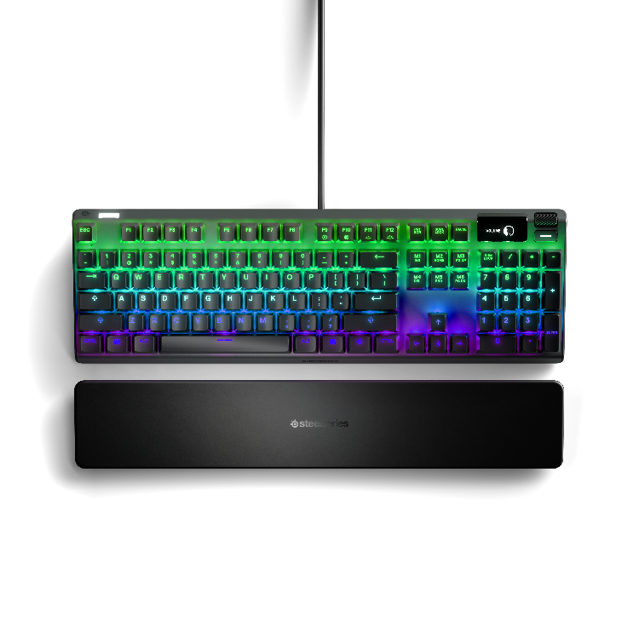
SteelSeries is also announcing the Apex 7 and Apex 7 TKL. Both keyboards are physically identical to the Apex Pro line, but instead of the OmniPoint adjustable actuation switches, gamers can choose between standard Red, Blue or Brown switches. The Apex 7 and Apex 7 TKL allow gamers to choose their preferred size and switch feeling.

The Apex 7 (full-size) & Apex 7 TKL (compact ten keyless) will be available in the US for $159.99 and $129.99 respectively. The Apex 7 (Red version) will be available in the US, Europe, and Asia in June. The Apex 7 (Brown and Blue Versions) will be available in US, Europe, and Asia later this fall. Apex 7 TKL (Red Version) will be available in the US and Asia in June. Available in Europe later this summer. Apex 7 TKL (Brown and Blue Versions) will be available in US, Europe, and Asia later this fall.

For more information about the Apex Pro line and the complete line of SteelSeries’ keyboards, visit www.SteelSeries.com for more information.

For high-resolution images, click here.

# # #

About SteelSeries
SteelSeries is a leader in gaming peripherals focused on quality, innovation and functionality, and the fastest growing major PC gaming headset brand in the US. Founded in 2001, SteelSeries improves performance through first-to-market innovations and technologies that enable gamers to play harder, train longer, and rise to the challenge. SteelSeries is a pioneer supporter of competitive gaming tournaments and eSports and connects gamers to each other, fostering a sense of community and purpose. SteelSeries’ team of professional and gaming enthusiasts help design and craft every single accessory and are the driving force behind the company.

To learn more about SteelSeries’ products and esports partnerships, visit http://SteelSeries.com or follow us on social media for the latest updates at http://facebook.com/steelseries and be a part of the conversation on Twitter @SteelSeries.

Media Contacts:
Rasmus Parelius
SteelSeries
rasmus.parelius@steelseries.com
+45 51333390

