**PAXYMER newsletter**

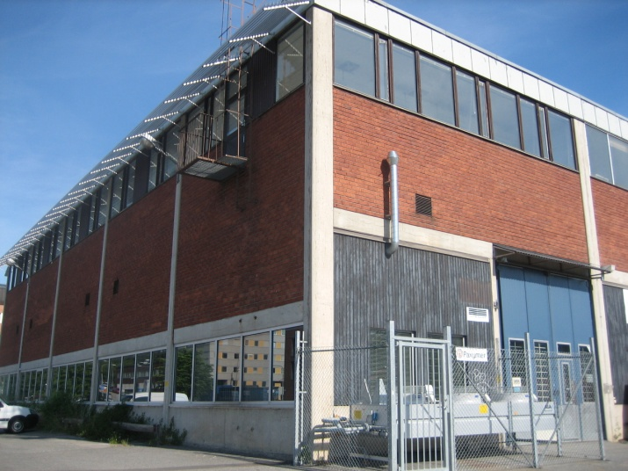

**2014: The Year of the Green Flame Retardant?**Flame retardants are on the agenda, big time. More companies are considering the safety and environmental impact of their material choices. This renewed interest is driven by a few trends:  **Ever increasing interest in recycling**: EU has presented new recycling guidelines and the recycling of plastic materials is becoming even more interesting as manufacturers are ‘rewarded’ for using it through certifications and labeling. The quality of recycled material is getting better – and prices are increasing. The main challenge with flame retardant recycled material is still however the variable quality of the base resins. Paxymer containing compounds have the added benefit that they can go back into the waste stream for recycling without deteriorating the final characteristics of the recycled materials.  
**LEEDS – green building certifications** are spreading in Europe. Sweden has had a voluntary registration and a directory of materials for some time. It was an initiative made by the major building entrepreneurs and manufacturers submit their materials for rating. The two systems BASTA and BVB gives a third party independent review of the materials that goes into our buildings. LEEDS has a similar system and points are given to companies utilizing materials that are free from ECDs and POPs. These systems are rapidly becoming norm in Europe. Paxymer’s participation in the UNEP ‘POPs free project’ and our two ‘[Recommended](http://www.byggvarubedomningen.se/sa/node.asp?node=484)’ products in BVB make us a good partner for these projects.  
**DecaBDE investigation launched** – another one of the previously major so-called safe brominated flame retardants is now under scrutiny by ECHA. This is part of a trend where HBCD was banned earlier in 2013. Paxymer can see that customers are looking elsewhere for solutions – important drivers are often a more holistic perspective on fire safety where smoke, heat release rate and flame spread parameters are taken into account. We at Paxymer believe that the focus on fitting right materials in the right place and to ensure relevant testing will reduce the exposure to persistent chemicals for people over the coming years.   
2014 seems to have a lot of ingredients that can make it ‘The Year of the Green Flame Retardant’, and we are looking forward to helping you to greener and safer material solutions.

**Newsflash**

**Paxymer® is entrusted supplier to blow molded  
white goods part**

Paxymer is the trusted supplier for one of the major white goods suppliers on the American market. The project was initiated when a change of legislation occurred last year. It had to be HFFR. The part is made HPDE and then blow molded. The solution containing Paxymer was able to meet both fire and processing requirements since other alternatives failed due to poor processing charac-teristics. Paxymer is supplying Paxymer MB704 for the project.

*/Amit Paul (MD of Paxymer AB)*

**Green buildings renders higher per square meter prizes!**LEED an internationally recognized green building certification system from U.S. promotes sustainable building and development practices through a suite of rating systems. They have introduced a new rating system they call v4. According to an [article](http://www.greenbiz.com/blog/2013/10/18/4-ways-leed-v4-will-change-business?mkt_tok=3RkMMJWWfF9wsRoluq%2FMZKXonjHpfsX56u0qXaWylMI%2F0ER3fOvrPUfGjI4DRcNlI%2BSLDwEYGJlv6SgFSLHEMa5qw7gMXRQ%3D&utm_campaign=cmp_266789&utm_source=getanewsletter) in [www.greenbiz.com](http://www.greenbiz.com) this system will change the business of real estate. Paxymer finds special interest in one of the new points to be fulfilled to score the highest rating.  
**Investigation of hazardous ingredients?** **– “HPD” will help you find out**  
LEEDs is addressing the question with potential toxicity of building product ingredients. For instance the building will collect points if a supplier-company proves that they are avoiding some of the most hazardous chemicals as determined by several governmental lists. There is this Health Product Declaration (HPD), a hazard-based standard format for reporting ingredients and health warnings, which is recognized by Leeds v4. <http://hpdcollaborative.org/> . Sweden has been working in this manner for some time and has two organizations working with evaluating producer’s self-reported data one is BASTA and the other is BVB (byggvarubedömningen).   
The Green Building council, which updates LEED standards periodically, is proposing to include a “chemical avoidance” provision. This could mean that energy effective products does not pass this provision such as PVC-piping, instead focus remains on avoiding hazardous products for the benefit of human lives. It is to be expected that green building trends will drive plastics construction use as the focus of the green building industry will continue to shift. New building design and construction will have to consider energy aspects, material choices and living conditions in buildings. But these parameters will also be evaluated in major renovation projects where efforts to “greening” and “rehab” of existing buildings will be rewarded.   
A highly commendable initiative comes from The International Living Building Institute who measures the actual performance of buildings one year after a building is completed to ensure that it is, in fact, meeting energy/environmental targets. <https://ilbi.org/lbc> .   
Source: greenbiz.com  **Paxymer concludes**: Of course we need to take care of minimizing the energy consumption, but taking care of the environment means that you also have to consider a lot of other parameters and one important aspect is hazardous ingredients in products affecting the environment in buildings.

**Chemical hazards in new vehicles**The average person spends about 5% of their time in automobiles. It is therefore an important issue to monitor the microenvironment for exposure to pollutants. Interior materials in cars include such compounds as, polybrominated diphenylesthers (PVDEs) and other brominated flame retardants BFRs, volatile organic compounds VOCs, phthalate plasticizers, hydrocarbons etc. Interiors of cars are exposed to a lot of heat and UV-radiation during use and the Total VOCs inside a car can reach values over 3000 (according to US-EPA recommendation the TVOC should not exceed 200mg/m3).   
**UV-ray exposure may cause “fogging”**“Fogging”, a phenomenon that can be observed on the windows in especially new cars as a slight film on the inside of the windshield, is an indication of pollution in your car. Heat can accelerate this process and UV-ray exposure may also cause chemicals to break down of materials into more toxic compounds. These chemical are inhaled or ingested by drivers and passengers through dust and air. One example is DecaBDE that may debrominate or break down when exposed to UV radiation. Some of the breakdown products include penta BDE and octa BDE which have been phased out by government health organizations and the global automotive industry due to their toxicity.  
**900 Vehicles are rated by** [**www.healthystuff.org**](http://www.healthystuff.org)According to rating done by Healthy Stuff Organisation material use across the world differs drastically. In Asia there is significantly less PVC in vehicle components, on average vehicles assembled in Japan or Korea showed a 50% reduction in the use of PVC. Honda is leading the rating on non-pollutant materials in cars. Manufacturers in Europe use the most PVC, more than twice the amount of vehicles assembled in other parts of the world. However levels of BFR use in vehicles are the lowest in Europe. North American manufacturers lag behind European and Asian produced vehicles in reduction of PVC and BFR use.   
**Paxymer concludes**: that a discussion of halogen free rather than comparing PVC vs. BFR use makes more sense. On one hand there are little BFRs in European cars but on the other hand they contain a lot of PVC, which is a halogen containing material. As there are completely halogen free substitutes on the market it makes sense to shift to halogen free systems.   
Source: On www.helathystuff.org you can find classification of cars with respect to pollution

**ECHA report on research on the substitution costs of hazardous chemicals**ECHA /European chemical Agency/ has initiated a project on” Estimating the abatement costs of hazardous chemicals”. The purpose of the project surrounding abatement cost is to create a decision making support for legislators and improve their capabilities when decision makers are considering legislation concerning hazardous chemicals. “Abatement” refers to measures which reduce the amount of “bad” occurring – e.g. the use of protective equipment, filter mechanisms to reduce emissions of hazardous substances to air or water, or substituting the chemical with an alternative substance or technology.   
**ECHA’s case studies show on a wide variation of costs**ECHA recently made a review of six case studies, the substances under scrutiny was amongst others Phthalates (DEHP, BBP, DBP and DIBP) and flame retardants HBCDD. They found that there was a wide variation of the sorts of abatement between and within substances. For instance, abatement costs for phthalates seem to start around €1000 per tonne of substance emitted, whereas for the abatement of HBCDD the cost could be as high as €180k for certain applications.   
The balance between estimated societal costs for substitution which also includes a feasibility estimate of available substitutes on the market is an important input when considering bans, timelines and exceptions for particular hazardous substances. ECHA’s experience will be useful for the various member states in their work on restriction dossiers.  
Source: ChemSec newsletter January 2014; <http://admin.getanewsletter.com/t/v/1_MzM2MjE0MTk2Mw==/>   
You can also find more information about this at: AMEC Environment & Infrastructure UK Ltd.

**Paxymer concludes**: Although these numbers can seem staggering a study by the UNEPs chemicals branch that we reported on in December 2012 indicates that the cost of continued use can be even more severe. One example was the calculated societal cost of orally ingested Cadmium use causing osteoporosis which is estimated close to 500 million €/year in Sweden alone.

*We welcome you to use and refer to the information in this newsletter and are grateful if you mention the source.*

*Editor: Ann-Christin Paul, ann-christin.paul@paxymer.se*

If you do not wish to receive our newsletters please reply to this e-mail: [info@paxymer.se](mailto:info@paxymer.se) with the Subject: “*Unsubscribe”* and you will be removed from our mailing list.