Media Invitation: An Auspicious, Colourful CNY with the Flying Dragon

Dear Editor,

In honour of Chinese New Year 2020, Kwai Chai Hong will be home to a new majestic feature, the Flying Dragon. In the heart of Kuala Lumpur, Kwai Chai Hong was once a dilapidated back alley furnished with pre-war heritage buildings that has now been transformed into a space that celebrates the Malaysian culture and history of KL Chinatown. With the new year just around the corner, like all Malaysian cultural festivities, this calls for a grand celebration.
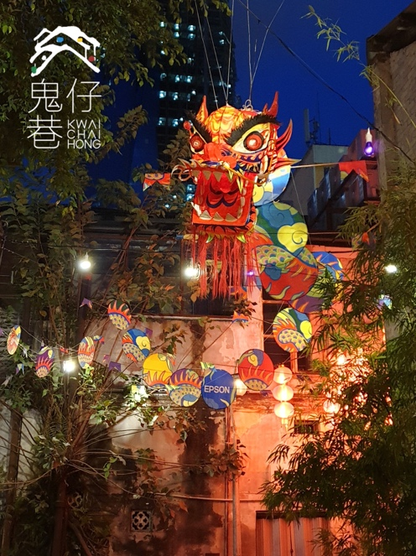

In conjunction with the Lunar New Year, an installation of a giant handmade Flying Dragon will be hung over the lanes of Kwai Chai Hong. Often seen during important celebrations and events, the dragon emblem is incorporated into many aspects of the Chinese culture as it symbolises wisdom, mightiness, wealth and good fortune. In kite-flying festivals, dragon kites were commonly flown, adorned with bright and intricate designs with panels that could stretch for thousands of meters. Combining the ancient art of producing the Dragon Head and Tail used in Dragon Dance, and the body mimicking the art of Dragon Kite production, this long majestic creature is embellished in designs and vibrant colours.

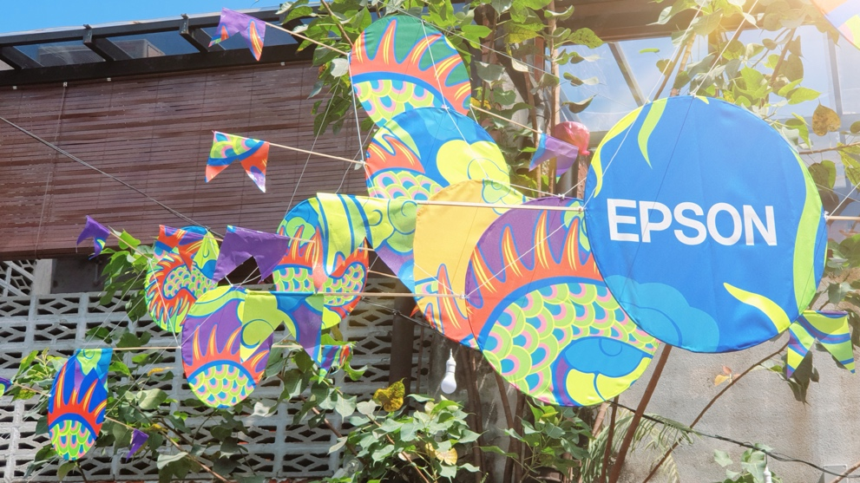

Using 68 fabric panels that stretch along the lanes of Kwai Chai Hong, the scaly detailing of the dragon’s body is printed using the all new Epson F-9430H Dye-Sublimation Digital Textile Printer. A first for Epson, the SC-F9430H printer offers businesses the additional feature of printing fluorescent colours using the new Epson genuine fluorescent yellow and fluorescent pink inks. Equipped with a Fluorescent Colour Collection library in Edge Print software, it enables colour processing for fluorescent inks, providing more colour variation during processing.

This installation will showcase a modern, dynamic interpretation of the diverse Chinese culture. And for Epson, it’s a part of our endeavour to enable the expression of creativity through technology and how such collaboration enhanced the outcome of arts and cultural experience and appreciation.

Come witness the Flying Dragon following the details below:

Date: 10th January – 15th February 2020
Venue: Kwai Chai Hong @ Lorong Panggung
Hour : 9am – 12am daily follow them on Facebook or Insta @kwaichaihong for special announcement on changes to the opening hours.

Gong Xi Fa Cai, and remember to bring with you your loved ones, your cameras, and your new year spirit!

###

For further media enquiries about the Flying Dragon Art Installation, you may drop your request at the Kwai Chai Hong Facebook or Instagram Page (@kwaichaihong).

About Epson
Epson is a global technology leader dedicated to becoming indispensable to society by connecting people, things and information with its original efficient, compact and precision technologies. The company is focused on driving innovations and exceeding customer expectations in inkjet, visual communications, wearables and robotics. Epson is proud of its contributions to realizing a sustainable society and its ongoing efforts to realizing the United Nations’ Sustainable Development Goals.

Led by the Japan-based Seiko Epson Corporation, the worldwide Epson Group generates annual sales of more than US$10 billion.
http://global.epson.com

For media enquiries, please contact:
Chua Li Tinn,
Marketing Communications Manager
Epson Malaysia Sdn Bhd
Tel: (03) 5628 8288 Ext 274
Email: ltchua@emsb.epson.com.my

LEWIS
Natasha Aida / Leong Ee Sa
Tel: +603 2716 5818
Email: EpsonMY@teamlewis.com

