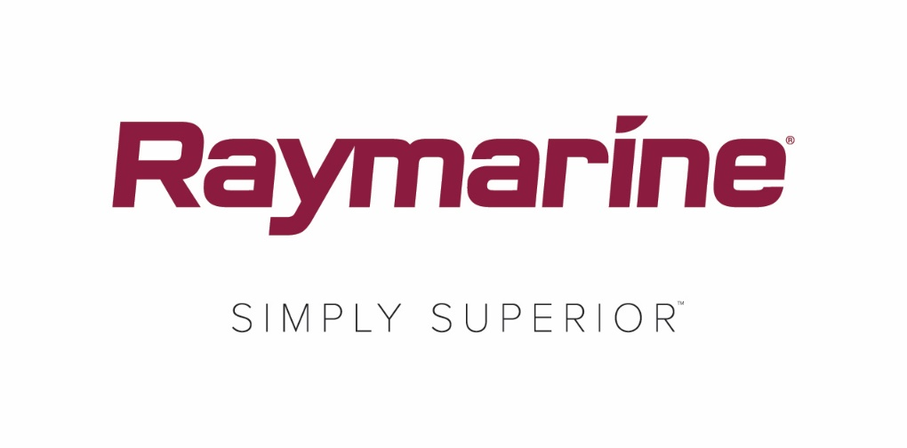
Raymarine LightHouse Bermuda: Superior for Sailors

New LightHouse Bermuda 3.10 operating system update unlocks exciting new sailing features on Raymarine Axiom multifunction displays

Sailing to Bermuda is an exciting way to experience the island’s vibrant blue waters and dramatic scenery. And the best way for sailors to get to Bermuda – or any other destination – is with Raymarine’s newest, free LightHouse™ 3 operating system update for Axiom®, Axiom Pro and Axiom XL multifunction displays.

LightHouse Bermuda v3.10 is loaded with new and enhanced features for sailboat cruisers and racers equipped with one or more Axiom MFD. As with every Raymarine LightHouse operating system update, downloads are free and easy at http://www.raymarine.eu/multifunction-displays/lighthouse3/.

60 New Vessel Polars
LightHouse Bermuda comes with 60 new sets of Polar Performance Data for popular sailing and cruising hulls, bringing LightHouse 3’s onboard library of polar data to over 260 models. Skippers and crew enjoy optimised laylines for their specific vessel by simply choosing its make and model.

Racing Data Dashboard
Lighthouse Bermuda’s new Racing Data Dashboard display provides full-screen views of critical start line information. Race time, actual time, line distance, wind and layline information are all displayed in a manner that’s big, bold and simple to understand.

Racing Sidebar
LightHouse Bermuda includes a convenient Racing Sidebar that can be displayed along the left edge of the vessel’s Axiom display. Simply swipe from the edge to open it, and swipe back to close. The sidebar provides instant access to valuable, real-time race information like timer, line distance, bias, and time to burn.

SmartStart™ Start Line
Racers can use this feature to easily ping the port and starboard ends of the starting line before the race begins. Simply sail to each position and touch the chart display for simple entry. Starting line ends can be swapped with a single touch.

Race Timer
A new Race Timer feature is accessible from Bermuda’s Racing Sidebar, or Racing Data Dashboard. Simply touch the timer to start the countdown, change the duration, or synchronise with official race timing.

PredictWind and Offshore Apps
Bermuda delivers Axiom onboard support for the popular PredictWind and Offshore performance sailing apps. Receive detailed wind and weather forecasts to you boat via Wi-Fi, satellite or SSB. Get detailed departure and weather routing plans right on the app. PredictWind or Offshore subscriptions are required.

####

Media contact:

Karen Bartlett
Saltwater Stone
+44 (0) 1202 669 244
k.bartlett@saltwater-stone.com

