Press release

For immediate release

# geo wins Smart Water Metering Innovation of the Year 2013

**(Cambridge, UK) Green Energy Options (geo), one of the leading providers of in-home displays and energy management services, has won the Smart Water Metering Innovation of the Year 2013. The award was presented at the European Smart Metering Awards in conjunction with the Smart Metering UK & Europe Summit in London.**

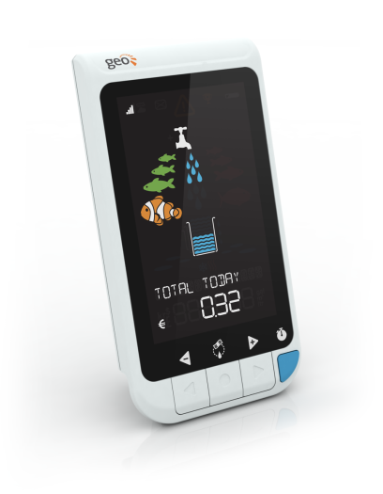**geo**’s innovative water monitoring device, **Ensemble Water**, wowed the judging panel by being “intuitive, smart and simple”. Their aim with the innovation was to deliver an engaging solution to help people save water in the domestic market.

The Ensemble Water is a fun and informative in-home display that gives consumers an at-a-glance awareness of their water consumption. It allows people to keep track of their hot and cold water use, shows use against budget and helps increase efficiency and raise awareness – all without restricting lifestyle. This last point is becoming ever more critical as we see more drought-ridden areas. The display can also show that a leak has been detected, saving consumers from expensive repairs and/or building damage.

Patrick Caiger-Smith, chief executive officer at **geo,** was there to accept the award. ‘We are delighted to receive this award,” said Mr Caiger-Smith. ”It feels great to be recognised by a diverse panel of judges for exactly what we are trying to achieve with our systems – simplicity and usefulness, delivered with style. We believe householders will learn a lot about their water consumption and will be able to adapt their routines without compromising their lifestyles.

--ENDS--

Notes for editors:

Interviews can be arranged with Patrick Caiger-Smith.

**About Green Energy Options**

**geo** designs and produces in-home displays, online energy services and mobile applications that make energy engaging. They enable utility suppliers, meter manufacturers and installers to strengthen relationships with their customers. They do this by putting end-users in control of their energy and water consumption, home appliances and budgets in a visual, informative and engaging way. **geo**’s products and services work together with pre-smart and smart meters and microgeneration to effect and support a truly energy-efficient home.

**Media Enquiries: Christine Rush, geo, +44 1223 851 390,** [**christine@greenenergyoptions.co.uk**](mailto:christine@greenenergyoptions.co.uk)