Press release by Planetaire AB - September 12, 2011
World Records for solar flight champ

ENGLISH | FRANCAIS | SWEDISH

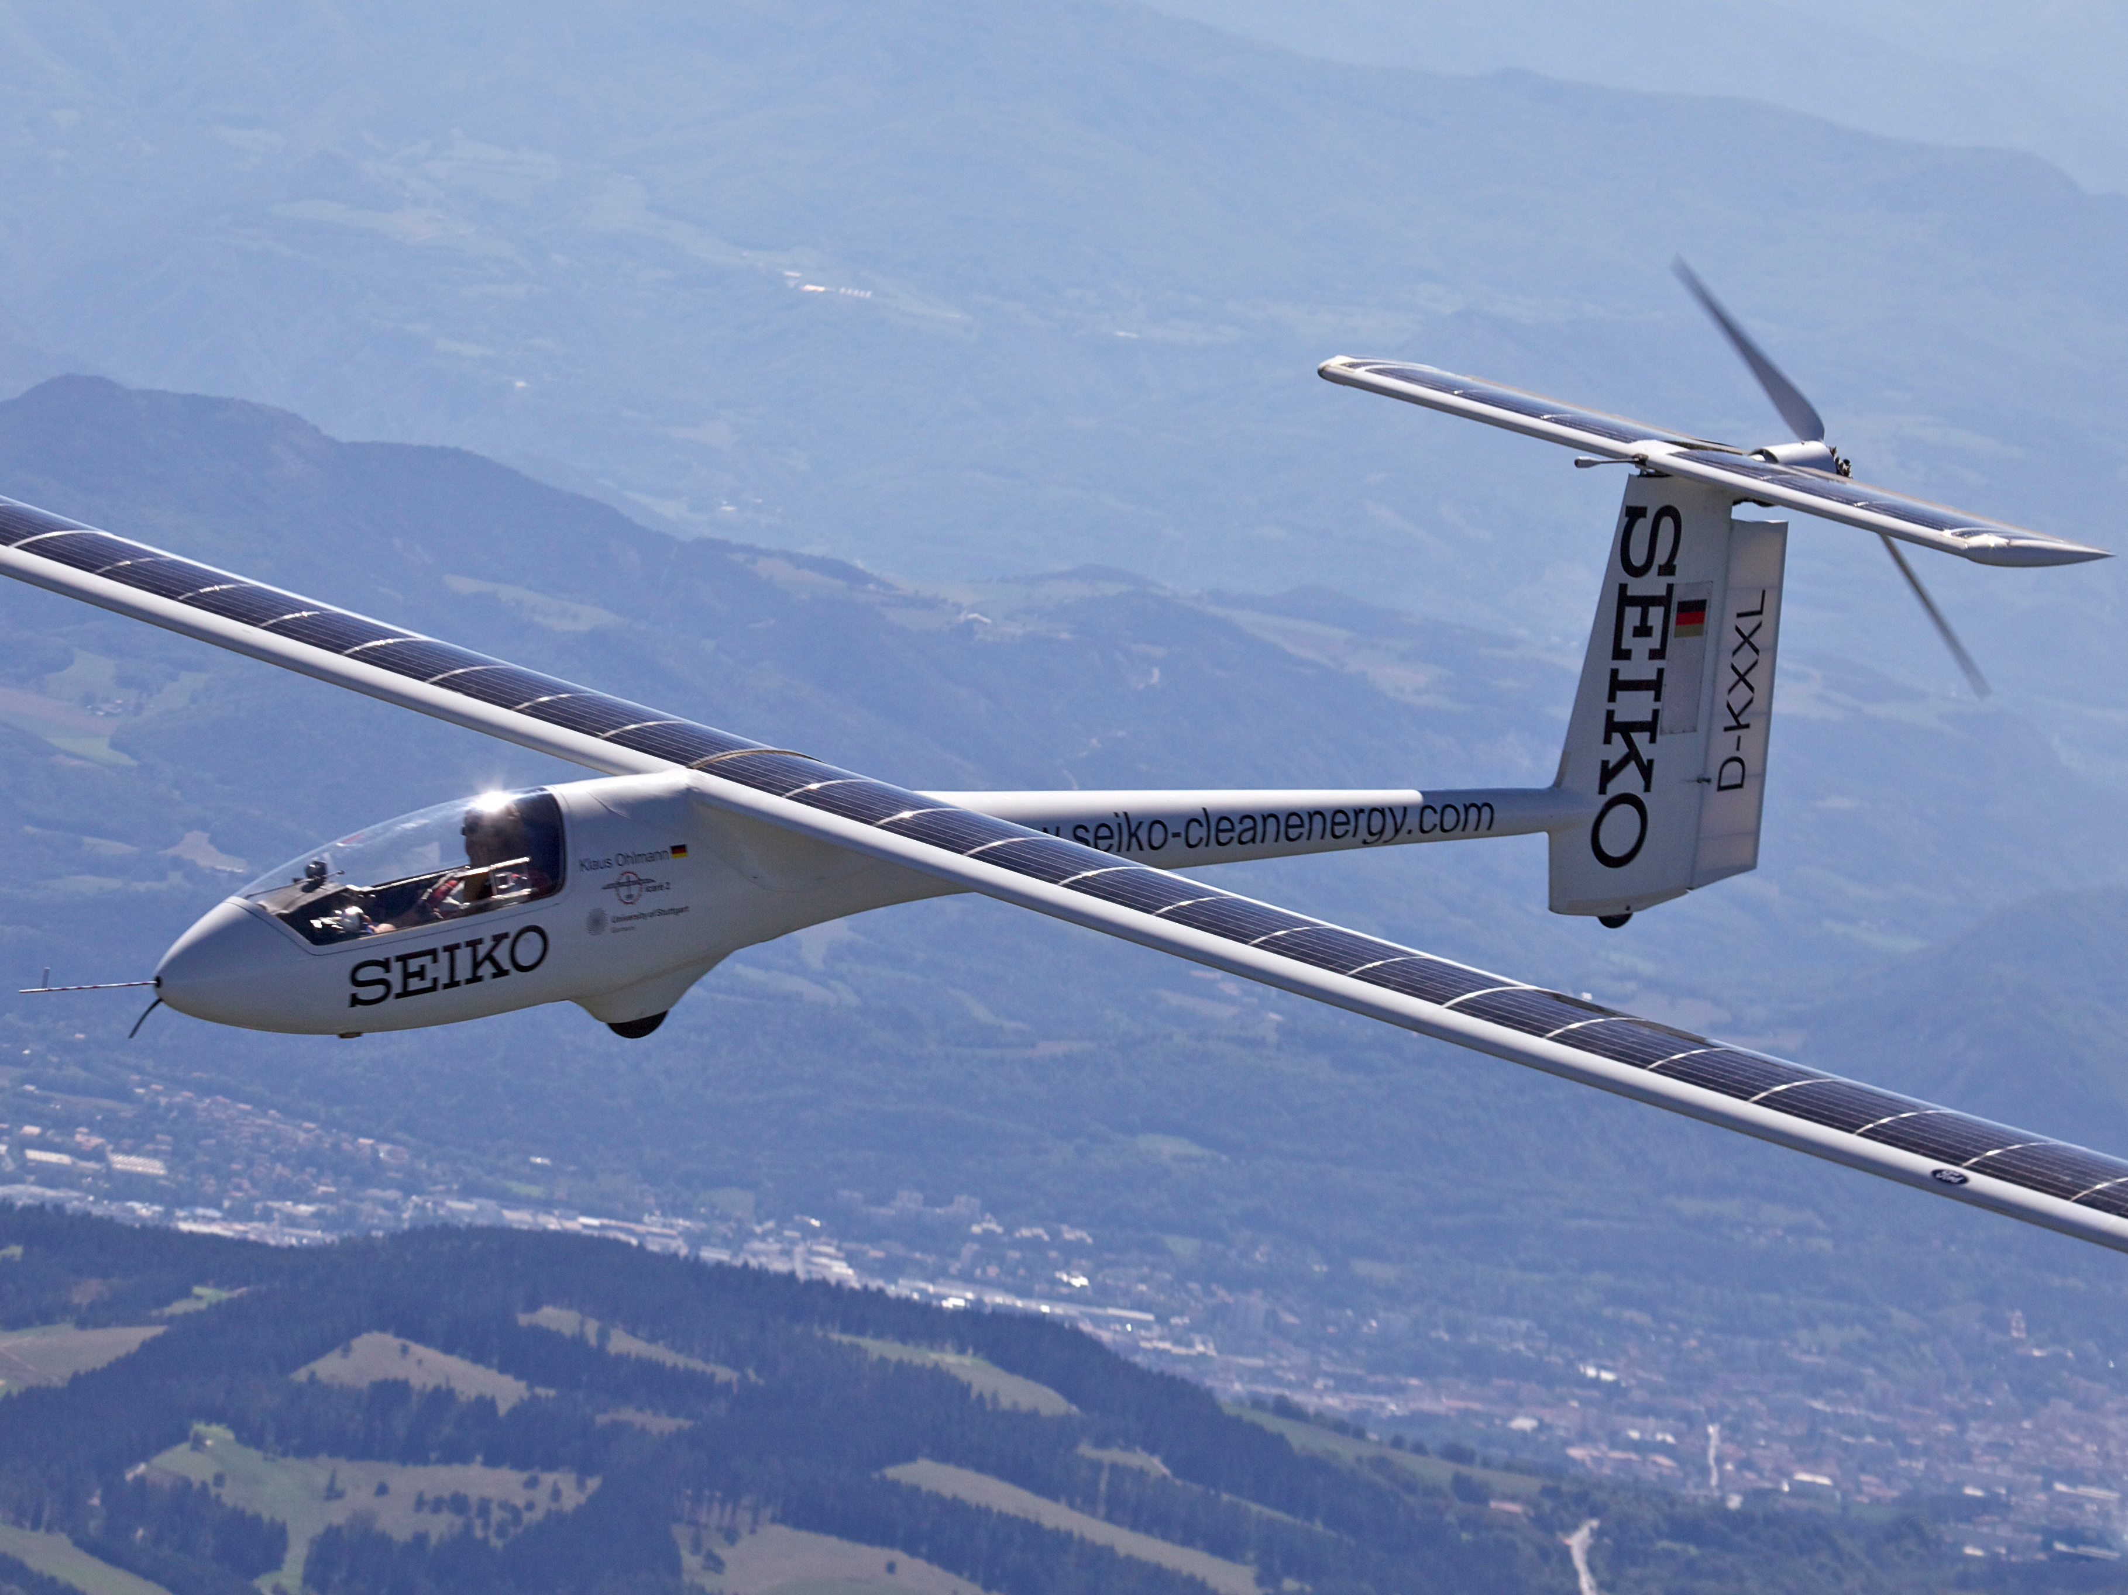 | 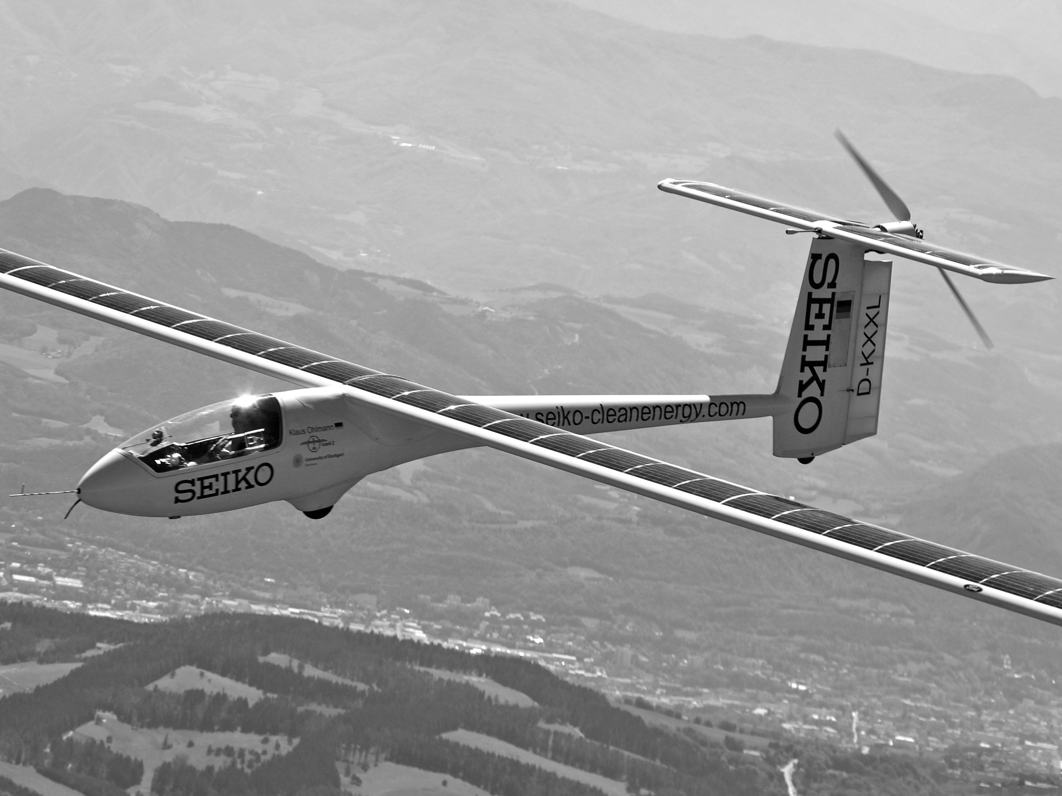 | 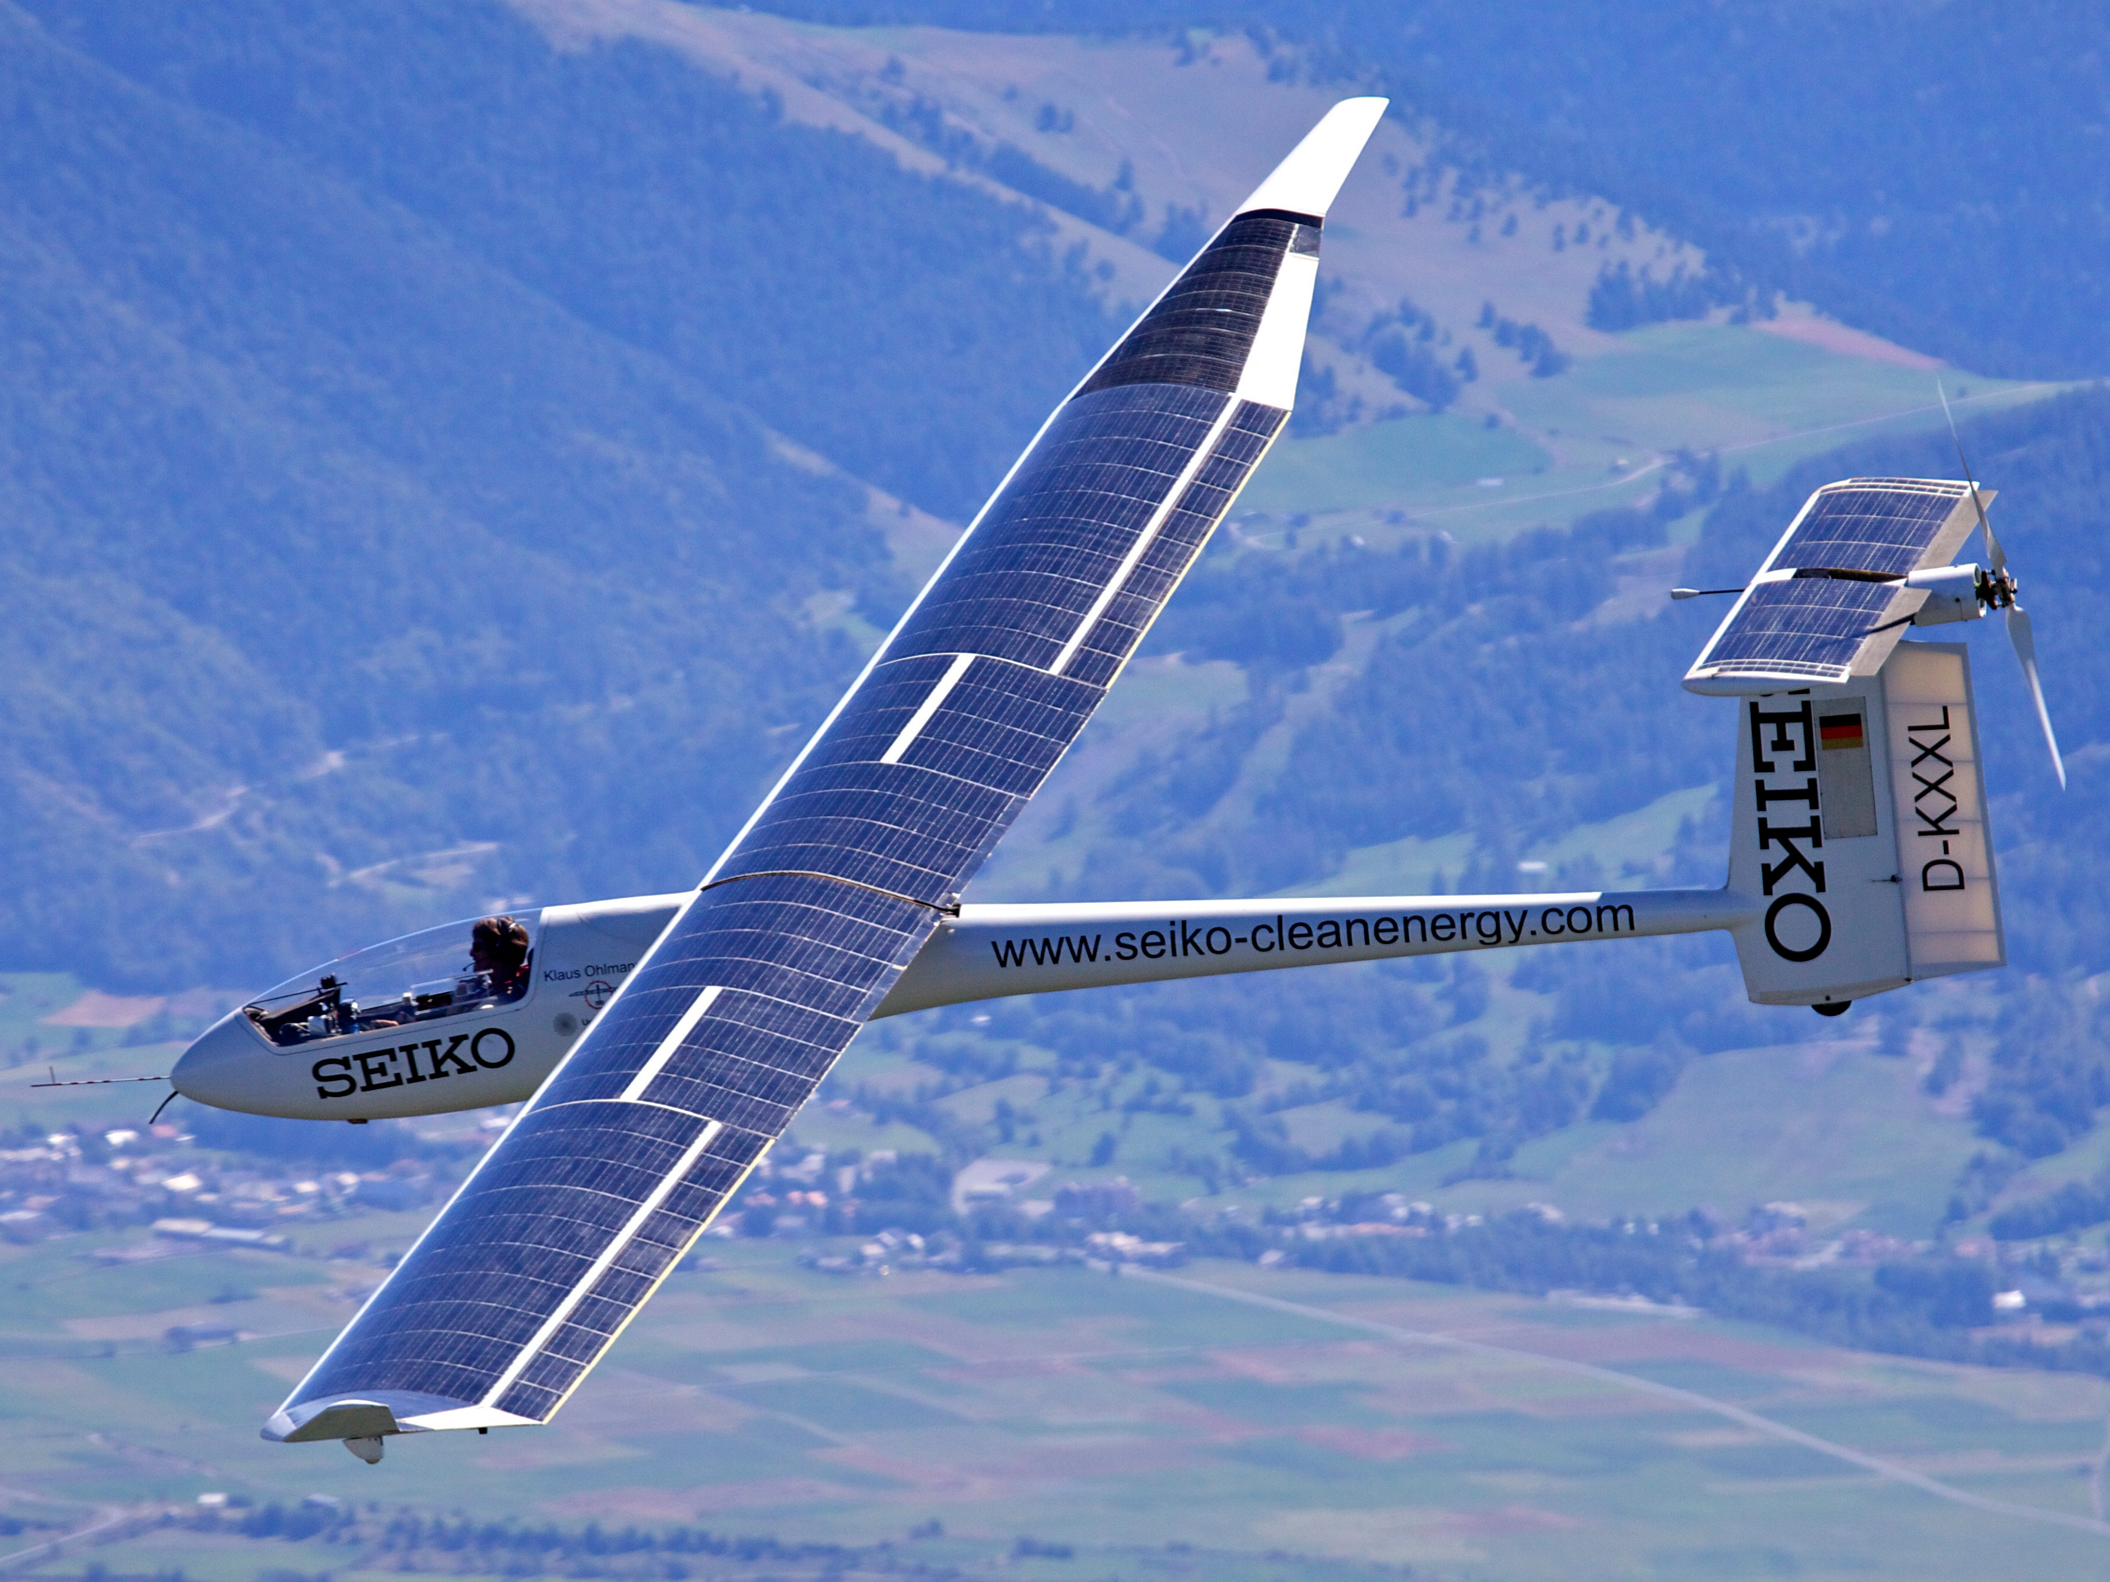 | 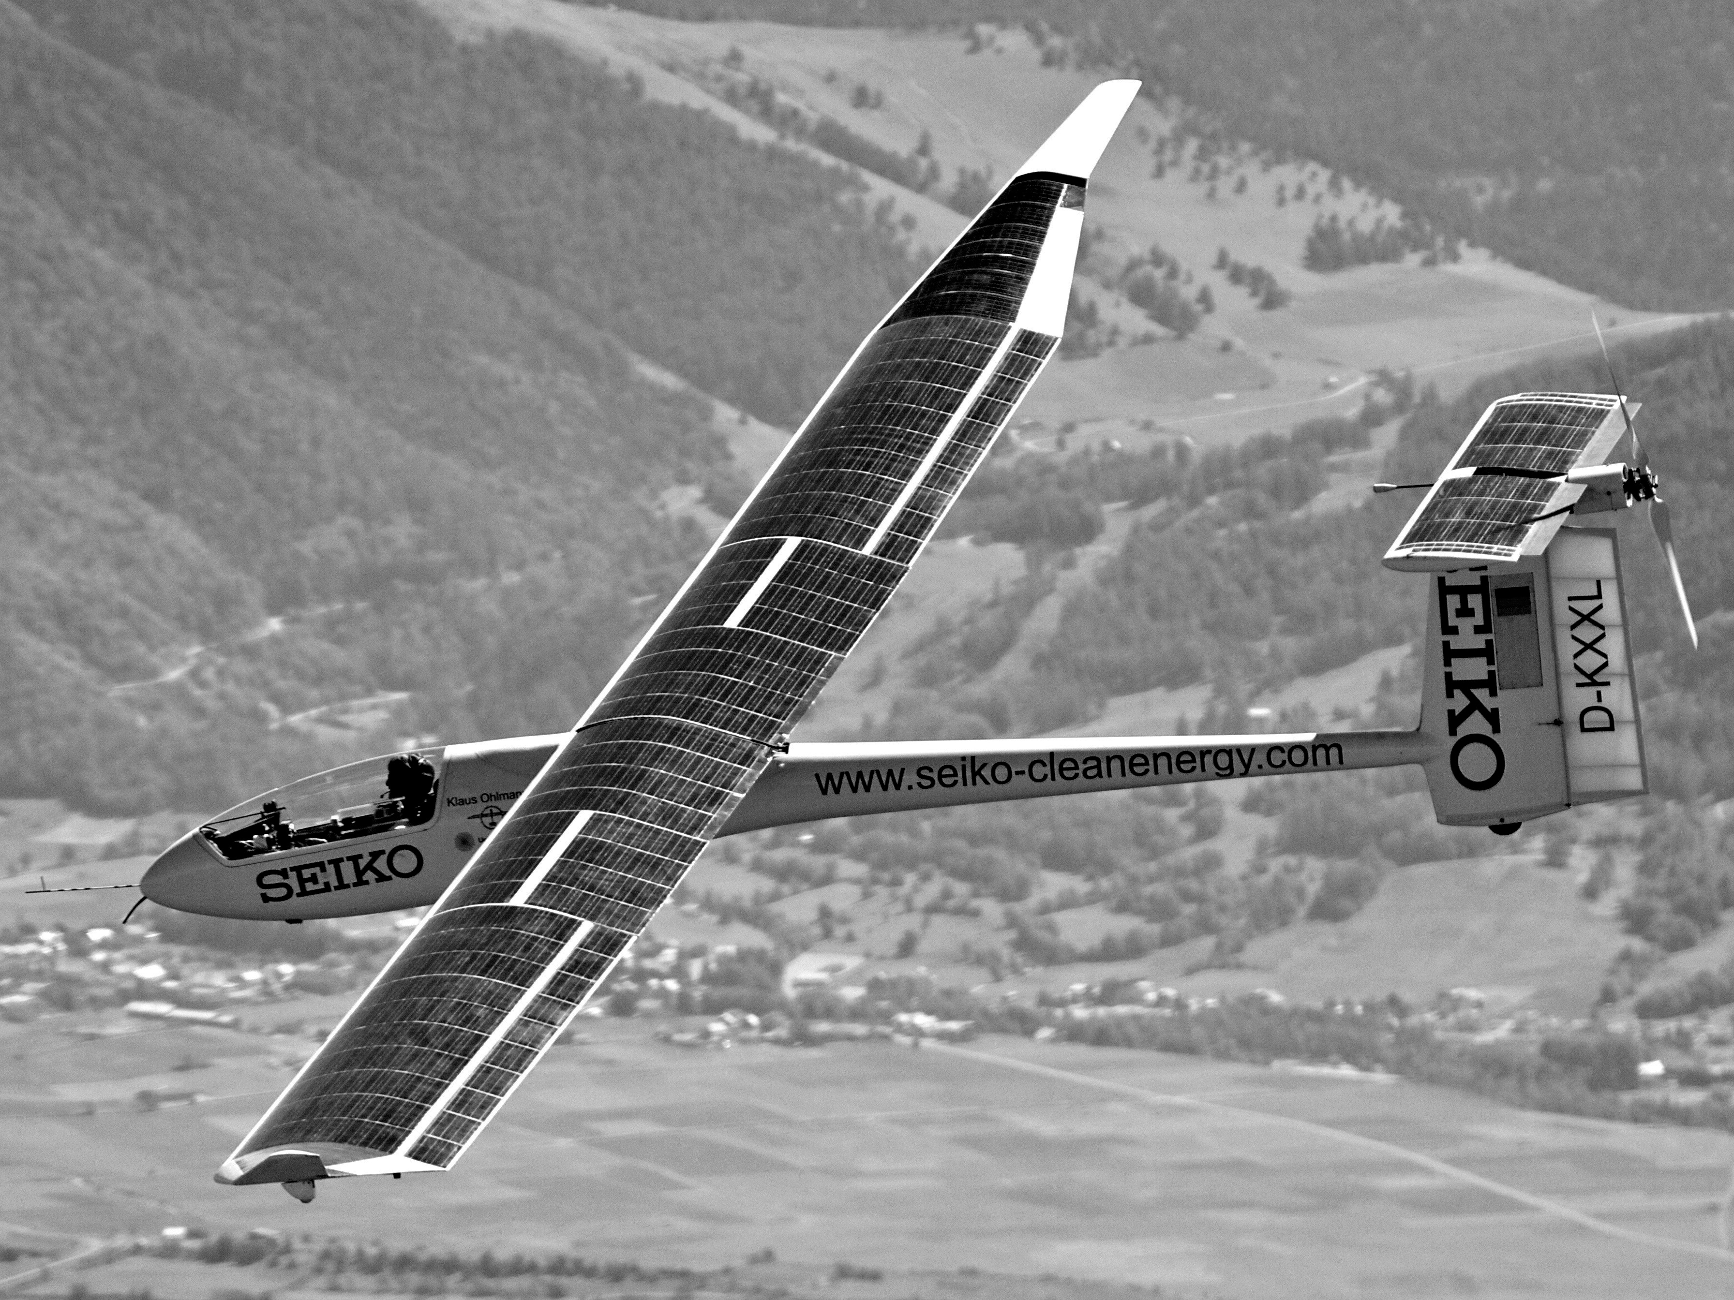
To view and download high resolution image, click the thumbnail
Photo caption: Klaus Ohlmann setting his distance record with Seiko-Icare2 in the Alpes Maritimes on Sept 10th
(photo: Michel Lebleux).

ENGLISH text

<starts>

September 12th, Gap, France: One of modern aviation’s most prolific record setters¹ has chalked up another distance milestone in the final weekend of his European season. The record belongs in the category “Solar-powered Aeroplanes” as defined by the FAI (Fédération Aéronautique Internationale).

German pilot Klaus Ohlmann already had 46 records to his name. He added to this trove on Saturday [September 10] with a 439km “Distance using up to 3 turn points” flight in the Alpes Maritimes in Southern France, this time aboard Seiko-Icaré2. In August he set a record in the “Out-and-return distance” of 384.4km, more than doubling his own previous record.

In a frenetic weekend trying to outdo himself, Ohlmann raced against the weather clock and a date with a racing commitment stateside.

He said: “Obviously I wanted just one more go at it before the autumn, and this was the perfect ending.”

“When you put pressure on yourselves like this, you have to be careful not to take risks and to do everything right, but the weather was with us and that made the difference.”

Seiko-Icaré2 is a solar powered glider built by a team at the University of Stuttgart and sponsored by the Japanese manufacturer, whose solar-powered watches are particularly successful on the US market. The technological innovations by the Stuttgart team have shown that solar flight is an achievable goal for small aircraft, even in the near future.

Seiko-Icaré2 generates all its energy from photovoltaic cells, which provide enough thrust to take off without the help of a towing plane. The pilot can alternate between soaring and powered flight whilst aloft.

He said: “Gliders are already extraordinarily efficient machines, and this is a new and almost inevitable step, not only exploiting the air heated by the sun, but also transforming the sun’s rays into electric energy.

“It opens new possibilities and I am determined to add some records to my collection.”

<ends>

¹ Klaus Ohlmann has 46 aeronautic records to his name, most of them in unpowered gliders. The records mentioned here – numbers 47 and 48 in his portfolio – were achieved in Seiko-Icaré2, a hybrid solar-glider aircraft. Icaré2 is capable of unpowered flight – or soaring – but also has the use of an electric motor powered entirely by the array of solar panels on the aircraft’s wings.

Press contacts / information:
Planetaire AB, Göteborg, Sweden, tél +46 31 94 5023
Nick Parker: nick.parker@planetaire.com
Aldrin Doudchitzky: aldrin.doudchitzky@planetaire.com

See also: www.icare2records.com

Official FAI records for Solar-Powered Aeroplanes: http://records.fai.org/data?c=25

Previous records by Klaus Ohlmann’s: http://records.fai.org/data?p=1902

