**Maria, 13, Sweden’s youngest non-fiction author #Green Smoothies - #Weight Loss Recipes**

***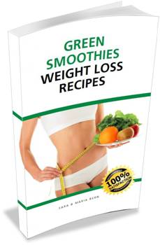Huddinge, - Sweden - 13 June 2014 -*** The Mother-Daughter team at Golden Opportunity, an established provider of Change, Coaching & Wellness services, today announced their debut of the book ***Green Smoothies - Weight Loss Recipes***, a compact, in-depth recipe book helping users lose pounds the fun, healthy and lasting way. It is co-written in a mother – daughter team, with the youngest non-fiction author in Sweden, [Maria Bern](http://a-golden-opportunity.com/wp-content/uploads/2014/06/IMG_4485_Maria.jpg), at merely 13 years old.

According to Golden Opportunity CEO [Sara Bern](http://a-golden-opportunity.com/wp-content/uploads/2014/06/101111_Sara_MG_6991_softver2_457-392.png), the *Green Smoothies - Weight Loss Recipes* book is now available for purchase at Amazon.com or at <http://alturl.com/o8pfu> (with instant access to a quick start guide with 5 recipes).

**It all started when Maria took the recipes from sticky notes on the pitchers to the computer**

"My thirteen year old daughter, Maria, and I have worked jointly on this book as a private project for some years and it is truly exciting to finally see it hitting the marketplace," said Bern. "It all started with sticky notes on the smoothie pitchers. Maria, who was staying home from school a few days, got bored and started to help me enter the sticky notes into a document. Then we decided to do a joint book project and contribute from our respective expertise. Maria had chosen the images and created the recipe titles. She also did the keyword research (yes, that´s true!) and has, generally, contributed well to the concept, content and design. We spent a considerable amount of time researching and developing this compact recipe book and we are very confident that consumers will find it of great value. It does not only give 55 recipes, but also guidance on how to make endless variations. Maria has also, in spite of her young age, proven to be a very competent partner in our joint seminars/workshops on the topic.”

**Benefits with this book: Green Smoothies – Weight Loss Recipes**

Bern explains: “This recipe book helps readers achieve:

* 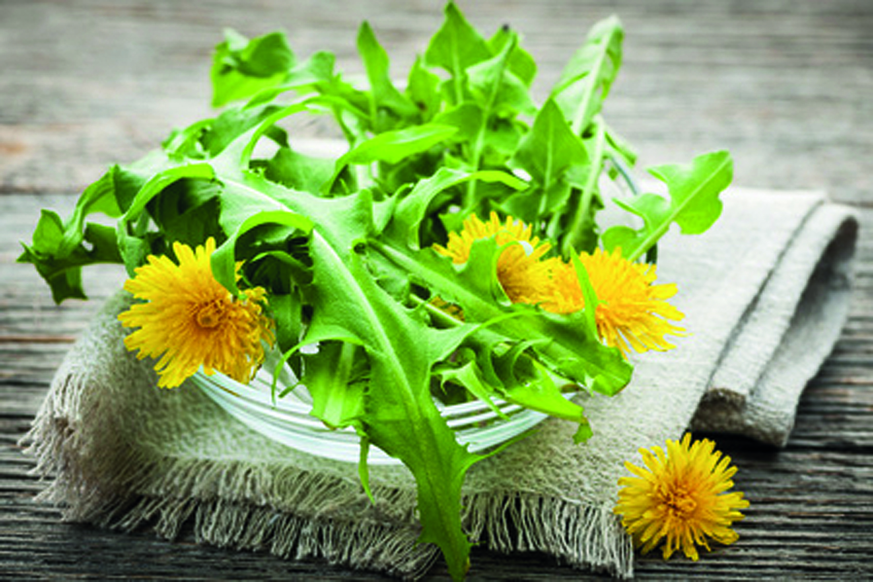sustainable weight loss,
* improved health, and,
* better self-confidence.”

Maria adds: “And it is also fast, easy and fun!

As Katharina Nyberg, one of their readers commented: “I LOVE Green Smoothies. And it is even more enjoyable to take out the weeds in the garden and include them in the smoothies."   
  
**More About Golden Opportunity**  
  
Founded in 2009, Golden Opportunity has helped many businesses and consumers with Change, Coaching & Wellness services. The company's mission statement is "to create lasting improvements - one individual habit at a time". To learn more about Golden Opportunity, visit them online at [www.A-Golden-Opportunity.com](http://www.A-Golden-Opportunity.com).  
  
**CONTACT INFORMATION**  
Golden Opportunity, Att: Sara Bern, Gamla Stockholmsv. 120, Huddinge, 141 32, SWEDEN  
Webpage: [www.A-Golden-Opportunity.com](http://www.A-Golden-Opportunity.com) Logo: <http://a-golden-opportunity.com/?p=1262>   
Email: [Sara@GoldenOpportunity.se](mailto:Sara@GoldenOpportunity.se) Videos/Images: <http://alturl.com/nfkt7>

Pressinfo (=About us with pictures): <http://a-golden-opportunity.com/?p=435>

# GREEN SMOOTHIES – QUICK START GUIDE

Here is the simple formula to get you started with healthy green   
smoothies.

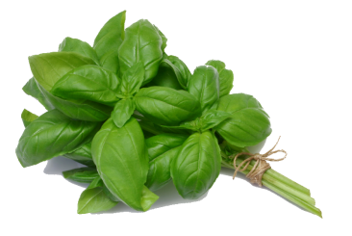

* **Put fruits and / or berries into a blender**
* **Add greens (e.g. salad, about as much as the fruits. Ideally 60%)**
* **Add 1-2 cups of water (or coconut milk)**
* **Mix it smooth.**

**THAT’S IT!**Serve and enjoy with a beautiful decoration!

**Order your full recipe book here:** <http://alturl.com/o8pfu>

**// Sara and Maria Bern**

# C:\Users\Sara Bern\Pictures\FREE pictures\Gröna smoothisar\Bilder till boken\apples on vine.jpg

# 22_Fotolia_32403083_S5 DELICIOUS GREEN SMOOTHIE RECIPES

**Basil Sprinkle**

1 Mango

1 Banan

Green leaf lettuce

Corn salad (Mâche)

Some basil leaves

1-2 cups water

**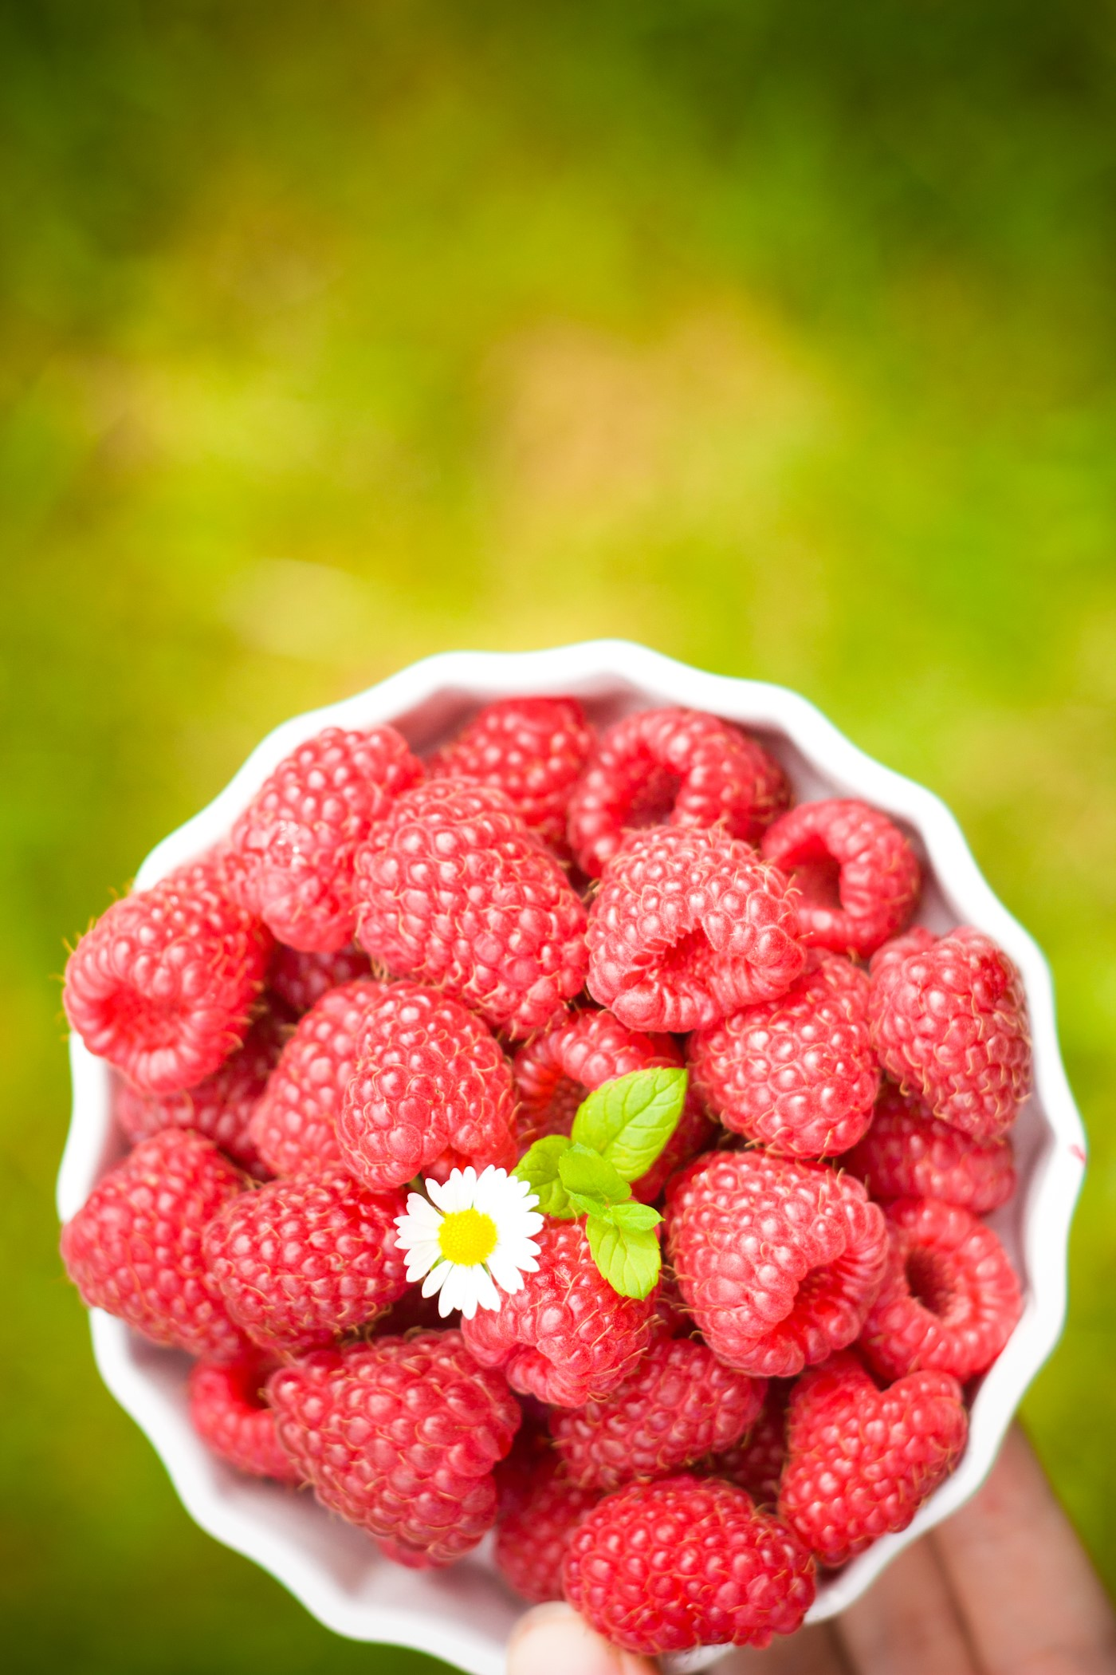**

**Banana Dance**

1 Banana

Green leaf lettuce

1/3 pot Fresh parsley

1-2 cups water

**Sweet Chard**

Swiss Chard (Mangold)

1 Banana

1-2 cups water

**Raspberry Patch**

1 Apple

1 Banana

Raspberries

Romaine lettuce

1-2 cups water

**Green Berry Blast**

1 Banana

Raspberries

Iceberg lettuce

Baby spinach

1-2 cups water