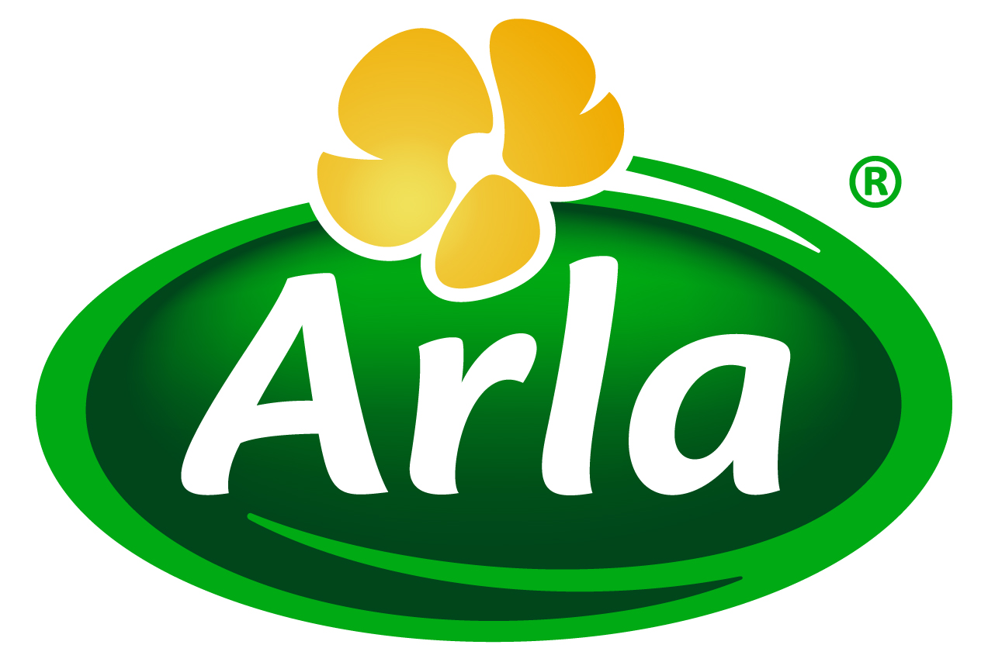


20 April 2015
PRESS RELEASE
Whey protein flexes its muscles
in the fight against sarcopenia

Arla Foods Ingredients is predicting a long-term increase in demand for whey protein ingredients suitable for use in products that address sarcopenia in seniors.

Sarcopenia is the loss of muscle mass with advancing age and is common in elderly people. It occurs as seniors become less active and consume less dietary protein, which results in a reduction in lean body mass that can impair movement and increase the risk of injury.

The recommended daily dietary intake of protein is currently 0.8g per kg of body weight – but nearly 40% of people over the age of 70 do not achieve this. In combination with the reduction in activity levels associated with ageing, the consequence of this is that an estimated 15% of people over 65 and 50% of people over 80 years will experience sarcopenia and its related physical limitations at some pointError: Reference source not found.

The problem of sarcopenia is only likely to worsen as a result of the world’s ageing population. The UK, Germany, France and Italy each has in the region of 11 million people aged over 65, according to Euromonitor. In the US the figure is 46 million, and the picture is similar in major growth markets such as South Korea, Russia, Argentina and Brazil.

Peter Schouw Andersen, Business Development Manager for Performance Health & Nutrition at Arla Foods Ingredients, said: “This year, Europe will have twice as many consumers aged 55 to 74 than young people aged 15 to 24 – a trend that is mirrored elsewhere in the world. This means that growing numbers of consumers will suffer from sarcopenia and its symptoms. In turn, this creates a significant opportunity to develop convenient, tasty and healthy food and drink products that help seniors get more high quality protein into their diet and prevent or even reverse sarcopenia.”

Arla Foods Ingredients will be at the forthcoming Vitafoods Europe exhibition (Stand P40) where it will present a concept drink rich in whey protein to highlight the commercial potential that exists for companies to develop consumer-ready products to combat sarcopenia. Vitafoods Europe takes place at the Palexpo in Geneva, Switzerland, from 5-7 May 2015.

Peter added: “The benefits of whey protein are well documented. It is more rapidly absorbed by the body compared with other protein sources and is known to increase muscle protein synthesis after exercise in both young and older people. Whey also offers a highly nutritional amino acid profile and is particularly rich in leucine, which initiates muscle protein synthesis. This package of benefits makes whey ingredients the perfect solution for addressing sarcopenia.”

ENDS

For more information, please contact:
Kine Bjoralt, Ingredient Communications
Tel: +44 141 280 4141
Email: kine@ingredientcommunications.com
@ingredientcomms

About Arla Foods Ingredients
Quality starts here: Arla Foods Ingredients is a global leader in natural whey ingredients for products in a range of categories – from sports, clinical and infant nutrition to beverages, bakery, dairy and ice cream. The cornerstones of our business are innovative ingredients, world-class facilities and a staff of dedicated experts. Drawing on our portfolio of functional and nutritional whey proteins, milk minerals, lactose and permeate, our expert team delivers solutions that bring new food products quickly and efficiently to market. Our application centres run hundreds of customer product trials every week. All ingredients are produced using state-of-the-art processing technology at our plant in Denmark, or by one of our joint ventures in Argentina, Germany and the UK. Arla Foods Ingredients Group P/S is a 100% owned subsidiary of Arla Foods, a global dairy company and cooperative owned by dairy farmers in Denmark, Sweden, the UK, Germany, the Netherlands, Belgium and Luxemburg.

RSS Feed
Visit our website at http://www.mynewsdesk.com/arla-foods-ingredients and sign up to our News RSS feed for all the latest developments – updated regularly.

Twitter
Follow us on twitter for all the latest updates @ArlaIngredients

LinkedIn
http://www.linkedin.com/company/arla-foods-ingredients

Burton & Sumukadas 2010, Optimal management of sarcopenia in Clinical Interventions in Aging 2010: 5 217-228
Global Burden of Disease study 2010; the Lancet 2012

