PRESS RELEASE
February 2018
TROLLBEADS MOTHER’S DAY 2018

Mamma Mia!
She is for joy. For fun. For comfort. And caring. She is the one who is always there. She is love and sunshine. Who? Mamma Mia!
For Mother’s Day 2018, Trollbeads launches the Mamma Mia! Bead. A vibrant and beautiful, limited edition glass bead with beautiful flowers. The joyful colours and spectacular design will for evoke warm feelings with any mom without any doubt.
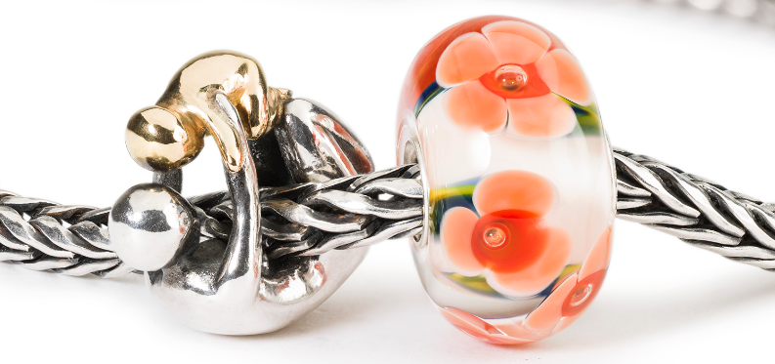
Generations of love
Let Mamma Mia! be accompanied by the stunning bead Maternity, a mother and her baby playing together. A lovely and sweet ritual, sacred since the beginning of motherhood. The Maternity bead comes in 18 karat gold and Sterling silver or in Sterling silver only.
Mother’s Day also include grandmothers. The bead Grandma is the perfect choice for grandmothers all over the world.
Trollbeads is the original, high quality bead-on-bracelet concept offering hundreds of beautiful beads – each bead is a little piece of art and tell a different story. Every mother has a different story to tell. Find the most suitable bead for her on Mother’s Day.
Mamma Mia! is designed by designer Neetu Gupta.
The collection is available in stores and online from February 16, 2018.
Exquisite craftsmanship
Trollbeads is world famous for the enchanting way it plays with glass in its jewellery. All glass beads are handmade in front of a red-hot, open flame.
Trollbeads jewellery is made from the highest quality raw materials, including 18 karat gold, Sterling silver, Italian Murano glass, freshwater pearls, amber and precious stones.
The exquisite craftsmanship of Trollbeads’ jewellery is only truly complete when you match the different beads that tell your stories in your own personal way. This is the true beauty of Trollbeads.
The “Mother’s Day” collection can be mixed and matched with existing and new jewellery - any way you and your mother like.
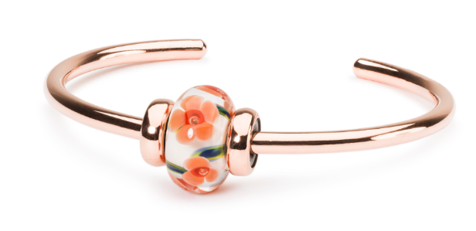

Prices:
Mamma Mia! bead EUR 45,-
Mother’s Day bangle as shown EUR 120,-
Maternity Bead – Gold/Silver EUR 495,-
Maternity Bead – Sterling silver EUR 75,-

For further information, imagery or samples, please visit www.trollbeads.com or contact:

Annette Spanggaard Bettina Løvstrøm Pedersen annette@thejournal.nu blp@trollbeads.com
Phone +45 29 26 20 24 Phone +45 33 93 60 93

About Trollbeads
Trollbeads, a Danish family-owned jewellery brand, was established in 1976 and invented the original bead-on-bracelet concept. At the core of the brand lies self-expression through 600 different beads in silver, gold glass and gemstones. Trollbeads jewellery is available in more than 30 countries through the company’s own flagship stores, independent retailers, and online at www.trollbeads.com

