For Immediate Release:
27th February 2020
Oi London 2020 event marks 50th anniversary of influential ocean science and technology
exhibition and conference series
More than 500 exhibitors are gearing up for the largest-ever
Oceanology International expo in the show’s half-century history
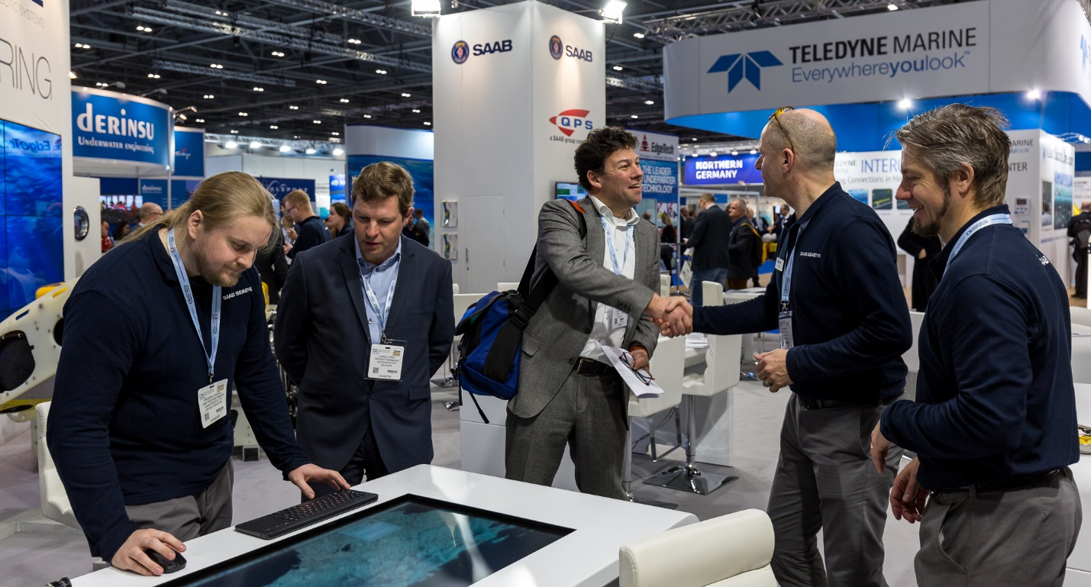
Oi London 2020 will be a meeting point for over 500 exhibitors. Photo from Oi London 2018
London, UK
There are less than three weeks to go until the opening of Oceanology International 2020 (17-19 March, ExCel London), a keenly-anticipated event which will mark the 50th anniversary of the world’s premier ocean science and technology exhibition and conference series. Prospective attendees are urged to register now via the Oi website at www.oceanologyinternational.com.

The London 2020 event is on track to become the largest Oi undertaking in the expo’s half-century history: an unprecedented 17,000+m² of floorspace has been freed up to accommodate more than 500 exhibitors from 90 countries, while twice as many companies than at previous Oi events will be given the opportunity to stage live on-water vessel and instrument demonstrations in the adjoining Royal Victoria Dock. Additionally, in excess of 8,000 visitors are expected to pour through the ExCel London doors over the three days of the show.

In the half-century since the Oi expo series was launched in Brighton, the exhibition and conference has grown to the point where a thriving Oi portfolio now exists, with parallel events hosted in the USA and China plus a forthcoming Oi show with a Middle East and Indian Ocean focus which is due to commence in Abu Dhabi this September. This means that an Oi expo will be taking place somewhere in the world every six months, providing an unmatched networking forum and global marketplace for maritime industry professionals, academics and government representatives alike.

Emphasising this vigorous international feel, new pavilions for Massachusetts and Italy are being introduced for Oi London 2020, taking their place alongside returning delegations from companies in Canada, France, the Netherlands, Germany, Norway, Ireland and the US. The general expansion of key resources is also reflected in an increased prominence for show mainstays including the Future Tech Hub, spotlighting advanced solutions from new-to-market technologists, and the Ocean ICT Zone, which will promote connectivity and data-related innovations with a particular relevance for the Offshore Oil & Gas, Aquaculture, Marine Science and Marine Renewables sectors.

The show will also provide an ideal showcase for companies looking to stage product launches and/or reveal their latest updates. Attendees can expect to encounter inspiring new developments in specialisms including ROVs, AUVs, robotics, satcoms, imaging and survey equipment.

The Oi London 2020 conference schedule, meanwhile, will as always augment the exhibition by presenting delegates with a similarly comprehensive abundance of future-focused content. With highly knowledgeable speakers drawn from a nexus of thought leaders and industry professionals, the free-to-attend technical tracks will cover a spread of hot-button oceanographic topics, these being Hydrography, Geophysics & Geotechnics; Offshore Energy Development; Imaging & Metrology; Unmanned Vehicles & Vessels; Ocean Observation & Sensing; Navigation & Positioning; Marine Pollution & Environmental Stressors; Coastal Zones & Shallow Water; Data Interpretation & AI; Asset Integrity & Monitoring; and Ocean ICT.

Attendees can also book tickets now for two returning one-day events. The Ocean Futures Forum will examine in depth the latest technological solutions to address the varied requirements of offshore industries, while Catch The Next Wave will see speaker pairings stressing the importance of cross-sector collaborations in establishing a sustainable future not just for the ocean science and technology community, but indeed the wider world.

“It’s very gratifying to see how smoothly all the elements are coming together on the eve of Oi London 2020,” says David Ince, Event Director, Reed Exhibitions, “so we feel confident in stating that everyone who attends, whether they are exhibiting, chairing conferences or merely visiting, will have an enjoyable and rewarding time at the show. We’re looking forward to inviting all attendees to join us in celebrating this golden anniversary landmark in the Oi calendar.”

Visitors can register to attend Oi 2020 here.

ENDS
Notes for Editors
Press registration for Oi London 2020 is now open. To receive a press pass, please click here.

For further information, please contact:

David Pugh
Saltwater Stone
Tel: +44 (0)1202 669244
d.pugh@saltwater-stone.com

Maria Harper
Head of Marketing, Energy & Marine
Reed Exhibitions
Tel: +44 (0)20 8439 8878
maria.harper@reedexpo.co.uk

About the Oceanology International Portfolio

Connecting the Global Ocean Technology Community

Oceanology International is the world’s leading marine science and ocean technology exhibition and conference. Beginning its journey in the UK in 1969, Oi has established itself as a truly global portfolio, with events running in London, San Diego, Shanghai an Abu Dhabi.

Oceanology International offers a series of global and regional forums where industry, academia and government share knowledge and connect with the marine technology and ocean science community, improving their strategies for exploring, monitoring, developing and protecting the world’s oceans.

The Oceanology International portfolio includes:
- Oceanology International - London: Oceanology International is the world’s largest exhibition and conference dedicated to serving all professionals working in the global marine science and ocean technology sector. The first Oceanology International was held in Brighton, in 1970. Today, its home is at ExCeL London. The Oi 2020 exhibition is ending its 50th anniversary celebration and is expected to attract 500+ exhibiting companies and 8,000+ attendees from over 90 countries. www.oceanologyinternational.com
- Oceanology International China - Shanghai: Developed with government and industry associations, Oi China provides organizations with the opportunity to capitalize on China’s rapidly growing offshore energy and marine industries. With 215 exhibitors from 20 different countries, more than 5,000 domestic and overseas professional attendees from 32 different countries and regions were attracted to Oi China 2018. www.oichina.com.cn/en-gb.html
- Oceanology International Americas - San Diego: Returning to the thriving US blue economy hub of San Diego, Oi Americas is a growing regional showcase of technology solutions and services with an expected audience of 2,750 attendees from 30+ countries. The third edition takes place on February 15-17, 2021. www.oceanologyinternationalamericas.com

- Oceanology International Middle East - Abu Dhabi: The latest edition to the Oceanology portfolio of events will launch in September 2020 at the Abu Dhabi National Exhibition Centre (ADNEC) and will focus on the Middle East and Indian Ocean region’s growing application of ocean technology across a variety of end-user sectors from Ocean Science to Aquaculture to Offshore Energy and more. https://www.oceanologyinternationalmiddleeast.com/en-gb.html

About Reed Exhibitions:
Reed Exhibitions is the world’s leading events organizer, with over 500 events in 30 countries. In 2018, Reed brought together over seven million event participants from around the world generating billions of dollars in business. Today, Reed events are held throughout the Americas, Europe, the Middle East, Asia Pacific and Africa and organized by 40 fully staffed offices. Reed Exhibitions serves 43 industry sectors with trade and consumer events. It is part of the RELX Group plc, a world-leading provider of information solutions for professional customers across industries. www.reedexpo.com

