PRESS RELEASE  Att: Head of News | Göteborg Dec 09, 2013
Inet is Swedens’s most prized computer dealer
- Computer Store of the Year 2013
- Online Store of the Year 2013
- Online Retailer of the Year 2013
Computer dealer Inet outperforms all competition in this year's comprehensive and independent surveys of this years best computer store in Sweden. Pricerunner again assigns Inet the award as Online retailer of the Year, Sweclockers appoints Inet Computer store of the Year for the sixth consecutive year and Prisjakt voted Inet Online Store of the Year for the fourth consecutive year.
– It feels almost unreal when Pricerunner, Sweclockers and Prisjakt give us their finest awards year after year. We work hard to give our customers what they expect and apparently we succeed pretty well, says Erik Wickman, Managing Director of Inet.

Computer dealer Inet crushes all competition when it comes to the most popular computer dealer in Sweden. Year after year, the company is rewarded for its exceptionally high quality customer service and to be the online retailer that consumers prefer when it comes to computer products.  This past week three different and independent votings once again conclude the same results when asking computer customers in Sweden. Sweclockers, Swedens largest online publication in computers, hardware and computer games with over 200 000 members, voted Inet as Computer Store of the Year for the sixth consecutive year.  Price comparison service Pricerunner compiled over 18,000 reviews after purchases made online and found Inet as the unanimous winner of the Online retailer of the Year of computer products.  The Swedish price comparison service Prisjakt came to the same conclusion in their vote among their members and rewarded, for the fourth consecutive year, Inet as Online Store of the Year.  – We aim to have state of the art customer service – blazing fast delivery, good prices and very knowledgeable advice. Our main customer base is computer and gaming enthusiasts, and they are extremely picky. We have to constantly keep an active dialogue with them to keep up, says Erik Wickman. |  | 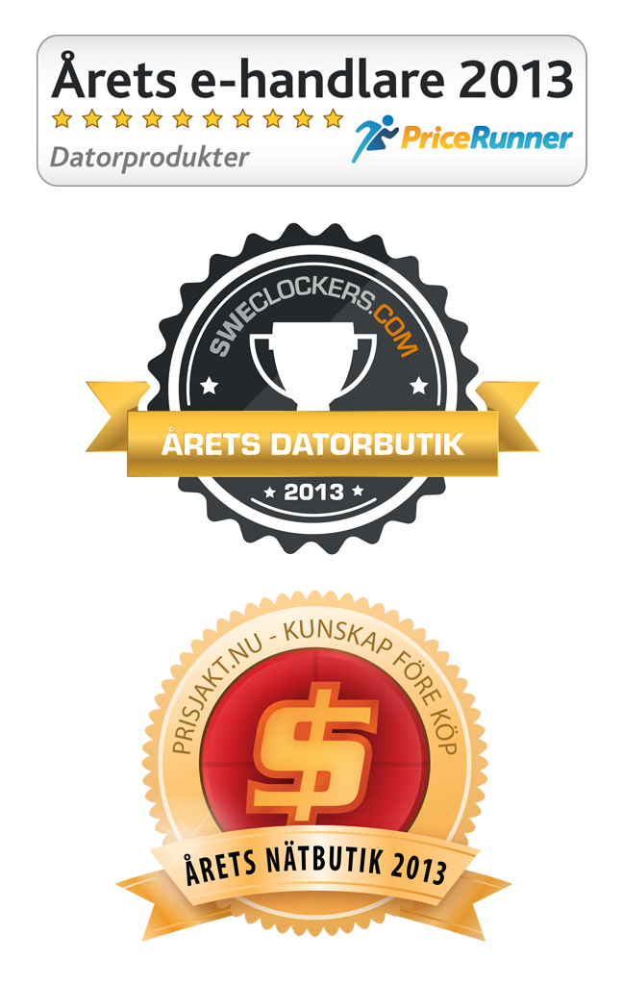  Inet has in three separate customer surveys been elected Sweden’s best Online dealer. Pricerunner for the second consecutive year, Sweclockers for the sixth consecutive year and Prisjakt for the fourth consecutive year.
Pricerunner is using reviews from consumers who shopped at retailers in different trades on the internet to select best Online retailer of the Year. This year 18,622 reviews the basis for the award. A week after the purchases Pricerunner follow up the survey and the consumer can respond if the delivery arrived on time and how any contact with customer service experienced.
Sweclockers Editor in Chief Andreas Dimestam comment on their vote, “Inet manages to maintain confidence among the enthusiasts year after year. Others have ups and downs, but Inet constantly keeps customers happy and are often praised for good service with knowledgeable staff. To be appointed Computer store of the Year by Sweclockers extremely picky members is the greatest honor a reseller can get."
The citation from Prisjakt reads:”Again Inet brings home with the victory. The store knows best how to keep customers satisfied. Inet has knowledgeable staff and a wide range of products and are able to deliver a top-notch service.”
– These awards makes us happy, proud and incredibly grateful. In today's cutthroat competition the winnings provide us with a great boost to find new ways to become an even better computer store, says Erik Wickman, Managing Director of Inet.
For further information please contact:
Erik Wickman , Managing Director Inet, +46708-65 27 02 , erik.wickman@inet.se
Magnus Sjöbäck , Press Officer Inet, +4670-445 15 99 , magnus.sjoback@inet.se

