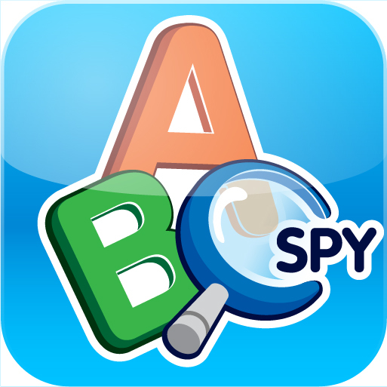

ABC Spy: An Alphabet Book for the YouTube Generation
Stealth Education launches ‘apptivity’ learning apps for iPhone and iPad

London – 2 May 2012 - If you’ve been struggling to find things to do whilst stuck inside on yet another rainy day, you can switch off the telly for few hours and give your young ones your phone. ABC Spy is an innovative app that combines children’s love of technology, photography and spying with learning, to create an app that you’ll be excited to see your child playing with.

Kids love touchcreens. They find them as seductive as adults do, but parents are increasingly concerned about excessive, passive screen time – which is where ABC Spy comes into play. Rather than just staring at a screen, ABC Spy encourages children to get active and explore the world around them – whether they’re at home, on a special day out, or even on a long car journey.

Much like the original ‘I Spy’ game ABC Spy encourages discussion and family participation as the child chooses a letter of the alphabet and then finds an object to photograph that begins with that letter. Assistance comes in the form of ‘Simon Spider’, an in-app character who makes suggestions about the types of things to look for and photograph. When they’ve taken the photo they can then frame, edit and name it to create a catalogue of the images they have spied.

Realising the importance of recognition and reward, ABC Spy awards trophies for key achievements such as taking a picture for every letter in the alphabet. Tapping ‘Make a film’ then transforms the photographs taken into a video that can be watched on the phone and even posted on YouTube to share with friends and family. Statistics provided within the app allow parents to see how their child is progressing – as well as checking on how much time they have clocked up using the app.

Commenting on the launch of the app, Stealth Education’s CEO Henry Playfoot said:

“We’re not in the business of creating a generation of digital zombies - we want to help parents help their kids learn and have fun at the same time. ABC Spy is about active learning: creativity, problem solving and collaboration… The things kids really need to thrive and survive in the 21st century. What I hope we have achieved with ABC Spy is given parents a way of entertaining their children without any need to feel guilty - the child will have great fun playing and you’ll be safe in the knowledge they’re learning, in an active, creative and exciting way, too.”

Notes to editors:
Information on the app: http://www.abcspy.com
Background on Stealth Education: http://www.stealtheducation.com

ABC Spy is available here:
iPhone: http://itunes.apple.com/gb/app/abc-spy/id483577483?mt=8
iPad: http://itunes.apple.com/gb/app/abc-spy-hd/id499920596?mt=8

ABC Spy Phonics is available here:
iPhone : http://itunes.apple.com/gb/app/abc-spy-phonics/id517018604?mt=8
iPad: http://itunes.apple.com/gb/app/abc-spy-phonics-hd/id517022332?mt=8

Expert Quotes from the Stealth Education Team:

“ABC Spy brings the ABC book format to the YouTube generation. It gives kids the freedom to create their own visual alphabet by enabling them to add their own content. The game element is fun and relevant, and to my mind more likely to achieve a more engaged learning experience.”

Ian Livingstone OBE, Life President Eidos

"ABC Spy puts a creative tool in the hands of the child and allows the adults to get out of the way. It gives the child choice - an opportunity to be creative; they're directing their own learning."

Prof Mark Alter, Professor of Educational Psychology, New York University

About Stealth Education:

Stealth Education was founded by education and technology experts Henry and Jim Playfoot to meet a need to come up with games and apps that are both fun and educational. Backed by a team of advisors who bring extensive experience from the worlds of education, gaming and technology and working with robust research and evidence,
Stealth Education will be bringing a series of games and apps to market that children will enjoy playing, while parents can be safe in the knowledge that while they have fun, they will also be learning.
For more information on ABC Spy or Stealth Education, please contact:

Henry Playfoot, CEO Stealth Education
henry@stealtheducation.com

