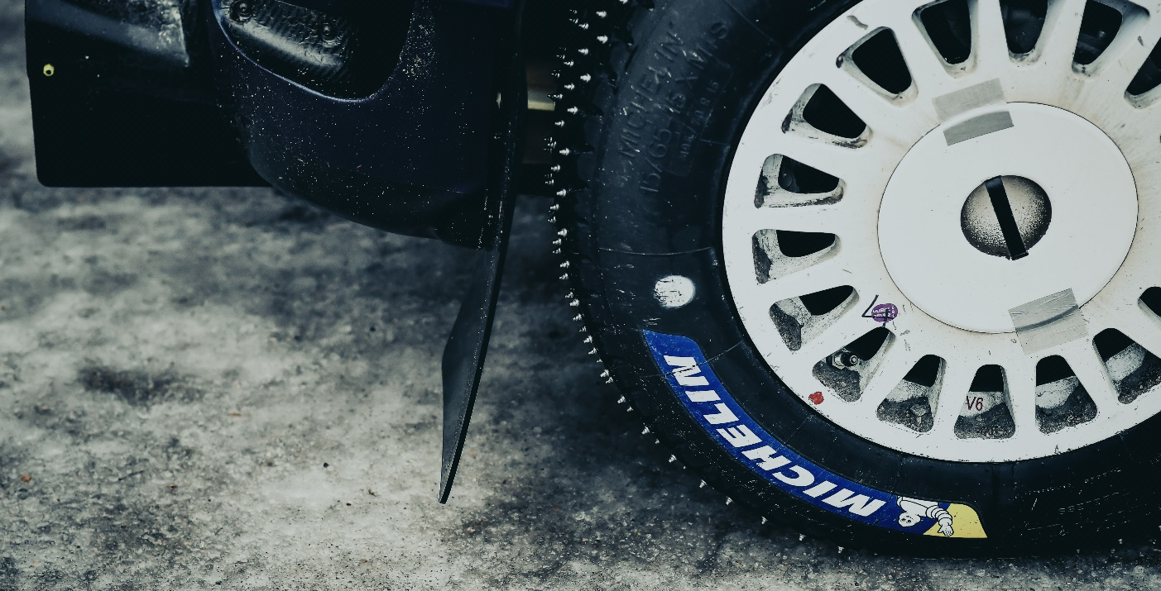
ARBESKO WILL LAUNCH SAFETY SHOES WITH RALLY TIRES
The Swedish shoemakers Arbesko has a long history of producing high quality safety shoes made in their own shoe factory in Kumla, Sweden. In a unique and long-term partnership with Michelin, Arbesko has equipped their safety shoes with high-tech soles based on Michelin’s rally tire, NA00. The result of the collaboration is the new safety shoe series Kontroll, which will be launched this fall; sporty safety shoes in sneaker-style equipped with high-performance soles by MICHELIN.
”For some time we and Michelin have wanted to create something together. And in April 2019, we agreed that now it’s time to put our ideas into practice and start our partnership. We put together a team consisting of our product developers, a Swedish fashion designer and MICHELIN sole experts. And the result is our new series Kontroll that really exceeds our expectations. The series combines our experience of what it takes to create a safe and functional shoe with unbeatable soles from MICHELIN, together with a design that makes you want to wear the safety shoe on a regular basis, and not only while working”, says Karin Lidman, CEO at Arbesko.
Michelin is a world leading tire manufacturer and like Arbesko, they have been around for a long time. With their expertise and experience when it comes to superior grip on the road, they have created a sole concept – “Soles by Michelin” – to equip shoes with the same exceptional grip. To meet Arbesko’s needs, Michelin designers teamed up with the product developers at Arbesko and they decided that the MICHELIN rally tire, NA00, should be the foundation of the new outsole. The new outsole has been named Safety Grip to reflect its key benefit – a safe grip.

"When choosing new partners, we always choose the best ones, and Arbesko is definitely one of them. Consumers who buy shoes with MICHELIN outsoles expect to have the same quality and performance of MICHELIN tyres. Both tires and soles are connected to the ground. The methods are different, but the footprint is the same. When developing Arbesko's exclusive sole they required us to engineer a sole that would guarantee adherence to the ground and durability. For this reason, Michelin designers have taken inspiration from the MICHELIN rally tire NA00 for the development of the sole, the perfect answer to Arbesko's needs. Our collaboration with Arbesko has been fantastic from day one. A great communication, teamwork and mutual respect, contribute to create an incredible long-lasting partnership", says Filippo Sartor at JV International, Michelin’s licensee for the development of soles by MICHELIN.

”The series is the start of a long-term collaboration to complement our existing assortment. Our mission is to protect hard-working feet and in order to do that, we always develop safety shoes based on the needs of our users and we never compromise on quality, safety and function”, says Karin.

The new safety shoe series Kontroll
The series will be launched this autumn and consists of five models which can be described as sporty safety shoes in sneaker-style. The common features for the series are according to the Arbesko DNA: quality, safety and function. The safety shoes have a heat-resistant and shock-absorbing Safety Grip-sole in nitrile rubber, a metal-free shank in the arch for extra stability on uneven ground, durable heel grip, extra heel cushioning, toecap in fiberglass, stretched upper for even more stability, extra toe protection and a soft, metal-free nail protection. The safety shoes are all ESD-approved.

Kontroll 200: airy and laced safety shoe in ventilating mesh. 100% metal-free. Protection: S1 P.
Kontroll 210: airy safety shoe in ventilating mesh with Boa® Fit System. Protection: S1 P.
Kontroll 220: waterproof and laced safety shoe with durable material. Protection: S3, WR.
Kontroll 230-10: waterproof and durable safety shoe with Boa® Fit System. Protection: S3, WR.
Kontroll 230-50: waterproof and durable safety shoe in woven textile with Boa® Fit System. Protection: S3, WR.
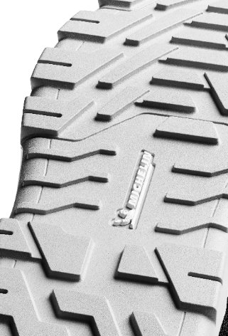
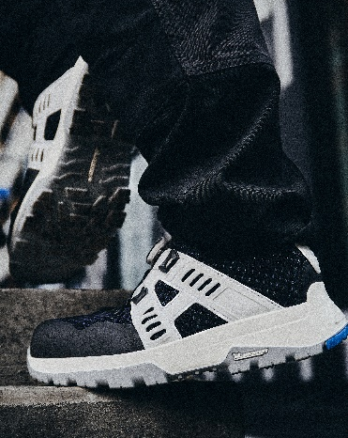
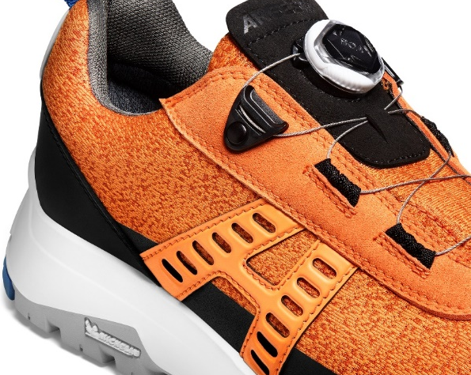

For more information, please contact:
Karin Lidman Stina Karlsson
CEO Marketing Manager
karin.lidman@arbesko.se stina.karlsson@arbesko.se
+46 73 078 36 41 +46 73 087 92 76

