**New 5-year data confirm maintained bone levels and biological sustainability with OsseoSpeed implants from DENTSPLY Implants**

*June 2015*—New 5-year data on OsseoSpeed implants (ASTRA TECH Implant System) show stable soft tissue and maintained bone levels from implant placement and implant loading, confirming an average bone level reduction of only 0.3 mm.

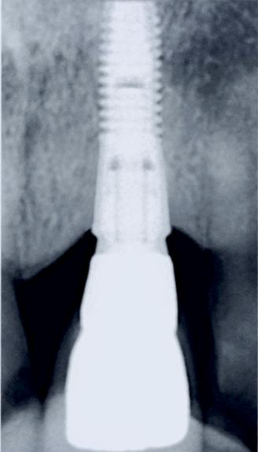Recent data from 17 scientific articles show that the average bone level reduction from implant placement to five years is 0.3 mm, whereas the accepted standard norm is currently at 1.5 mm.   
In addition, data from 62 scientific articles confirm the 0.3 mm average bone level reduction one year after implant loading, with remained stability for five years.

“These great results are not a surprise to us, but we are of course very happy to be able to present data based on sound science, proving our marginal bone maintenance. We have followed the performance of the ASTRA TECH Implant System, with the OsseoSpeed implants, for many years, and we continue to find evidence of maintained marginal bone well above the standard norm,” says AnnaKarin Lundgren, Director Global Clinical Affairs at DENTSPLY Implants.

For dental professionals and their implant patients, it is important that implant treatment not only restores function, but also results in natural-looking esthetics. To fulfill this promise, a prerequisite is biological sustainability, i.e. the harmony of marginal bone and surrounding soft tissue over time. AnnaKarin Lundgren continues; “Achieving biological sustainability is important for optimal dental implant treatment outcome, professional success and satisfied patients. That’s why we continue to focus on just that, in order to continue to challenge the scientific boundaries and deliver quality of life for patients.”

A key factor in delivering biological sustainability is the ASTRA TECH Implant System BioManagement Complex. This unique combination of interdependent features ensures reliable, predictable and esthetic results both in the short and long term.

**Strong commitment to science and clinical research**

Parallel to the introduction in markets all over the world, DENTSPLY Implants has continued its dedication to science and clinical research. DENTSPLY Implants’ products and solutions are well-documented with reliable clinical results, and are supported by more than 1,650 scientific publications. Currently, there are 200 ongoing studies worldwide, involving more than 450 clinicians. Documentation is an integrated and essential part of the product development process.

To read more about the science behind DENTSPLY Implants’ products and solutions, please visit   
[www.dentsplyimplants.com/science](http://www.dentsplyimplants.com/science)

**About DENTSPLY Implants**

*DENTSPLY Implants offers comprehensive solutions for all phases of implant therapy, including ANKYLOS®, ASTRA TECH Implant System™ and XiVE® implant lines, digital technologies, such as ATLANTIS™ patient-specific CAD/CAM solutions and SIMPLANT® guided surgery, SYMBIOS®   
regenerative solutions, and professional and business development programs, such as STEPPS™. DENTSPLY Implants creates value for dental professionals and allows for predictable and lasting   
implant treatment outcomes, resulting in enhanced quality of life for patients.*

**About DENTSPLY International**

*DENTSPLY International Inc. is a leading manufacturer and distributor of dental and other healthcare products. For over 115 years, DENTSPLY’s commitment to innovation and professional collaboration has enhanced its portfolio of branded consumables and small equipment. Headquartered in the United States, the Company has global operations with sales in more than 120 countries.*

**For further information, please contact:**

Kerstin Wettby—Senior Manager, Global Marketing Communication & PR, DENTSPLY Implants, Sweden

Cell phone +46 705 16 32 02 | [kerstin.wettby@dentsply.com](mailto:kerstin.wettby@dentsply.com) | [www.dentsplyimplants.com](http://www.dentsplyimplants.com)

As a member of the press, you can also visit our News & Press Room at:

[www.dentsplyimplants.com/en/Resources/News-and-Press](http://www.dentsplyimplants.com/en/Resources/News-and-Press)



###