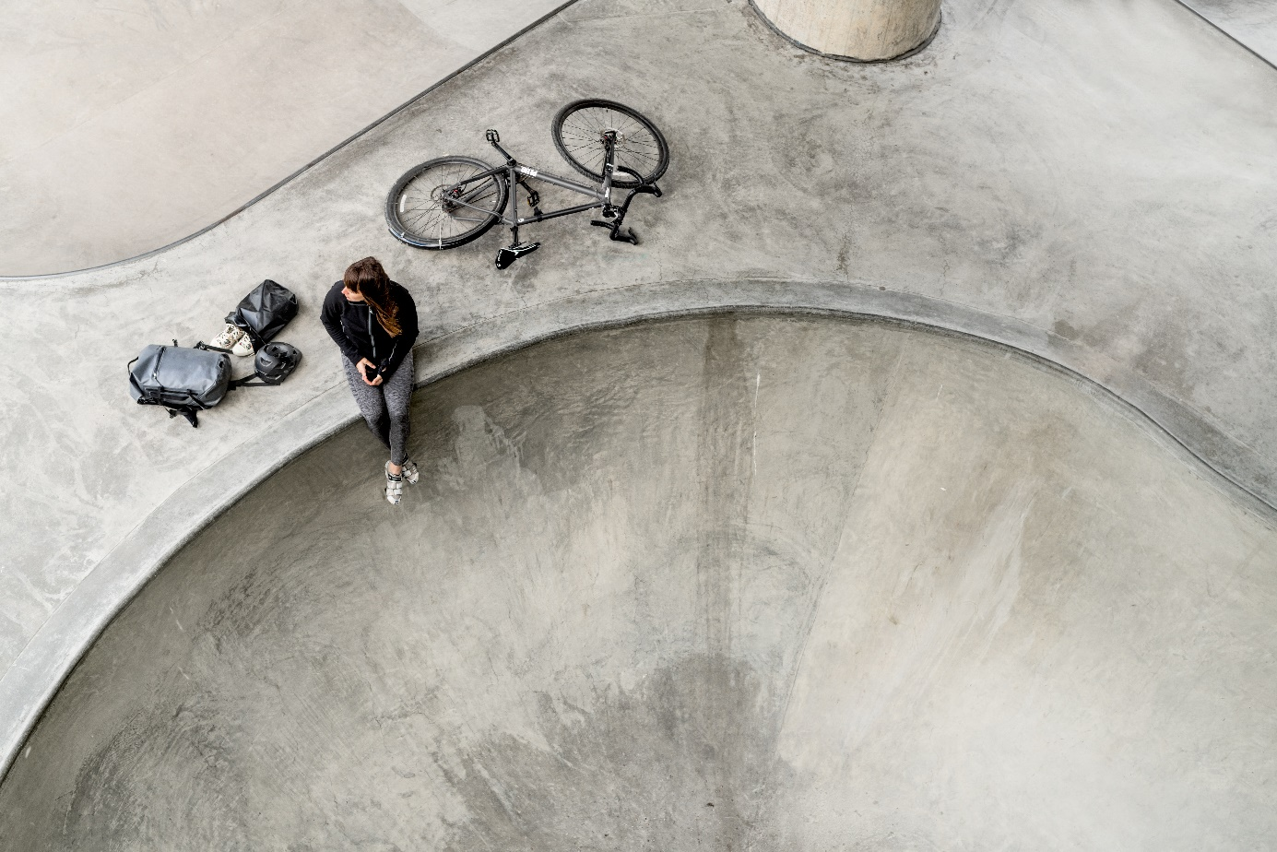**SPRING/SUMMER 2019: NEW PRODUCTS  
SILVA LAUNCHES SMART BACKPACKS WITH A FLEXIBLE PACKING SYSTEM**

**SILVA launches their new 360**°**-backpacks based on the idea of providing the user with 360 degrees of visibility, protection and flexibility. They are designed for those with an everyday-active-lifestyle and have the perfect blend of city and outdoor. The unique add on-system makes it possible to customize the backpack for extra packing space or protection. The backpacks can be used 24-7, in sunshine or rain, for commuting or hiking.**The backpack series consists of three models: Orbit, Lap and Loop. When designing the backpacks, Silva have focused on the following three main features: 360 degress of visibility, 360 degrees of protection and 360 degrees of flexibility.

“We believe that there are no such backpacks on the market. There are either more city or more outdoor focused backpacks. But with our 360° backpacks we have found a design and functionality that has the perfect blend.”, says Marcus Hjortsberg, project manager at Silva.

**The design story**

The 360° visibility ensures the user’s safety with reflective material all around the backpack. You are visible from all angles and the backpacks have a visibility light holder in the front and the back. With 360° protection Silva means that the backpacks protect the gear from rain, dirt and so on. The backpacks are water-resistant and waterproof and made of durable material. And the 360° flexibility makes it possible to use the backpacks for any activity and in any weather, and the user can also customize the backpacks for their specific needs. The smart attachment loops and lash points are the core in Silva’s 360°-system. In seconds you can attach or detach a pouch or mesh. Use a waterproof pouch to get extra packing space or to separate items from the rest of your gear. Or an elastic mesh for extra packing space or a helmet. The smart straps can also be used separately as compression straps for a jacket, skateboard etc.

**The backpacks**

360° Orbit comes in three sizes (18L, 25L, 30L) and is a waterproof and durable backpack that offers great protection for you and your gear whether you are going for a hike, an offshore adventure or just heading into town for work. The number one choice for the serious multitasker and traveller.  
  
360° Lap comes in two sizes (18L, 25L) and is a weatherproof and versatile backpack with extra laptop protection for the commuter who is out in any weather. It also offers the flexibility to use it for a weekend adventure or to bring your laptop along and work in the open.

360° Loop comes in one size (24L) and is a versatile every day backpack with an easy closure system and fully waterproof main compartment through the included drybag. The simple choice for the urban traveller and outdoor enthusiast.

**Recommended retail prices**

360° Orbit 30L, 159,99 EUR.  
360° Orbit 25L, 139,99 EUR.  
360° Orbit 18L, 119,99 EUR.  
360° Lap 25L, 119,99 EUR.  
360° Lap 18L, 99,99 EUR.  
360° Loop 24L, 79,99 EUR.  
360° Pouches (three sizes: 6L, 9L, 13L), 29,99-44,99 EUR.  
360° Mesh, 24,99 EUR.   
   
**Links**[360° concept page](https://silva.se/360-backpacks/)[Promo movie](https://vimeo.com/306357645)  
[Product movie](https://vimeo.com/305007726)  
  
Text and associated images can be downloaded in SILVA:s [newsroom](http://www.mynewsdesk.com/silva).

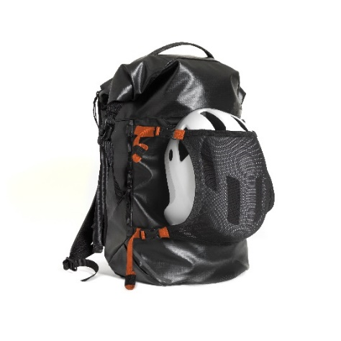  
**Press contact**Stina Karlsson  
Marketing Coordinator  
[stina.karlsson@silva.se](mailto:stina.karlsson@silva.se)   
+46 72 090 87 29

